


DAEN 690
Project Report
Virat Vighnesh Guduru
Zeeshan Khalid
Adler Cargill
Monisha Jaganathan

Fall 2024
GMU Terrorism, Transnational Crime and Corruption Center (TraCCC) — Terrorism Research and Dashboard

About the Cover
James Baldo is an associate professor and serves as the Director of the George Mason University (GMU), College of Engineering and Computing (CEC), Volgenau School of Engineering (VSE), MS Data Analytics Engineering (DAEN) program. Dr. Baldo has served in this position since Fall 2018 and recently returned this past May after a 2-year sabbatical applying state-of-the-art data analytics engineering concepts and technologies to solve real world problems.
Prior to becoming director of the DAEN program he served 19 years as a CEC adjunct professor while working as a practicing engineer. His career has over 45 years of industry and government experience with roles as data analytics engineer and software engineer.
His interest in large scale data, data management, analytics, and tools has provided him with opportunities to engage in assessing and applying new technologies across a diverse range of problems. The adoption of new technologies is exciting; however, adoption of new technologies requires careful planning and in addition to the technology, taking special care for planning how to successfully address for both organizational and cultural factors of the enterprise. This requires not only engineering knowledge and skills, but the ability to work on teams that interact across different corporate stakeholders.
Dr. Baldo continues to consult part-time with industry and leverages this knowledge and experience as feedback to the DAEN program. With technology moving at a lightening pace and technology adoption rates increasing, Dr. Baldo closely monitors the skillset needs of industry and how the DAEN program can provide graduates to fulfill these needs.
Dr. Baldo is currently researching applications of data mesh and data fabric for data management and exploring how analytics will be integrated into agentic systems.

Contents
Table of Contents
Abstract 1
Section 1: Introduction 3
1.1 Report Purpose 3
1.2 Report Readership 3
1.3 Report Structure 3
Section 2: Problem Definition 4
2.1 Problem Space 4
2.2 Research 6
2.3 Solution Space 7
2.4 Project Objectives 8
2.5 Primary User Stories 8
2.5.1 Researchers 8
2.6 Product Vision 9
2.6.1 Scenario #1 9
2.6.2 Scenario #2 9
Section 3: Datasets 9
3.1 Overview 9
3.1.1 Data Architecture 10
3.2 Field Descriptions 11
3.3 Data Context 12
3.4 Data Conditioning 15
3.5 Data Quality Assessment 16
3.5.1 GRID_INCIDENTS 16
3.5.2 GRID_PERPS 16
3.5.3 GRID_SOURCE 17
3.6 Other Data Sources 17
3.7 Storage Medium 17
3.8 Storage Security 18
3.9 Storage Costs 18
Section 4: Analytical Approach 19
Section 5: Visualizations 27
5.1 Visualizations and Interpretations 27
5.1.1 Research question 1: 27
Which regions or countries recorded the most terrorist incidents from 2018 to 2023? Which months saw the highest number of people killed and wounded during the same period? 27
5.1.2 Research question 2: 31
Which ten groups had the highest number of casualties (people killed and wounded) from 2018 to 2023? 31
5.1.3 Research question 3: 33
How many types of tactics (e.g., suicide attacks, kidnapping, car ramming, assassinations, stabbing, shooting, bombing, ambush, and planting mines/IEDs) were used from 2018 to 2023? Which ten groups employed these tactics the most, and how has their use of these tactics changed from 2018 to 2023? 33
5.1.4 Research question 4: 40
What are the most used weapon types (e.g., firearms, explosives, UAVs, incendiary devices, and melee weapons)? Which five group use firearms, IEDs, rockets, mortars, grenades, missiles, and UAVs the most? 40
5.1.5 Research question 5: 43
Which victims categories are most frequently targets (e.g., general population/civilians, government officials, professionals, political figures)? Which five groups primarily target civilians, military personnel, politicians, government officials, and professionals? 43
5.1.6 Research question 6: 49
What are the similarities and differences between Iran-backed and jihadist terrorist groups? 49
5.1.7 Research question 7: 53
What tactics have lone actors used from 2018 to 2023? Which ideologies (jihadist, far right, or nationalist) most influence lone actors? 53
5.1.8 Research question 8: 57
Is there a positive correlation between the types of terrorist perpetrators and the types of tactics used? 57
5.1.9 Research question 9: 59
Do weapon types influence the tactics used by terrorist organizations? Do target types influence the tactics used by terrorist organizations? 59
Section 6: Findings 62
Section 7: Summary 62
Section 8: Future Work 63
Appendix A: Domain Background 65
Appendix B: Glossary 68
Appendix C: GitHub Repository 69
Overview 69
GitHub Repository Link 69
Appendix D: Risks 70
Sprint 1 Risks 70
Sprint 2 Risks 71
Sprint 3 Risks 71
Sprint 4 Risks 72
Sprint 5 Risks 72
Appendix E: Agile Development 73
Scrum Framework Team Approach 73
Sprint 1 Lessons Learned 74
Sprint 2 Lessons Learned 75
Sprint 3 Lessons Learned 75
Sprint 4 Lessons Learned 75
Sprint 5 Lessons Learned 76

Table of Figures
Figure 1: A Collective newspaper headlines of Terrorism 4
Figure 2: Devastation and long-lasting impacts of terrorism. 5
Figure 3: Data Architecture Diagram 9
Figure 4: Workflow for Data Capture and Integration into the Database 13
Figure 5: Map of the countries with recorded terrorist incidents from 2018 to 2023. 27
Figure 6: This figure shows the total number of incidents by country 28
Figure 7: This figure shows regions with recorded terrorist incidents from 2018 to 2023. 29
Figure 8:This stacked bar chart shows causalities by month from 2018 to 2023 around the world. 29
Figure 9:This figure shows the top 10 groups which made the highest causalities and their count from 2018 to 2023. 30
Figure 10: This figure shows the top 10 groups which made the highest causalities and areas affected by them from 2018 to 2023 31
Figure 11: The figure shows the frequency of various tactics used by different groups from 2018 to 2023 32
Figure 12: The figure shows the changing use of various tactics by” unknown” perpetrators from 2018 to 2023. 33
Figure 13:The figure shows the changing use of various tactics by Taliban group from 2018 to 2023. 34
Figure 14: The figure shows the changing use of various tactics by ISIS group from 2018 to 2023 34
Figure 15: The figure shows the changing use of various tactics by Al-Shabaab group from 2018 to 2023. 35
Figure 16: The figure shows the changing use of various tactics by Houthis group from 2018 to 2023 36
Figure 17: The figure shows the changing use of various tactics by CPI group from 2018 to 2023 36
Figure 18: The figure shows the changing use of various tactics by ISIS DRC group from 2018 to 2023 37
Figure 19: The figure shows the changing use of various tactics by Boko Haram group from 2018 to 2023 38
Figure 20: The figure shows the changing use of various tactics by CPP group from 2018 to 2023 38
Figure 21: The figure shows the changing use of various tactics by Hizballah group from 2018 to 2023 39
Figure 22: The figure shows the most used weapon types using a bubble chart 40
Figure 23: The figure shows a bar graph representing different weapon types against the perpetrator groups 41
Figure 24: The figure shows a bar graph representing different weapon types against the perpetrator groups 42
Figure 25: The figure shows a bubble chart with most targeted groups 43
Figure 26: The figure shows a bar graph representing top 5 groups targeting general population 44
Figure 27: The figure shows a bar graph representing top 5 groups targeting government officials 44
Figure 28: The figure represents top 5 groups targeting professionals 45
Figure 29: The figure represents top 5 groups targeting political figures. 46
Figure 30: The figure shows top 5 groups targeting None. 46
Figure 31: The figure represents top 5 groups targeting others. 47
Figure 32: The figure represents Iran-backed vs. religious jihadist incidents worldwide. 48
Figure 33: The figure represents Iran-backed vs. religious jihadist incident tends from 2018 to 2023. 49
Figure 34: The figure represents Tactic Type Comparison between Iran-Backed vs Religious (Jihadist). 50
Figure 35: The figure represents Target Comparison between Iran-Backed vs Religious (Jihadist). 51
Figure 36: The figure represents Weapon Type use Comparison between Iran-Backed vs Religious (Jihadist). 51
Figure 37: The figure represents the most used Tactics by Lone Actors from 2018 to 2023 53
Figure 38: The figure represents what ideologies had the greatest influence on the lone actors. 54
Figure 39 :The figure represents what ideologies influence the lone actors by country. 55
Figure 40: Heatmap depicting correlations between perpetrator types and tactics. 56
Figure 41: Figure represents a Line Chart showing each perpetrator type’s correlation. 57
Figure 42: The figure represents a Sankey plot to visualize the tactics influence on weapon type. 58
Figure 43: The figure represents a Sankey plot to visualize the tactics influence on victim types. 59
Figure 44: Sprint project dates. 73

Table of Tables
Table 1: Glossary Table 18
Table 2: Sprint 1 Risks 20
Table 3: Sprint 2 Risks 21
Table 4: Sprint 3 Risks 21
Table 5: Sprint 4 Risks 22
Table 6: Sprint 5 Risks 22

This page is intentionally left blank

Abstract
Abstract
The ongoing global threat of terrorism demands a nuanced understanding of its trends, tactics, and impacts. This project leverages the Global Terrorism Trends and Analysis Center (GTTAC) database to analyze patterns in terrorist incidents from 2018 to 2023. The study addresses nine critical research questions, investigating the geographical distribution of terrorism, operational tactics, weapon preferences, victim targeting, and the ideological influences on lone actors. Insights were derived using advanced data visualization. Key findings include the identification of Western Asia and Sub-Saharan Africa as the regions most affected by terrorism, with Syria, Afghanistan, and the Democratic Republic of Congo ranking among the countries with the highest number of incidents. Unknown perpetrators accounted for the highest number of casualties, with the Taliban ranking as the second-highest contributor to fatalities. Bombings, shootings, and incendiaries were the most frequently employed tactics, with bombings undergoing a significant bifurcation in classification in 2020 into categories such as IEDs and planting mines. Temporal trends revealed shifts in group strategies, including ISIS's increasing reliance on improvised explosives and the Houthi rebels’ integration of advanced technologies like UAVs. The analysis also revealed weapons and tactics preferences of terrorist groups, with firearms and explosives emerging as the most used weapons. Civilians and government officials were identified as the most frequently targeted victim categories, reflecting a dual strategy of creating widespread fear and destabilizing governance structures. A comparative analysis of Iran-backed and jihadist groups highlighted stark differences: Iran-backed groups primarily operated in the Western Asia, targeting political figures with advanced tactics, while jihadist groups exhibited a broader global presence, often employing high-impact bombings against civilian populations. Advanced visualizations were employed to effectively communicate these trends and relationships. These findings provide actionable insights for policymakers, researchers, and security analysts, contributing to the development of data-driven counterterrorism strategies.

This page is intentionally left blank

Report

Introduction

Report Purpose
This report addresses data analytics challenges in understanding and combating global terrorism. By leveraging datasets from the Global Terrorism Trends and Analysis Center (GTTAC), the project aims to identify key patterns and trends in terrorist incidents, tactics, and weapon usage from 2018 to 2023. The primary goal being to answer research questions, such as identifying the regions most affected by terrorism, the groups with the highest frequency of terrorist acts, and the evolving tactics employed by terrorist organizations. Additionally, the report visualizes these trends, providing it for policy makers and researchers. Through detailed data analysis and visual representation, this work enhances understanding and contributes to the development of more effective counterterrorism strategies.

Report Readership
The target audience for this report includes policymakers and security analysts who are responsible for developing counterterrorism strategies and allocating resources. By analysing trends in global terrorism, such as the tactics, weapon types, and regions most affected, this report provides actionable insights that can guide decision-making. Policymakers can use this information to draft policies aimed at reducing the impact of terrorism, while security analysts can leverage the data to identify high-risk areas for targeted interventions. Additionally, this report is intended for researchers and academic institutions studying global terrorism trends. The insights provided will support scholarly work by offering data-driven answers to research questions, such as the operational capabilities of various terrorist groups and the impact of their tactics. This terrorism analysis is expected to be a valuable tool for these audiences, providing them with data visualizations and analysis to monitor terrorist activities and evaluate the effectiveness of current counterterrorism measures.

Report Structure
This report is structured into eight sections to thoroughly present the project details. Section 1, "Introduction," introduces the report's purpose, intended readership, and overall structure. Section 2, "Problem Definition," explores the problem space, related research, proposed solutions, project objectives, primary user stories, and product vision scenarios. Section 3, "Datasets," provides a detailed overview of the datasets, including field descriptions, context, system architecture, additional sources, and storage considerations. Sections 4 and 5 are based on the project type, covering analysis and visualizations of all the nine research questions. Section 6 highlights the findings, while Section 7 summarizes the results. Section 8 discusses future work. The appendices include domain background, glossary, GitHub repository details, risk assessments, and Agile development insights.

Problem Definition

Problem Space
The persistent threat of terrorism continues to undermine global security, instilling widespread fear, destabilizing societies, and causing significant economic disruption. Terrorist organizations exploit geopolitical tensions, societal divisions, and fragile political systems to perpetrate acts of violence, furthering instability and creating an enduring sense of insecurity. This environment of uncertainty compels nations to prioritize heightened security measures and counterterrorism efforts, diverting critical resources from essential sectors like education, healthcare, and infrastructure. As a result, societal progress is impeded, leading to long-term ramifications that extend beyond immediate threats to life and property.
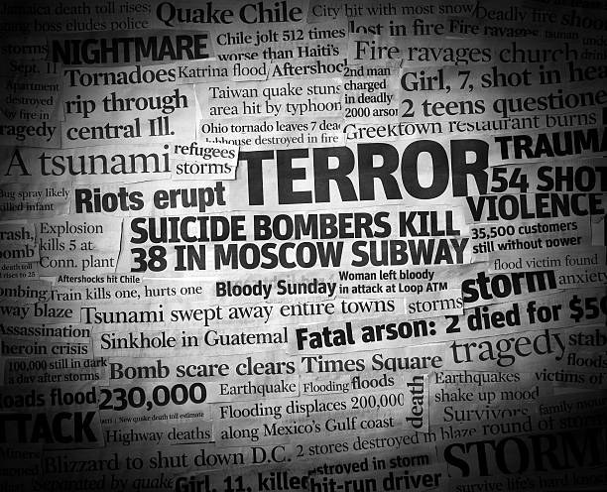
Figure 1: A Collective newspaper headlines of Terrorism
Understanding the scale of terrorism’s impact requires addressing its multifaceted dimensions. These include analyzing the tactics employed, the weaponry used, the motivations of perpetrators, and the demographics of victims. The economic costs of terrorism often extend far beyond the immediate destruction caused by attacks, affecting investment climates, tourism, and global trade networks. Additionally, terrorism reshapes political priorities, influencing how governments allocate funds and approach international collaboration.

Figure 2: Devastation and long-lasting impacts of terrorism.
The Global Terrorism Trends and Analysis Center (GTTAC) provides a curated dataset encompassing detailed records of terrorist incidents worldwide, from 2018 to the present. This dataset offers a unique opportunity to explore trends, uncover patterns, and identify key correlations in global terrorism activities. By leveraging this dataset, researchers and policymakers can develop evidence-based strategies that address the root causes and consequences of terrorism. The scope of this project focuses on addressing specific research questions that illuminate the dynamics of terrorism from 2018 to 2023. These include identifying the regions and countries most affected by terrorist incidents, analyzing the most lethal groups and their tactics, understanding the use of weaponry, and exploring patterns in victim targeting. By narrowing the analysis to these targeted areas, this project seeks to provide actionable insights that inform counterterrorism strategies while highlighting the broader implications for global security and societal well-being.
Key areas of the problem space include:
Geographical trends focus on identifying regions and countries most affected by terrorist incidents, with an emphasis on temporal patterns. Casualty analysis aims to determine which groups are responsible for the highest casualties and to understand the tactics and weapons that contribute to their lethality. Tactical insights delve into the diversity of tactics employed by terrorist groups, how these tactics have evolved over time, and their correlation with ideological motivations. Weapon utilization examines the prevalence and distribution of weapon types across groups and regions, highlighting the technological evolution of terrorism. Victim targeting explores patterns in victim categories to uncover trends in group motivations and operational strategies. Comparative analysis evaluates the behaviors of different types of terrorist groups, such as Iran-backed organizations versus jihadist groups, to identify unique and overlapping characteristics. Lone actor dynamics investigate the tactics and ideological influences of lone actors, a growing trend in modern terrorism. Interrelationships explore the correlations between perpetrators, tactics, weapon types, and target categories to uncover systemic patterns. While the project focuses on answering nine specific research questions, it acknowledges the broader problem space—the need for comprehensive data-driven insights into terrorism to inform policy and public discourse. This study represents an essential step toward understanding the complex interplay of factors that drive terrorist activities. By equipping stakeholders with actionable intelligence, this research aims to contribute to a more secure and resilient global society.
This report addresses the problem space without incorporating an interactive dashboard but leverages advanced data analysis and visualization techniques to ensure findings are accessible, clear, and impactful. The absence of a dashboard does not diminish the value of this research; instead, it underscores the potential for future expansions to include dynamic, user-friendly tools for real-time exploration of terrorism data.

Research
To develop a comprehensive analysis of the Global Terrorism Trends and Analysis Center (GTTAC) data, extensive research has been conducted to ensure accurate insights and effective presentation of information. The first step in this process involved performing a thorough data analysis to answer nine specific research questions related to terrorist activities. This analysis examined patterns of terrorism across various dimensions, such as geographical distribution, target trends, and the characteristics of perpetrators and victims. Researchers utilized statistical methods and data visualization techniques to extract meaningful insights from the data. This included employing software tools like R and Python, which offer powerful libraries for statistical analysis and visualization, such as Pandas, Matplotlib, and Seaborn. Understanding how to manipulate and analyze the dataset effectively was essential for revealing trends and relationships among the variables.
The initial data analysis phase laid the foundation for answering key research questions. This phase began with handling missing values and transforming data into a format suitable for further examination. Once the data was prepared, exploratory data analysis was conducted to uncover underlying patterns, correlations, and trends. Researchers used summary statistics to obtain a high-level overview of the dataset, followed by more detailed analyses such as identifying outliers, clustering terrorist incidents by location or method, and analyzing time-based trends. Statistical tests were employed during this phase to validate assumptions and guide the focus for deeper investigation. This structured approach to data analysis ensured that findings accurately represented the key trends in global terrorism. Research extended beyond data analysis to include considerations of data visualization techniques and their applications. Investigating best practices in data visualization informed the selection of appropriate chart types, color schemes, and layouts. For example, bar charts and line graphs were identified as effective tools for comparing trends over time, while heatmaps were recommended for displaying geographical patterns. Moreover, clarity and accessibility in data presentation were prioritized to ensure the findings could be easily interpreted by diverse stakeholders, including researchers and policymakers. The importance of user-centric design was another significant focus of the research process. Although an interactive dashboard was initially considered, the project instead prioritized producing static visualizations that provided clear, actionable insights. The information on countries, tactics, weapon types, perpetrators, and victim types were systematically structured to ensure clarity. Quantitative data, such as the number of people killed, wounded, and kidnapped, was segmented, and visualized in ways that allowed for straightforward comparisons. Tactics such as suicide attacks, kidnappings, and shootings were visualized using comparative tools to identify trends over time. In addition, the research delved into methodologies for classifying and categorizing terrorism-related data. For instance, understanding how to categorize weapon types and perpetrator demographics was crucial for accurate representation. This required reviewing literature and examples of similar analyses to identify effective classification frameworks. The research also involved exploring correlations between different variables, such as the relationship between weapon types and tactics or target categories, to ensure comprehensive insights. Finally, usability testing was identified as a critical step to validate the findings and ensure they met the needs of the intended audience. While not implemented in this phase of the project, the research emphasized the value of gathering feedback from potential users, such as researchers and counterterrorism experts. This iterative process would help refine the visualizations and analytical approaches, ensuring that the results were both informative and actionable.
By focusing on a dual approach—analytical rigor and thoughtful design—this research phase ensures that the project outcomes are robust, insightful, and aligned with the needs of its stakeholders. This combination of research and applied analysis aims to contribute to a deeper understanding of global terrorism and support data-driven decision-making in the fight against this persistent threat.

Solution Space
Our approach to analyzing the GTTAC data centers on integrating data analysis with user-centric design principles to deliver actionable insights. At a high level, we began by conducting an in-depth analysis of the GTTAC dataset, focusing on key aspects such as the frequency and distribution of terrorist incidents, the demographics of perpetrators, and the types of tactics and weapons employed. This analysis employed statistical methods and visualization tools to uncover meaningful trends and relationships, ensuring stakeholders can derive value from clear, evidence-based insights.
The solution space focuses on addressing the nine research questions through a structured analytical process. Each question was designed to highlight a different facet of terrorism trends, from geographical patterns to tactics and weapon usage. The analysis was complemented by detailed visualizations that presented these insights in an accessible and organized manner. For instance, bar charts, line graphs, and heatmaps were used to effectively convey temporal trends, geographical distributions, and tactical variations among groups. The solution space also considers the value delivered to users through accurate, data-driven insights. By providing clear information on terrorist activities, this project enables policymakers, researchers, and security analysts to make informed decisions. Users can identify hotspots, evaluate risks, and explore the dynamics of tactics, weapon types, and target categories with precision. Additionally, this approach contributes to broader counterterrorism efforts by offering a systematic understanding of trends that shape global security challenges. Though an interactive dashboard was initially planned, this project prioritizes delivering static visualizations and detailed analysis. This decision reflects the goal of providing clear and actionable insights without requiring extensive technological infrastructure. Future enhancements could incorporate interactive elements to facilitate dynamic exploration of data, expanding the utility of the system for a wider audience.
Ultimately, the solution space is grounded in the goal of enhancing understanding and enabling evidence-based decision-making. By integrating rigorous analysis with thoughtful presentation, this project addresses the pressing need for accessible and reliable data on global terrorism trends. The insights generated serve as a foundation for further research and contribute to ongoing discussions on effective counterterrorism strategies.

Project Objectives
The team assumes that upon completing this project, we will gain a deeper understanding of the complexities surrounding global terrorism trends. Specifically, we anticipate learning how various factors such as geographical location, tactics used, and demographics of perpetrators interact to shape the landscape of terrorist activities. We expect that our analysis will reveal previously unnoticed patterns and correlations that can inform future counterterrorism strategies.In terms of achieved solutions, we aim to synthesize the GTTAC data into actionable insights through comprehensive and accessible visualizations. While static visualizations are the focus of this phase, the project ensures the data is presented in an intuitive format that allows users to easily explore the complex nature of terrorism. This will serve as a tool for researchers, analysts, and policymakers, enabling them to access critical data and draw informed conclusions about the state of global terrorism.Furthermore, the team assumes that engaging in this project will enhance its understanding of the underlying causes and consequences of terrorism. By uncovering patterns and trends, we hope to contribute to the development of data-driven strategies that address both the manifestations and root causes of terrorist activities. As a product of this project, we assume our work will provide significant value to a variety of stakeholders, including government agencies, academic researchers, and non-governmental organizations involved in security and counterterrorism efforts. By offering centralized and organized insights from GTTAC data, this project aims to empower these groups with the information necessary to make informed decisions. Ultimately, we believe our work will contribute to a more informed dialogue around terrorism and its prevention, fostering collaboration among those committed to enhancing global security

Primary User Stories
As per the project's objectives, the following primary user stories have been created:
Starting from user stories to target research questions that must be answered,

Researchers
- As a researcher, I want to analyze terrorism incident data from 2018 to 2023, so that I can identify the regions or countries with the most terrorist activity.
- As a researcher, I want to know which months from 2018 to 2023 saw the highest number of people killed and wounded, so I can identify trends.
- As a researcher, I want to identify the ten groups responsible for the highest number of casualties from 2018 to 2023, so that I can focus on the most impactful organizations.
- As researcher, I want to study the different tactics used in terrorist attacks from 2018 to 2023, so I can understand trends in operational strategies.
- As a researcher, I want to know which ten groups most frequently employed various tactics (suicide attacks, bombings, etc.) and how their use evolved from 2018 to 2023, so I can observe shifts in behavior.
- As a researcher, I want to analyze the most common weapon types used in terrorist incidents, so I can identify key patterns in armament.
- As a researcher, I want to identify which five groups used firearms, IEDs, rockets, mortars, grenades, missiles, and UAVs the most, so I can focus on the most dangerous groups.
- As an analyst, I want to know which victim categories are most frequently targeted in terrorist incidents, so that I can understand the scope of their impact.
- As a terrorism expert, I want to compare Iran-backed and jihadist terrorist groups in terms of tactics and strategies, so I can differentiate their operational approaches.
- As a researcher, I want to study the tactics used by lone actors from 2018 to 2023, and the ideologies that influence them, so I can analyze emerging threats.
- As a researcher, I want to explore whether certain types of terrorist perpetrators are associated with specific tactics, so that I can identify correlations.
- As a researcher, I want to analyze how weapon types and target types influence the tactics used by terrorist organizations, so I can predict future trends.

Product Vision

Scenario #1
For academic researchers focusing on security studies, who seek to understand the evolving nature of terrorist activities, the analysis serves as a critical tool. Comprehensive data presentation is an asset that allows researchers to identify patterns in tactics and demographics over time. Unlike traditional datasets that may be cumbersome to navigate, our product offers an intuitive user interface that facilitates quick data exploration and visualization. This allows researchers to formulate hypotheses and support their findings with empirical evidence. However, challenges exist researchers must ensure they interpret the data within the broader context of socio-political factors that can influence terrorism trends.

Scenario #2
For policymakers tasked with developing counterterrorism strategies, who need accurate and up-to-date information to inform their decisions, the visualizations provides essential insights into the types of threats faced by their region. The detailed breakdown of incidents by country, tactic, and weapon type is particularly useful for identifying areas of concern and allocating resources effectively. Unlike generic reports that may lack specific actionable data, our product delivers targeted insights that can directly impact policy formulation. However, challenges include the necessity for policymakers to combine this data with qualitative assessments and community input to create holistic strategies.

Datasets

Overview
The dataset utilized in this project originates from the Global Terrorism Trends and Analysis Center (GTTAC), established in 2018 through a contract with the U.S. Department of State’s Bureau of Counterterrorism. The purpose of GTTAC is to develop and maintain an unclassified global terrorism incident database, which aids the Department of State in fulfilling its congressionally required annual reports on global terrorism. GTTAC is responsible for maintaining this database, assisting in the creation of the Country Reports on Terrorism, and preparing the Annex of Statistical Information on Terrorism for these reports. This initiative is a collaborative effort between Development Services Group (DSG), the primary contractor, and the Terrorism, Transnational Crime, and Corruption Center (TraCCC) at George Mason University, which serves as the subcontractor. All incidents recorded in the GTTAC database adhere strictly to the definition of terrorism provided by the State Department:
“The unlawful use of force or violence by State-Department-designated terrorist groups (Foreign Terrorist Organizations-FTO list), other terrorist groups, subnational groups, clandestine agents, or non-state actors, aimed at achieving political, economic, religious, social, or ideological objectives, and directed against non-combatants, civilians, or property, with the goal of instilling fear, coercing, intimidating, or delivering a message to influence an audience.”
The data collected in this database comes from a variety of credible sources, ranging from trusted local media outlets in local languages to international news agencies. These sources are carefully chosen for their reliability and lack of bias, ensuring that only those trusted by the Department of State are used. Initially, artificial intelligence (AI) tools gather the data, after which human analysts thoroughly review the incidents, verifying the information before manually entering it into the database. This two-step process guarantees a high degree of accuracy in the reported incidents, as human analysts cross-check information from multiple sources. The GTTAC database is updated weekly, with new data added every Monday. It provides a comprehensive and detailed record of global terrorism incidents, including information on the perpetrators, the methods and weapons used, and the number of casualties. The dataset is highly detailed and well-curated, making it an invaluable resource for terrorism research.

Data Architecture
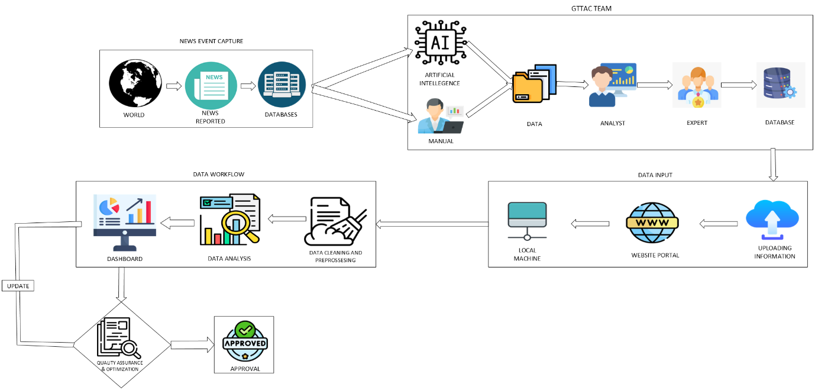
Figure 3: Data Architecture Diagram
The data architecture of the Global Terrorism Trends and Analysis Center (GTTAC) represents a sophisticated system that transforms raw incident reports into actionable intelligence through multiple interconnected stages. At its foundation, the process begins when terrorist incidents occur around the world and are documented by various news outlets and media sources. These initial reports, published in multiple languages across different platforms, form the raw material for GTTAC's comprehensive database. GTTAC employs a hybrid data collection methodology. Their cutting-edge artificial intelligence system handles approximately 60% of the incident capturing process, systematically scanning through reputable news sources worldwide. This AI-driven approach ensures unbiased coverage across different regions and languages. Complementing this automated system, GTTAC's human analysts manually collect the remaining 40% of incidents, particularly focusing on cases that might require nuanced understanding or come from less prominent sources. Their data validation process follows a structured hierarchy designed to maintain the highest standards of accuracy. Each collected incident passes through multiple checkpoints: first through skilled analysts who verify the information's accuracy and relevance, then through subject matter experts who provide additional context and validation. This dual-layer verification system ensures that every incident in their database meets strict quality standards before being permanently recorded. The validated data then enters GTTAC's central database system, marking the transition from raw information to structured data. They've organized this information into three distinct datasets which we're using for our analysis: the primary incident database- containing comprehensive records from 2018 to present, the perpetrator information file and the source documentation These files, accompanied by the detailed metadata codebook form the backbone of our analytical capabilities.
In our analytical workflow, we begin with rigorous data cleaning and preprocessing to ensure consistency and reliability. We then conduct detailed statistical analyses using a combination of powerful tools - Tableau for interactive visualizations, Python for complex data manipulation and statistical analysis, and R for specialized statistical computations. This multi-tool approach allows us to thoroughly address our nine research questions, examining everything from regional incident distributions to complex correlations between perpetrator types and tactics. Our findings are transformed into intuitive visualizations and comprehensive dashboards, making complex patterns and trends accessible to stakeholders. The final stage of our process involves a thorough quality assurance review. We present our analysis for feedback, making necessary iterations based on input received. This iterative approach ensures that our final product not only meets technical standards but also provides practical value for understanding global terrorism trends. Only after receiving final approval do we consider our analysis complete. In summary, the data architecture for the GTTAC project involves a multi-step process that begins with global data collection, passes through rigorous review and validation, and concludes with analysis, visualization, and client feedback. This ensures that the data is both accurate and actionable, providing a comprehensive view of global terrorism trends and insights that are valuable for stakeholders.

Field Descriptions
This research on terrorism utilizes data from the Global Terrorism Trends and Analysis Center (GTTAC) via the Global Record of Incidents Database (GRID), which meticulously records terrorist incidents worldwide. The dataset is organized into three distinct files: GRID_INCIDENTS, GRID_PERPS, and GRID_SOURCE, encompassing a total of 624 columns. Each file captures critical aspects of terrorist events—GRID_INCIDENTS details locations, dates, tactics, and casualties; GRID_PERPS tracks perpetrator affiliations and characteristics; and GRID_SOURCE lists the media outlets used to document and verify each incident. For initial analysis and to address key research questions, 16 specific columns across these datasets are essential. These columns provide comprehensive insights into the perpetrators, tactics, weapons used, victim categories, and the human impact of each event in terms of casualties. The data collection process starts with an AI system that scans millions of news articles annually from over 10 countries and in multiple languages, narrowing down approximately 10,000 articles to 600-1,000 relevant reports. While AI efficiently processes large datasets, human analysts validate and cross-check the information, especially when incidents are reported by multiple sources. Analysts adjust for local media biases, selecting the most reasonable casualty estimates and event descriptions. Each terrorist incident undergoes rigorous review and verification by GTTAC’s senior team, ensuring the GRID database provides accurate, real-time, and transparent insights into global terrorism trends from 2018 to 2023, making it an invaluable resource for counterterrorism research and analysis.
- Incident ID (Type: integer) – Serves as a unique identifier for each incident, ensuring that every event is distinctly tracked and can be linked to various variables such as perpetrators, tactics, and casualties. Each record in the dataset must have a unique Incident ID.
- Incident Date (Type: date) – Represents the date the incident occurred, formatted as YYYY-MM-DD. This field is crucial for time-based analysis, enabling the identification of trends over time, such as the months with the highest casualties from 2018 to 2023.
- Country/Region (Type: string) – Indicates the country or region where the incident took place. This is essential for identifying which countries or regions experienced the highest frequency of terrorist incidents between 2018 and 2023.
- Perpetrator Group Name (Type: string) – The name of the terrorist group responsible for the incident. This field allows for tracking which groups are involved in the highest number of incidents and casualties during the analysis period.
- Tactic Type (Type: string) – Specifies the tactic used during the incident (e.g., suicide attack, kidnapping, assassination). Understanding the tactics used by different groups over time is vital for analyzing shifts in terrorist strategies.
- Weapon Type (Type: string) – Describes the type of weapon used in the incident (e.g., firearms, explosives, incendiary devices). This is crucial for identifying commonly used weapons and associating them with specific groups.
- Num Killed (Type: integer) – The total number of fatalities caused by the incident. This field helps quantify the severity of each attack and determine which months or regions experienced the most fatalities.
- Num Wounded (Type: integer) – The total number of people injured during the incident. Like the number of fatalities, this helps evaluate the impact of the attack on victims.
- Victim Type (Type: string) – Describes the category of victims (e.g., civilians, government officials, military personnel) targeted in the incident. This field helps analyze who is most frequently targeted by specific terrorist groups.
- Perpetrator Type (Type: categorical) – Identifies whether the perpetrator was part of a larger group or acting alone (lone actor). This is essential for determining the differences in tactics and ideologies between organized groups and lone actors.
- Perpetrator Characteristics (Type: string) – Provides detailed information about the perpetrator’s ideology (e.g., jihadist, far-right, Iran-backed). This is particularly useful for comparing different types of terrorist groups.
- Claimed Responsibility (Type: boolean) – Indicates whether the group or individual claimed responsibility for the incident. This field provides insight into how openly groups acknowledge their involvement in attacks.
- Multi-tactic Indicator (Type: boolean) – A flag indicating whether multiple tactics were used in a single incident. This helps in understanding the complexity of specific attacks.
- Casualty Summary (Type: string) – A combined description of the number of people killed and wounded in the incident, useful for quickly comparing the overall impact of various incidents.
- Target Facility Type (Type: string) – Describes the type of facility or location targeted during the incident (e.g., schools, government buildings, public spaces). This helps determine the types of infrastructure most frequently attacked by terrorist groups.

Data Context
The Global Terrorism Trends and Analysis Center (GTTAC) operates as a hub for collecting, filtering, and categorizing terrorism-related data, aiming to track and analyze global terrorism trends. GTTAC’s data collection process is a hybrid system that combines the efficiency of artificial intelligence (AI) with the judgment of human verification. The AI system plays a significant role, sourcing approximately 60% of the data by scanning vast quantities of media reports, articles, and online sources for content potentially related to terrorism. This system relies on a set of predefined keywords, semantic analysis, and contextual clues to flag information that may involve terrorist activities. By using machine learning algorithms, GTTAC can quickly sift through massive volumes of data and identify relevant content, this would be nearly impossible to achieve manually on a global scale. The remaining 40% of data comes from direct human searches, an essential part of the process, especially for incidents in regions where media coverage may be sparse or challenging to analyze with AI alone. After the AI system identifies potential data points, the flagged content moves into a human verification stage, where each flagged report is reviewed to ensure its accuracy and relevance. Human reviewers at GTTAC play a crucial role in this stage by validating the information and confirming that the reports accurately represent real-world events tied to terrorism. The hybrid approach of combining AI filtering with human validation helps to reduce errors like false positives, where irrelevant information may be incorrectly flagged, or false negatives, where important data might be overlooked. The human verification phase is essential, as machine learning models may still misinterpret nuanced language, or the political implications embedded within certain reports. For example, AI might struggle with subtle distinctions in the way different sources report incidents, especially when the narrative around an event could be politically charged or culturally specific. Human analysts provide the contextual understanding necessary to accurately assess these details, ensuring that only valid and verified information is included in the dataset.
Training new analysts for this role is taken very seriously at GTTAC, reflecting the organization’s commitment to both accuracy and accountability. New analysts begin with a rigorous 10-day training program focused on understanding the definitions and field descriptions used within the GTTAC system. This includes learning about key terminology related to terrorism, specific categorizations for various types of incidents, and the nuanced ways that data should be interpreted. After the initial training, analysts go through an additional three to four months of shadowing a more senior team member, where they receive direct mentorship and practical experience in data review and verification. GTTAC also places a strong emphasis on hiring analysts from diverse regions worldwide, particularly those fluent in the local languages where they source data. This linguistic and cultural expertise is invaluable, as it allows analysts to better interpret information from regional sources and provide accurate translations, which is critical for incidents reported in areas where English media coverage may be limited or unavailable.
Despite the precautions and training, data bias remains an inevitable challenge in GTTAC’s collection and verification process. Bias can emerge at various points, from the AI’s initial data flagging to the human verification stage, influenced by the limitations of both technology and human judgment. AI models are trained on historical data, and as a result, they are influenced by the biases embedded in those original sources. For example, if certain media outlets have historically under-reported or over-reported terrorism incidents in specific regions or by certain groups, the AI might disproportionately flag content from those sources. Similarly, human reviewers may unconsciously carry their own biases, particularly if they are more familiar with one region or perspective over another. To mitigate these biases, GTTAC has implemented a policy that requires each reported incident to have at least two sources. This helps ensure that the information is corroborated and reduces the likelihood of relying too heavily on potentially biased accounts. Additionally, GTTAC tries to avoid state-sponsored media sources, though in certain regions, such sources may be unavoidable. When using state-sponsored media, human reviewers apply a higher degree of scrutiny and contextual knowledge to assess the reliability of the information. Adding to the complexity of GTTAC’s process is the fact that bias can also stem from the nature of the media sources themselves. Different outlets may have ideological or political leanings that shape the way incidents are reported. For instance, the Ad Fontes Media Chart highlights the range of political biases among news outlets, from left-leaning to right-leaning, which can influence not only the frequency of terrorism coverage but also the way incidents are described. Outlets with strong political or ideological biases may emphasize certain types of terrorism over others, or frame incidents in ways that align with their audience’s viewpoints. To account for this variability, analysts are trained to cross-reference data from different sources, analysts can apply methodologies to normalize or balance biases, helping to provide a more accurate and well-rounded representation of terrorism trends. An important aspect of GTTAC’s verification process is the way it handles political classifications and definitions related to terrorism. For example, the U.S. State Department determines which groups are classified as foreign terrorist organizations, a designation that can shift with each administration. This variability can impact how incidents are categorized within the dataset, as groups that are recognized as terrorist organizations under one administration may be treated differently under another. GTTAC’s policy, however, is to adhere to the definitions in place at the time of each report to ensure consistency in classification. Furthermore, GTTAC’s criteria explicitly exclude certain acts, such as coups d’état carried out by individuals already in government, as these events do not meet the organization’s criteria for terrorism. This distinction is important, as it prevents the data from being conflated with incidents of political instability or regime change, ensuring that the focus remains strictly on terrorism-related events.
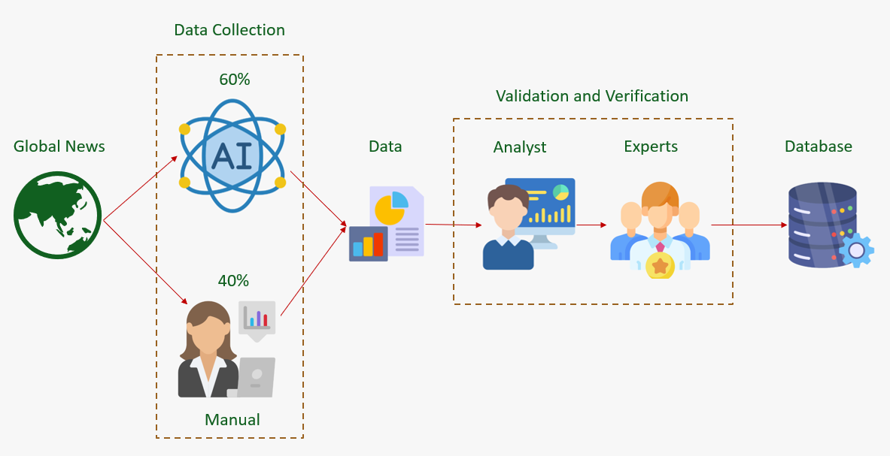
Figure 4: Workflow for Data Capture and Integration into the Database
In reporting fatalities and casualties, GTTAC follows a conservative approach by recording the lowest credible figures from reliable sources. This policy minimizes the risk of inflating numbers or sensationalizing incidents, which can lead to misinterpretation and potentially skewed data analysis. In cases where a new group is suspected of engaging in terrorism, GTTAC applies extra caution before labeling them as a terrorist organization. This step is especially critical, as such classifications carry significant weight and can have real-world implications. GTTAC’s protocol requires thorough verification and validation to ensure that the evidence meets the standards for inclusion, with each case carefully reviewed by senior analysts. The data collection process at GTTAC ultimately culminates in a layered verification approach. Once an article is flagged by the AI, it is passed to a human reviewer who completes additional research and verifies information against other news sources. This information is then reviewed by a senior faculty member who ensures that junior analysts have not introduced unintended bias. This final stage of senior verification serves as a safeguard, allowing for a comprehensive review that incorporates both initial AI screening and human analysis. Through this combination of technology and expert human judgment, GTTAC aims to build a reliable, balanced dataset that serves as a valuable resource for understanding global terrorism trends. While no data collection process can eliminate bias entirely, GTTAC’s structured approach helps to mitigate these influences as much as possible, providing a foundation for accurate, data-driven insights into the complex landscape of global terrorism.
This rigorous methodology reflects the center’s commitment to accuracy and fairness, with each stage of the process carefully designed to ensure that data is both reliable and relevant. By acknowledging and addressing the challenges inherent in data collection, GTTAC sets a standard for transparency and accountability, serving as a model for other organizations involved in complex data analysis. The insights gained from GTTAC’s process highlight the importance of context, verification, and thoughtful analysis in creating a dataset that accurately represents the realities of global terrorism, a goal that is essential not only for researchers and policymakers but for the broader understanding of terrorism’s impact on global security. A meticulous approach to data collection when the information is open source must include strategies for addressing two major challenges. First, not all media outlets have the same reporting standards. GTTAC strives to keep the data collection process from being biased by unreliable media coverage, especially in conflict zones. To this end, GRID includes only terrorist incidents that are reported by independent and reliable sources. GRID does not use any reports from terrorist media sources, and it excludes any incidents about which there is considerable uncertainty or conflicting reporting. Second, quantifying harm to victims and identifying the perpetrators of terrorist incidents are challenging when the open-source information (particularly about the number of persons killed or wounded) is imprecise. We address this issue in several ways:
- GTTAC employs a well-trained, multilingual, and multicultural team of subject-matter experts, technologists, and researchers who continually monitor and enhance the methodology and thereby maintain a comprehensive, accurate, and systematic process for collecting data in more than 90 languages.
- GTTAC has established an international advisory board, the Global Terrorism Experts Group, which reviews content and ensures objectivity by capturing local contexts and nuances.
- To strengthen data accuracy and completeness while maintaining consistency, GTTAC created a scale (Table M.1) that uses the principle of the lowest reasonable estimate for quantifying imprecise amounts reported in the media
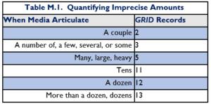
Table 1:Quantifying Imprecise Amounts Based on Media Descriptions
Before 2018, data on persons killed and wounded were omitted when open-source information did not cite specific numbers; casualties described in terms such as “a few,” “many,” or “dozens” were classified as “missing data” and were not counted. Because GRID counts these casualties in accordance with the scale in Table M.1, its numbers tend to be higher than those reported by START (2012-2017) and the Worldwide Incidents Tracking System (2004-2011).

Data Conditioning
Data conditioning is required for three existing datasets—GRID_INCIDENTS, GRID_PERPS, and GRID_SOURCE—to ensure they are accurate, consistent, and ready for analysis. All datasets require cleaning to address missing values, standardize formats, establish reliable connections between related data points, and maintain consistency. In the GRID_INCIDENTS dataset, key fields such as Incident Date, Country/Region, Num Killed, and Num Wounded will be cleaned by either imputing missing values or removing incomplete records. The Incident Date will be standardized to the (YYYY-MM-DD) format, and fields like Tactic Type and Country Code will be normalized to eliminate inconsistencies. Duplicate entries based on Incident ID will be removed, and any outliers in casualty data will be adjusted to maintain trend accuracy. In the GRID_PERPS dataset, which is related to perpetrators involved in incidents, the relationship between Perp Incident ID and Incident ID will be verified to ensure correct linkages. Categorical fields, such as Perpetrator Group Name, will be cleaned, and missing values in fields like Perpetrator Characteristics will be addressed. Lastly, for GRID_SOURCE, Source URLs will be validated to ensure they are functional, and Publication Dates will be standardized. Duplicate records will be removed to ensure each source is linked to a unique incident.

Data Quality Assessment
The GTTAC dataset consists of three primary files: “GRID_INCIDENTS.csv”, “GRID_PERPS.csv”, and “GRID_SOURCE.csv.” Each file captures specific aspects of global terrorism incidents from 2018 to the present, including incident records, perpetrator involvement, and data source details. This section assesses the data quality for each dataset across several dimensions, including completeness, uniqueness, accuracy, atomicity, conformity, and overall quality.

GRID_INCIDENTS
The GRID_INCIDENTS dataset is comprehensive, containing detailed records for each terrorist incident, including Incident ID, dates, locations, and casualties. However, casualty data, such as the number of wounded, may sometimes be missing or rely on estimates due to limitations in media reporting. To address this, GTTAC employs a methodology that provides reasonable estimates. Each incident is uniquely identified by a unique ID, and multi-incident events are further distinguished by sequence numbers, ensuring no duplication. The dataset also tracks related incidents through a multi-incident event ID (incident_id) and sequence number (incident_seq), enhancing its uniqueness. The accuracy of the data is ensured through GTTAC's rigorous process of cross-referencing media reports, and incidents corroborated by multiple sources are flagged (is_multi_source_corr). However, accuracy can vary due to inconsistent reporting, especially in conflict zones, but GTTAC’s use of reasonable estimates and corroboration flags helps improve reliability. The dataset is highly atomic, with individual fields representing distinct data points such as year, month, day, and binary variables like suicide attacks or IED use. It also adheres to standardized formats, using consistent country codes and date formats to allow for easy analysis and comparison. Despite some missing data, the overall quality of the dataset is high, making it well-structured and reliable for analyzing terrorism trends.

GRID_PERPS
This dataset captures detailed perpetrator information for each incident, including fields like perp_incident_id, perp_name, and ICat (perpetrator characteristics). While some data may be incomplete, especially in cases where perpetrator identities are unknown or unverified, default values like 0 (unknown) are used to maintain data consistency. Each record is uniquely identified by a perp_incident_id, ensuring no duplication, and multiple perpetrators involved in a single incident are tracked independently using unique perpetrator IDs, preserving the dataset’s uniqueness. Perpetrator data accuracy depends on the availability of open-source reports, with some variability in conflict zones where media coverage can be inconsistent. GTTAC flags incidents where perpetrator claims have been corroborated (claimed) and uses default classifications (ICat_Unknown) for unverified characteristics. The dataset is atomic, with each field representing a distinct perpetrator attribute, such as ICat_Jihadist or ICat_Right, stored as binary variables for easy interpretation. It adheres to standard formats, with consistent coding (1 for "Yes," 0 for "No") across fields such as claimed, ICat_Ethn, and ICat_Rjih, ensuring uniform standards for analysis.

GRID_SOURCE
The GRID_SOURCE dataset provides comprehensive details about the media sources used to document each incident, including fields like source_id, publication_date, and media_outlet. In cases where only one source is available for an incident, completeness may be impacted, but GTTAC mitigates this by flagging incidents with multiple sources using the is_multi_source_corr variable. Each media source is linked to a unique source_id and unique_incident_id, ensuring that multiple sources for a single incident are tracked without duplication. The dataset allows for multiple media outlets to be recorded for each incident, ensuring distinct identification of each source. Source accuracy is maintained by only including reliable, independent media outlets and excluding terrorist-affiliated reports. However, discrepancies may arise due to variations in media reports, especially in conflict zones. GTTAC flags sources that have been corroborated (is_multi_source_corr) to highlight those validated by multiple outlets. The dataset maintains atomicity, with fields like publication_date, source_id, and media_outlet representing single, clear data points for easy analysis. It conforms to standard formats, with consistent coding for binary variables (e.g., is_multi_source_corr) and dates formatted as "dd/mm/yyyy," ensuring easy cross-referencing with other datasets. GTTAC datasets demonstrate strong data quality, with well-maintained uniqueness, atomicity, and conformity. While some limitations in accuracy and completeness exist due to open-source reporting, GTTAC’s rigorous methodology ensures consistent handling of missing or uncertain data. Overall, the datasets are reliable and well-suited for analyzing global terrorism trends and addressing the project’s research questions.

Other Data Sources
For this report, we elected to utilize the data curated from the Global Terrorism Trends and Analysis Center (GTTAC), excluding supplementary data from other sources. This approach aligns with the specific needs of our audience, which comprise stakeholders who rely exclusively on the carefully collected and verified data curated by GTTAC. By limiting our analysis to this dataset, we maintain the integrity of the source and offer users insights based solely on GTTAC’s expert-reviewed information. This choice allows for a more accurate representation of terrorism trends as captured and assessed by GTTAC, without the risk of conflicting or unverified data influencing outcomes.
Furthermore, using only the GTTAC dataset ensures that our insights, metrics, and visualizations directly align with the organization's data collection and validation protocols. This focused approach enables us to create a tool that is both user-friendly and wholly representative of GTTAC's mission, leveraging the center's dedicated resources for data accuracy. By refraining from integrating external datasets, we can tailor our product exclusively for those who trust GTTAC’s data standards, ensuring that end users can make informed decisions rooted in a single, reliable source.

Storage Medium
In this project, the dataset will be stored on the individual machines of each group member. Since this dataset is publicly available and of relatively small size, this should provide sufficient storage without any need for cloud-based solutions. Local data storage will enable group members to work offline and without dependence on the rest of the team; this will be very convenient without relying on internet connectivity. This approach also enhances data security by restricting access to the member's devices. Moreover, it reduces risks of unauthorized access or third-party involvement. Meanwhile, it reduces challenges related to data management because no complex cloud security measure is involved. The integrity of the data will be assured using the version control system GitHub, which avoids a loss of data and allows for recovery methods in the event of hardware failure. This solution provides for local storage in alignment with the scope of the project that requires such efficiency in the access to the dataset in view of analysis.

Storage Security
For this project, ensuring secure storage of the dataset on individual devices is crucial. Each group member’s
device is protected with strong passwords and up-to-date antivirus software. To avoid data loss, regular backups are maintained through GitHub, ensuring the most recent version of the dataset is always recoverable in case of device failure or accidental deletion. Additionally, access to the GitHub repository is restricted to authorized group members only, protecting the dataset from unauthorized modifications. Due to these security measures, the project’s data will remain protected and accessible only to relevant contributors, ensuring data integrity throughout the project’s lifecycle.

Storage Costs
Since the project’s data is stored locally on each team member’s device, there is no direct cost related to cloud services or external data hosting. Each team member's device is adequately endowed with sufficient storage capacity to handle this publicly available dataset that is not too large. This eliminates any need for paid-for cloud storage solutions like AWS, Google Cloud, or Azure, thereby making the minimal cost feasible. Other indirect costs may arise in the use of GitHub for version control, its free tier has been good enough for this project; therefore, current prospects of going overboard in costs remain slim. Because the storage is localized and free version control services like GitHub are utilized, the overall cost related to the storage of data for this project is nil.

Analytical Approach
The research component of this project involves addressing nine primary questions, each designed to uncover critical insights into global terrorism trends from 2018 to 2023. These questions are broken down into subparts where necessary, with each subpart focusing on specific dimensions of the inquiry. For each question and subpart, the methodology, variables used, and analytical approach are explained in detail to provide a comprehensive understanding of the process.
Research Question 1:
Which regions or countries recorded the most terrorist incidents from 2018 to 2023? Which months saw the highest number of people killed and wounded during the same period?
To answer this multi-faceted question, the inquiry is divided into three subparts, each focusing on a distinct aspect of the data.
A. Which countries recorded the most terrorist incidents from 2018 to 2023?
The Country attribute of the GTTAC database was used to group and count the number of terrorist incidents recorded in each country. To ensure accuracy, data entries were filtered to include only incidents occurring between January 1, 2018, and December 31, 2023. Incidents with missing or ambiguous country names were excluded. After grouping, the total number of incidents for each country was calculated, and the results were ranked to identify the most affected nations. Visualization tools such as bar charts and choropleth map were employed to provide a comparative overview of the countries with the highest number of terrorist incidents.
B. Which regions recorded the most terrorist incidents from 2018 to 2023?
For this subpart, the data was further grouped by regions instead of individual countries. Regional classifications were derived from the Country/Region attribute, ensuring that each country was accurately assigned to its corresponding region (e.g., Western Asia, Sub-Saharan Africa). The incidents were then aggregated for each region, revealing the areas most affected by terrorism over the five-year period. Choropleth map was utilized to visually represent regions, offering a spatial perspective on terrorism trends accompanied by a bar plot that aggregates the total number of incidents in each region.

C. Which months saw the highest number of people killed and wounded during the same period?
The Incident Date, Casualties (Num Killed, Num Wounded) attributes were used to analyze monthly casualty trends. Data entries were grouped by month and year, and the total numbers of fatalities and injuries were computed for each month. This process required cleaning the dataset to handle missing or inconsistent date entries. Stacked bar charts were generated to illustrate the months with the highest combined casualties, highlighting periods of intensified violence.
Research Question 2:
Which ten groups had the highest number of casualties (killed and wounded) from 2018 to 2023?
This question required identifying the top 10 terrorist groups based on the combined number of fatalities and injuries they caused. The analysis focused on the Perpetrator Group Name, Num Killed, and Num Wounded attributes. Incidents with missing or "Unknown" perpetrator group names are included under the "Unknown" category as defined by GTTAC. Casualty figures for each group were summed, and the results were ranked to determine the top contributors to global terrorism-related casualties. A bar chart was used to visually compare the impact of these groups, emphasizing their lethality and geographic spread. A choropleth map was utilized to show the countries where each of these top 10 groups were active in between year 2018 to 2023.
Research Question 3:
What types of tactics were used from 2018 to 2023, and how has their usage changed over time?
This question explores the diversity of tactics employed by terrorist groups and investigates how their usage patterns evolved between 2018 and 2023. The analysis is conducted in three parts: the identification of the most frequently used tactics, an examination of the top ten groups employing these tactics, and a temporal analysis of how the tactics changed over time for key groups. By leveraging the Tactic Type attribute and grouping data across years and groups, a comprehensive understanding of tactical strategies was developed.
A. What types of tactics were used from 2018 to 2023?
The first step in addressing this question involves categorizing incidents by the types of tactics employed. The Tactic Type attribute provided detailed classifications, such as suicide attacks, kidnappings, car ramming’s, assassinations, stabbings, shootings, bombings, ambushes, and planting mines or IEDs. To ensure consistency, the data was standardized by unifying naming conventions and addressing ambiguous entries. This meticulous process ensured that each incident was accurately classified.
The frequency of each tactic was then calculated, revealing the prominence of certain methods. A bar plot was generated to visualize these findings, with tactics displayed on the x-axis and the number of incidents on the y-axis. The analysis showed that bombings, shootings, and ambushes were the most employed tactics. Bombings exhibited consistent usage across various groups, reflecting their effectiveness in causing widespread damage and fear.
B. Which ten groups employed these tactics the most?
To identify the groups that most frequently used these tactics, the incidents were aggregated by Perpetrator Group Name and Tactic Type. The total count of tactics employed by each group was calculated, focusing on the ten most active groups.
The results were visualized using a bubble plot, where each bubble represented a terrorist group. The size of the bubble corresponded to the total number of incidents involving the group, and the color differentiated between the groups. This visualization revealed that ISIS, the Taliban, and al-Shabaab were the dominant users of tactics such as bombings and ambushes. Groups like Boko Haram and the Houthi rebels demonstrated unique operational preferences, with Boko Haram relying heavily on kidnappings and bombings, while the Houthi rebels showed increased use of UAVs in targeted operations.
C. How has the use of these tactics changed from 2018 to 2023?
The temporal analysis focused on understanding how the use of tactics evolved over the study period. Incidents were grouped by year and Tactic Type, with a particular emphasis on the top ten groups identified in the previous step. This analysis also accounted for key changes in data classification, such as the bifurcation of bombings into "bombings" and "IED/planting mines" categories starting in 2020.
To present these findings, stacked bar charts were generated for each group, showing the percentage of incidents involving specific tactics each year. The x-axis represented the years from 2018 to 2023, while the y-axis displayed the percentage distribution of tactics. Each tactic was represented by a distinct color, providing a clear view of the evolution of tactical strategies.
For example, the analysis of the Taliban revealed that bombings and ambushes dominated their operations from 2018 to 2021. However, following the group's recognition as a state government in 2022, their activities were no longer recorded by GTTAC. Similarly, ISIS demonstrated a consistent reliance on bombings and shootings, with an increasing use of IEDs after the reclassification in 2020. Al-Shabaab maintained steady use of shootings and ambushes, while Boko Haram showed occasional spikes in kidnappings alongside their consistent use of bombings.
Other groups exhibited unique patterns as well. The Houthi rebels increasingly utilized UAVs alongside traditional tactics like ambushes and bombings. The Communist Party of India demonstrated a focus on ambushes and IEDs, while ISIS DRC and the Communist Party of the Philippines showed varying reliance on shootings and ambushes. Fulani militants predominantly employed shootings, targeting specific communities, and Hezbollah utilized advanced tactics, including UAVs, in addition to ambushes and shootings.
The analysis of tactics used by terrorist groups from 2018 to 2023 provides valuable insights into their operational strategies. Bombings and shootings emerged as the most frequently used tactics, reflecting their effectiveness in causing mass casualties and disruption. Certain groups demonstrated clear preferences for specific tactics, such as the Houthi rebels' use of UAVs and Boko Haram's reliance on kidnappings and bombings. The evolution of tactics over time highlights how groups adapt their strategies in response to changing political and operational contexts. The reclassification of bombings into distinct categories provided more granularity, helping to understand the specific methods employed by groups. These findings enhance the understanding of terrorist tactics and their evolution, offering critical insights for counterterrorism strategies and academic research on global terrorism trends.
Research Question 4:
What are the most used weapon types, and which groups used specific weapons the most?
This question explores the weapon types used by terrorist groups and identifies the groups that most frequently employ specific weapons. By analyzing the Weapon Type attribute from the GTTAC database, the study provides insights into the operational preferences of terrorist organizations and their access to weaponry. The analysis is divided into two parts: identifying the most used weapon types and determining the groups that use specific weapons the most.
A. What are the most used weapon types?
To identify the most frequently used weapon types, incidents were grouped by the Weapon Type attribute. This attribute categorizes weapons into firearms, explosives, IEDs, UAVs, incendiary devices, melee weapons, and others. Each category’s usage frequency was calculated, highlighting the operational preferences of terrorist groups.
The findings were visualized using a bubble plot. Each bubble represents a weapon type, with the size of the bubble corresponding to the number of incidents in which that weapon was used and the color distinguishing between weapon categories. This visualization provides a comparative overview of the prominence of different weapon types.
The analysis revealed that firearms and explosives are the most used weapon types, reflecting their widespread availability and effectiveness in creating mass casualties. UAVs, while less common, show significant usage in high-profile operations, particularly by technologically advanced groups. Melee weapons and incendiary devices are less frequently used but remain relevant in specific contexts.
B. Which five groups use firearms, IEDs, rockets, mortars, grenades, missiles, and UAVs the most?
To understand which groups predominantly use specific weapons, the data was further categorized by both Weapon Type and Perpetrator Group Name. The top five groups using each weapon type were identified by calculating the frequency of incidents involving that weapon. The results are visualized through bar plots for each weapon type - Explosives, including bombs and grenades, are widely used by groups such as ISIS, Boko Haram, and the Taliban. The x-axis represents the top five groups, while the y-axis shows the count of incidents involving explosives. Each bar is color-coded to differentiate between groups. Firearms are the most frequently used weapon type, with groups like al-Shabaab and Boko Haram relying heavily on them. The plot shows the count of incidents involving firearms for each group, highlighting their operational preferences. Improvised Explosive Devices (IEDs) are a signature weapon for groups like ISIS, often used in asymmetric warfare. This plot illustrates the count of IED-related incidents for the top five groups. Incendiary devices, such as Molotov cocktails, are less common but are used strategically by certain groups. This plot identifies the groups most frequently using such devices. Melee weapons, though less prevalent, are employed in targeted attacks or ambushes. The plot highlights the top five groups that use these weapons. This category includes weapons not specifically classified in the GTTAC database. The analysis revealed patterns in the use of unconventional weapons, with certain groups specializing in their deployment. Unmanned Aerial Vehicles (UAVs) represent a technological advancement in terrorism. Groups like Hezbollah and ISIS have been identified as frequent users, employing UAVs for surveillance, delivery of explosives, and propaganda. This plot visualizes the frequency of UAV usage by the top five groups. Plots 1 to 4 are arranged in a 4x4 grid to provide a compact overview of the most common weapon types. Plots 5 to 7 are displayed in a separate grid to emphasize the unique nature of these weapon types and their strategic importance.
The analysis offers several key insights into the weapon preferences of terrorist groups. Firearms and explosives are the most used weapons, reflecting their accessibility and versatility in various attack scenarios. Groups like ISIS and the Taliban exhibit a preference for IEDs, leveraging them for both tactical and strategic purposes. UAVs, though less commonly used, signify a shift toward more technologically advanced warfare, with groups like Hezbollah leading in their deployment. Certain groups rely on unconventional or improvised weapons, showcasing their adaptability and resourcefulness. This comprehensive analysis highlights the operational capabilities of terrorist groups, providing valuable insights for security and counterterrorism efforts.
Research Question 5:
Which victim categories are most frequently targeted, and which groups target these categories the most?
The goal of this analysis is to identify the most frequently targeted victim categories and determine which terrorist groups are responsible for targeting these categories. This inquiry sheds light on the operational strategies of terrorist groups and provides insights into their specific focus areas. To achieve this, the analysis is divided into two parts, examining the frequency of targeted victim categories and identifying the groups responsible for targeting each category.
A. Which victim categories are most frequently targeted?
The analysis began by examining the Victim Type attribute from the GTTAC database, which categorizes victims into groups such as civilians, government officials, professionals, political figures, and others. Each recorded incident was categorized based on this attribute, and the frequency of incidents targeting each category was calculated. A bubble plot was created to visualize the relationship between victim categories and the groups responsible for these incidents. Each bubble represents a distinct terrorist group, with its size indicating the number of incidents linked to that group and its color distinguishing between different groups. This visualization highlights the groups that are most active in targeting specific victim categories, offering a comparative overview of their impact.
The results show that civilians are overwhelmingly the most frequently targeted category, reflecting the strategic use of terrorism to instill fear among the general population. Groups such as ISIS, Boko Haram, and al-Shabaab were identified as major perpetrators in this category, emphasizing their focus on widespread societal disruption. Government officials emerged as the second-most targeted category, with groups like the Taliban and Iran-backed militias being prominent actors. This reflects a strategic objective to destabilize governance structures and political stability.
B. Which five groups primarily target civilians, military personnel, politicians, government officials, and professionals?
To gain deeper insights into the targeting strategies of terrorist groups, the analysis identified the top five groups responsible for incidents within each victim category. The incidents were grouped by both Victim Type and Perpetrator Group Name, and the percentage of incidents attributed to each group was calculated. This approach provided a standardized view of the groups’ targeting patterns, making it possible to rank them within each category.
The results are presented through six bar plots, each focusing on a specific victim category - The analysis revealed that groups like ISIS, Boko Haram, and al-Shabaab are the primary perpetrators targeting civilians. These groups rely on tactics designed to maximize civilian casualties, aiming to create fear and destabilize societies. Groups such as the Taliban and Iran-backed militias were identified as the leading perpetrators targeting government officials. Their focus on this category aligns with their political and military objectives to weaken state governance and influence regional power dynamics. Certain groups aim to create widespread disruption without specifically targeting individuals. This category includes incidents where no direct casualties are reported, reflecting a focus on generating chaos or sending symbolic messages. Groups in this category often target undefined or broad victim categories, using tactics that aim to instill general fear without a precise focus. This approach is common in situations where the primary goal is societal destabilization rather than targeted attacks. Political figures are a key focus for groups such as Iran-backed militias, which use targeted attacks to further their political agendas and disrupt governance structures. Professionals, including journalists, aid workers, and educators, are targeted by groups aiming to undermine societal infrastructure. Groups like Boko Haram and al-Shabaab are notable for their focus on this category.
The visualization of these results allows for a nuanced understanding of the strategies employed by different groups. Bar plots for the first four victim categories are arranged in a 4x4 grid, providing a compact comparison of the top perpetrators in each. The bar plots for political figures and professionals are displayed separately in a 2x1 grid, emphasizing the strategic significance of these categories. The analysis reveals distinct patterns in the targeting strategies of terrorist groups Civilians are the most frequently targeted category, highlighting the use of terrorism as a tool for instilling fear and destabilizing societies. Government officials and professionals are targeted by groups with more specific strategic objectives, such as destabilizing governance or undermining critical societal functions. Certain groups prioritize creating general chaos or making symbolic statements rather than focusing on specific victim categories.
Research Question 6:
What are the similarities and differences between Iran-backed and jihadist terrorist groups?
This question examines the operational, geographical, and strategic distinctions between Iran-backed and jihadist terrorist groups, including individuals influenced by jihadist ideologies. To address these complexities, the analysis explores multiple dimensions, including geographic distribution, temporal patterns, tactics, target types, and weapon preferences. These analyses leverage attributes from the GTTAC database and employ various visualization techniques to uncover nuanced insights.
The first step in addressing this question involved filtering and categorizing the data into two groups: incidents linked to Iran-backed groups and those associated with jihadist groups or individuals influenced by jihadist ideologies. These categorizations were based on the Perpetrator Group Name and additional metadata related to group ideology.
To understand the geographical spread of incidents, a choropleth map was generated to visualize the countries with the most incidents caused by Iran-backed groups and jihadist groups. The data was aggregated by country using the Country attribute. Each country was assigned a distinct intensity value based on the number of incidents for each group. The resulting map revealed stark contrasts: Iran-backed groups were concentrated in the Middle East, with hotspots in countries like Iraq and Syria, whereas jihadist groups exhibited a broader global reach, with significant activity in regions like Sub-Saharan Africa and South Asia. Additionally, a stacked bar plot was developed to compare the number of incidents by country. Countries were plotted on the x-axis, with the y-axis representing the incident count. Incidents were grouped into the two categories, Iran-backed and jihadist, with colors distinguishing the two groups. This visualization highlighted how the operational focus of Iran-backed groups is limited to a few countries, while jihadist groups operate across a wider range of nations. At the regional level, a second stacked bar plot was created, grouping incidents by region rather than country. The Region attribute was mapped to larger geopolitical regions such as the Middle East, Sub-Saharan Africa, and South Asia. This plot provided a broader view, showing that Iran-backed activities are primarily confined to the Middle East, while jihadist incidents span multiple regions. To analyze trends over time, the incidents were grouped by year using the Incident Date attribute. The annual counts for each group were calculated and visualized in a line plot. The x-axis represented the years from 2018 to 2023, while the y-axis displayed the number of incidents, with separate lines for Iran-backed and jihadist groups.
The plot revealed that jihadist groups exhibited a steady or increasing trend in activity over the years, reflecting their ongoing global influence. In contrast, Iran-backed groups showed fluctuating patterns, with peaks corresponding to specific geopolitical events, such as regional conflicts or escalations involving proxy wars. The tactical preferences of the two groups were analyzed using the Tactic Type attribute, categorized at Level 2 for greater granularity. A heatmap was constructed to compare the frequency of each tactic type employed by Iran-backed and jihadist groups. The y-axis of the heatmap represented different tactic types (e.g., bombings, ambushes, kidnappings), while the x-axis compared the two group categories. The heatmap revealed notable differences: jihadist groups heavily relied on bombings and ambushes, emphasizing high-impact, large-scale operations. Iran-backed groups, on the other hand, showed a preference for tactics targeting political or military figures, such as assassinations and armed confrontations, reflecting their strategic focus on influencing regional power dynamics. The next analysis explored the victim types targeted by the two groups. Using the Victim Type attribute, incidents were grouped by the type of victim (e.g., civilians, government officials, military personnel). A heatmap was created with victim types on the y-axis and the group categories on the x-axis. The results showed that jihadist groups predominantly targeted civilians, aiming to instill fear and destabilize societies. In contrast, Iran-backed groups were more likely to target government officials and infrastructure, aligning with their political and military objectives. Finally, the analysis examined the weapon types used by the two groups. The Weapon Type attribute was categorized, and a heatmap was generated to visualize the relationship between weapon types and group categories. The y-axis represented weapon types (e.g., firearms, IEDs, UAVs), while the x-axis compared the two groups. Jihadist groups were found to favor explosives, firearms, and IEDs, leveraging readily available and cost-effective weapons for their operations. Iran-backed groups demonstrated a broader range of weapon usage, including advanced systems like UAVs, reflecting their access to state-sponsored resources.
This analysis highlights both the operational and strategic differences between Iran-backed and jihadist groups. Geographically, Iran-backed groups are regionally focused, while jihadist groups operate on a global scale. Temporally, jihadist activities show consistent growth, whereas Iran-backed incidents align with specific political or regional events. Strategically, the two groups differ significantly in their choice of tactics, targets, and weapons, reflecting their distinct ideologies and objectives. These insights provide valuable perspectives for policymakers and security analysts working to counter terrorism at both regional and global levels. The Country/Region and Tactic Type attributes were cross-referenced to determine regional patterns in tactic usage. Incidents were grouped by region and tactic, and heatmaps were generated to illustrate the concentration of specific tactics in different areas. This analysis highlighted regional preferences for tactics, such as bombings in conflict zones and kidnappings in politically unstable regions.
Research Question 7:
What tactics have lone actors used from 2018 to 2023? Which ideologies (jihadist, far right, or nationalist) most influence lone actors?
This research question is broken into two subparts to examine the tactics employed by lone actors and the ideological motivations driving their actions.
- What tactics have lone actors used from 2018 to 2023?
To analyze the tactics used by lone actors, the Tactic Type and Perpetrator Type attributes were utilized. Lone actors were identified based on the classification in the Perpetrator Type attribute. The incidents were grouped by year and Tactic Type, and the percentage distribution of tactics was calculated for each year. A stacked bar plot was generated, with years on the x-axis and the percentage of incidents on the y-axis, grouped by tactics. This visualization highlights shifts in tactics preferences among lone actors over the specified timeframe, enabling insights into their operational trends.

- Which ideologies (jihadist, far right, or nationalist) most influence lone actors?
The Perpetrator Characteristics attribute was used to classify lone actors by their ideological affiliations: jihadist, far right, or nationalist. The number and percentage of incidents attributed to each ideology were calculated. A bubble plot was created, where the size of each bubble represents the number of incidents, and the color indicates the ideology. This plot effectively visualizes the prominence of various ideologies influencing lone actors during the study period.
Research Question 8:
Is there a positive correlation between the types of terrorist perpetrators and the types of tactics used?
To understand the relationship between perpetrator types and tactics, a correlation analysis was conducted. The Perpetrator Type and Tactic Type attributes were analyzed to identify patterns and associations. Two separate correlation plots were developed:
Correlation Between Perpetrator Type and Tactics:
This plot identifies how specific perpetrator types (e.g., lone actors, organized groups) correlate with certain tactics. Each cell in the matrix represents the strength of the correlation, with darker shades indicating stronger positive relationships.
Correlation Between Perpetrator Groups and Tactics:
This plot focuses on specific groups (e.g., ISIS, Taliban) and their preferred tactics, providing insights into strategic behaviors across different organizations.
These correlation plots offer a nuanced understanding of how perpetrator attributes influence tactical decisions, contributing to strategic counterterrorism planning.
Research Question 9:
How do specific groups target different victim categories? Do weapon types influence the tactics used by terrorist organizations? Do target types influence the tactics used by terrorist organizations?
This question is divided into two subparts to explore the relationships between weapon types, target categories, and the tactics employed by terrorist organizations.
- Do weapon types influence the tactics used by terrorist organizations?
The Weapon Type and Tactic Type attributes were analyzed to determine how specific weapons align with tactics. Cross-tabulations were performed to identify the associations between weapon types and tactics. A Sankey plot was generated to visualize these relationships, highlighting the pathways between weapon types and the tactics they enable. For instance, the plot may show how firearms are predominantly used for ambushes, while explosives are more common in bombings.

- Do target types influence the tactics used by terrorist organizations?
The Victim Type and Tactic Type attributes were analyzed similarly to understand how target categories influence tactical choices. For example, certain tactics may be more frequently used against civilians, while others are directed toward government officials. Another Sankey plot was generated to illustrate these relationships, showing the connections between target types and corresponding tactics. This dual analysis provides valuable insights into the operational strategies of terrorist organizations, emphasizing the interdependence between weapon choice, victim categories, and tactical decisions.

Visualizations
In this section of the report, we delve into the findings of our data analysis project conducted for the Global Terrorism Trends and Analysis Center (GTTAC). This project focuses on exploring and interpreting terrorism-related data from 2018 to 2023 to answer nine pivotal research questions. These questions aim to uncover key insights into the geographic and temporal distribution of terrorist incidents, the groups responsible for the most casualties, the types of tactics and weapons used, and the victim categories most frequently targeted. By systematically addressing each of these research questions, our analysis provides a comprehensive view of the patterns, trends, and impact of global terrorism over the last five years. The insights gained from this analysis are crucial for understanding the evolving nature of terrorism and informing counterterrorism strategies that aim to address these security challenges on both a regional and global scale.

Visualizations and Interpretations

Research question 1:

Which regions or countries recorded the most terrorist incidents from 2018 to 2023? Which months saw the highest number of people killed and wounded during the same period?
To enhance clarity and understanding, we divided research question 1 into three distinct sub-parts, each addressing a specific component of the broader inquiry. By breaking the question into these parts, we were able to focus on each aspect individually and conduct a detailed analysis, which we support with visualizations throughout the explanation. This approach allows for a more comprehensive and structured examination of the data.
These Questions are as follows:
- Which countries recorded the most terrorist incidents from 2018 to 2023?
- Which regions recorded the most terrorist incidents from 2018 to 2023?
- Which months saw the highest number of people killed and wounded during the same period?
The first research question seeks to determine which countries recorded the highest number of terrorist incidents during this period. By examining global incident data, we were able to pinpoint the nations most affected by terrorism during this period, shedding light on regions facing persistent violence and instability.

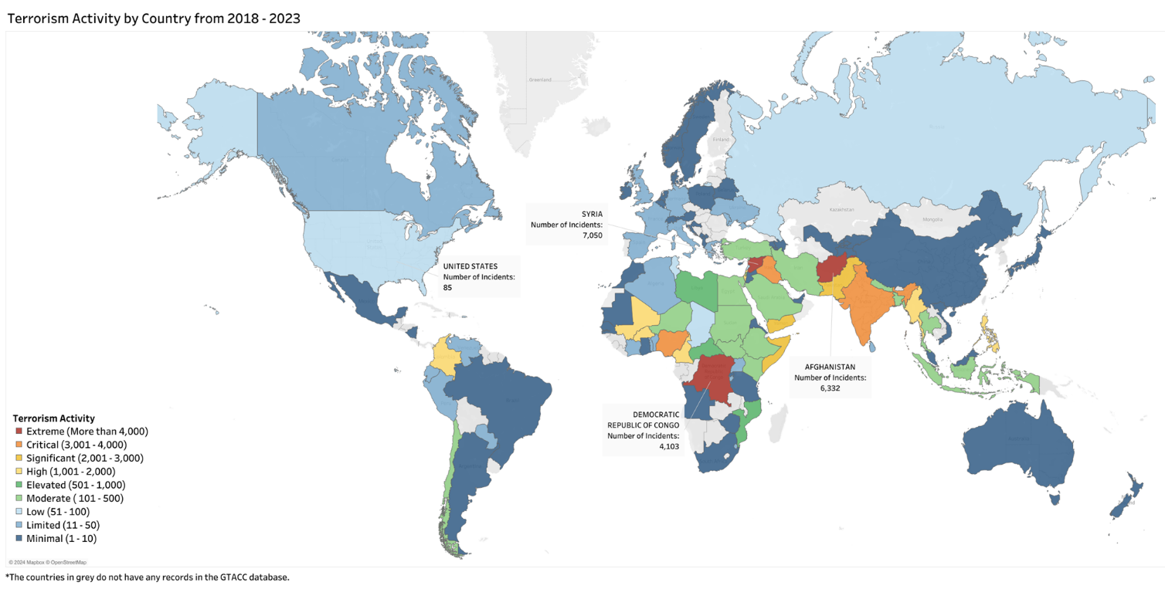
Figure 5: Map of the countries with recorded terrorist incidents from 2018 to 2023.
The findings, represented in both the map and bar chart, reveal that Syria leads with an alarming total of approximately 7050 terrorist incidents. This high figure is closely followed by Afghanistan, which recorded around 6,332 incidents. The intense level of activity in Syria and Afghanistan reflects the enduring conflicts, insurgencies, and the presence of extremist factions that have fueled sustained violence in these nations. The Democratic Republic of Congo ranks third, with 4,103 recorded incidents. India, with 3,485 incidents, also stands out as a country facing frequent terrorist attacks, mainly due to separatist movements and regional tensions, especially in areas like Jammu and Kashmir and northeastern India.
Other countries that appear prominently in our findings include Iraq, Nigeria, and Yemen, each recording over 2,000 incidents. Iraq, still grappling with the remnants of ISIS and sectarian conflict, continues to experience significant terrorist activity. Yemen’s position reflects the impact of its ongoing civil war, where terrorist incidents have been fueled by both sectarian violence and the actions of groups like al-Qaeda in the Arabian Peninsula (AQAP).
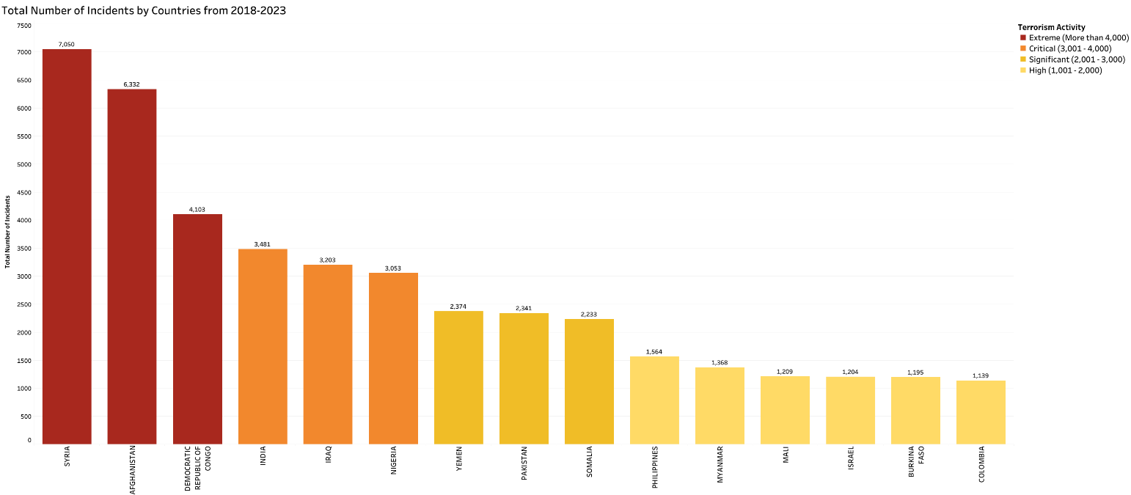
Figure 6: This figure shows the total number of incidents by country
This analysis underscores a critical insight: countries facing prolonged conflict, political instability, and strong extremist presences tend to have the highest levels of terrorist activity. The visualization on the map, with dark shades highlighting the most affected countries, emphasizes the concentrated nature of terrorism in particular regions. The bar chart further clarifies these findings by directly comparing incident counts, illustrating the scale of terrorism across these nations. Our research highlights that terrorism is not evenly distributed across the globe; rather, it is intensely concentrated in regions facing complex socio-political challenges, making them hotspots for ongoing and frequent terrorist incidents.
In addition to analyzing specific countries, we examined the data at a regional level to identify broader trends. The analysis reveals that from 2018 to 2023, Western Asia recorded the highest number of terrorist incidents, totaling 15,534. This region, encompassing countries like Syria, Iraq, and Afghanistan, remains a hotspot due to prolonged conflicts and the presence of groups such as ISIS and the Taliban. Sub-Saharan Africa follows with 5,305 incidents, driven by groups like Boko Haram and Al-Shabaab in nations facing political instability, including Nigeria and the Democratic Republic of Congo. Southern Asia ranks third, with 5,267 incidents fueled by internal conflicts and cross-border tensions in countries like India and Pakistan. Other regions like Southeastern Asia and Northern Africa also saw significant activity, with over 1,000 incidents each, due to insurgencies and political unrest. In contrast, regions such as Eastern Asia, Australia and New Zealand, and Central Asia recorded minimal incidents, highlighting a concentrated distribution of global terrorism in areas of ongoing conflict and instability.
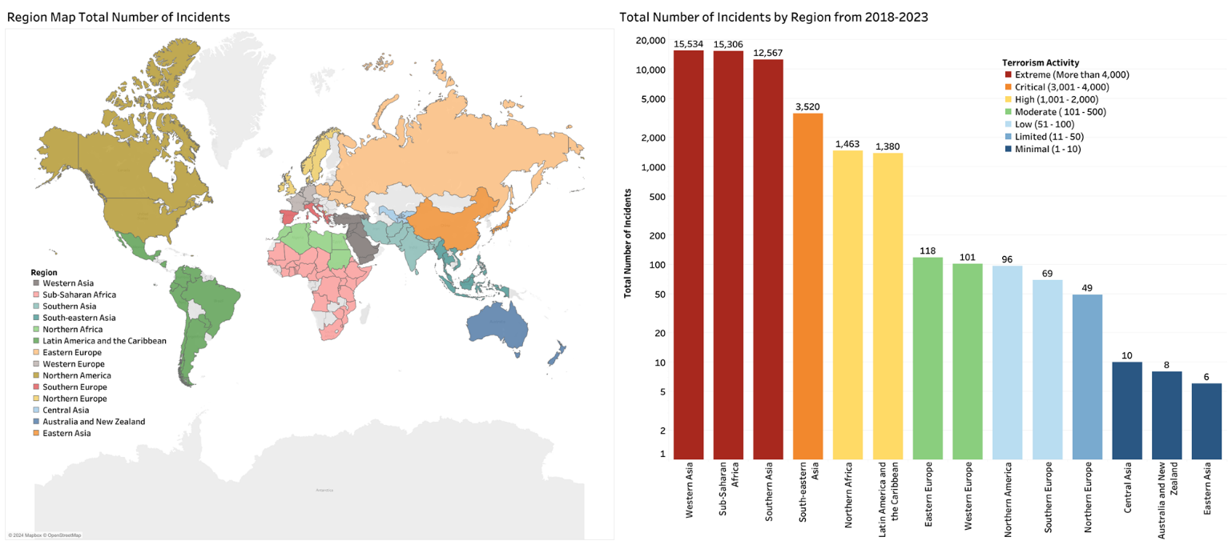
Figure 7: This figure shows regions with recorded terrorist incidents from 2018 to 2023.
To complement our geographic analysis, we have identified March, May, and January as the months with the highest numbers of casualties (both killed and wounded) from 2018 to 2023. March recorded the highest peak, with a total of 26,654 casualties, followed closely by May with 26,429 and January with 26,085. These months show significant spikes in terrorism-related violence, as seen in the combined blue (wounded) and red (killed) segments of each bar, which together represent total casualties. The consistently high numbers during these months suggest periods of intensified activity, possibly tied to specific events, seasonal factors, or campaign cycles within ongoing conflicts. In contrast, December and September saw lower casualty figures, indicating relative declines in terrorist violence. This monthly breakdown provides valuable insights into patterns of terrorist activity, highlighting times of heightened risk.
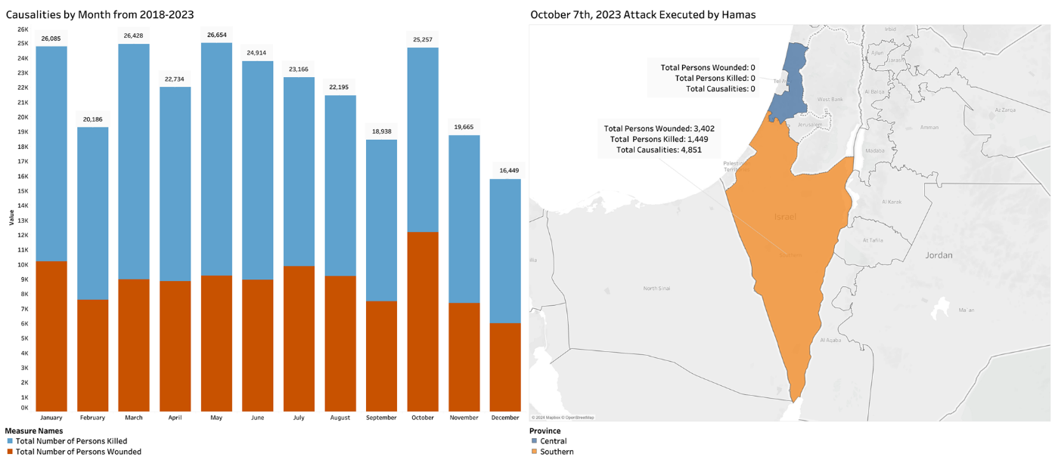
Figure 8:This stacked bar chart shows causalities by month from 2018 to 2023 around the world.

Research question 2:

Which ten groups had the highest number of casualties (people killed and wounded) from 2018 to 2023?
This question focuses on identifying the top ten terrorist groups responsible for the highest casualties (killed and wounded) from 2018 to 2023. The map highlights countries most impacted by these groups, with each color representing a different terrorist organization. This geographical view emphasizes the spread and regional influence of each group, illustrating how their activities have affected multiple countries across Africa, the Middle East, and South Asia.
The bar graph on the right ranks these groups by total casualties, providing a clear comparison. Surprisingly, the highest number of attacks are done by unknown perpetrators which tops the list with 58,453 casualties, indicating incidents where the perpetrators were unidentified but had a significant impact. The Taliban follows closely with 47,680 casualties, reflecting their substantial role in the prolonged conflict in Afghanistan. ISIS, with 16,369 casualties, and al-Shabaab, with 14,420 casualties, also rank high due to their widespread activities in Iraq, Syria, and parts of East Africa. Other groups like Boko Haram and ISIS-affiliated factions in various regions (such as West Africa and the Democratic Republic of Congo) show considerable impact as well, with thousands of casualties each.
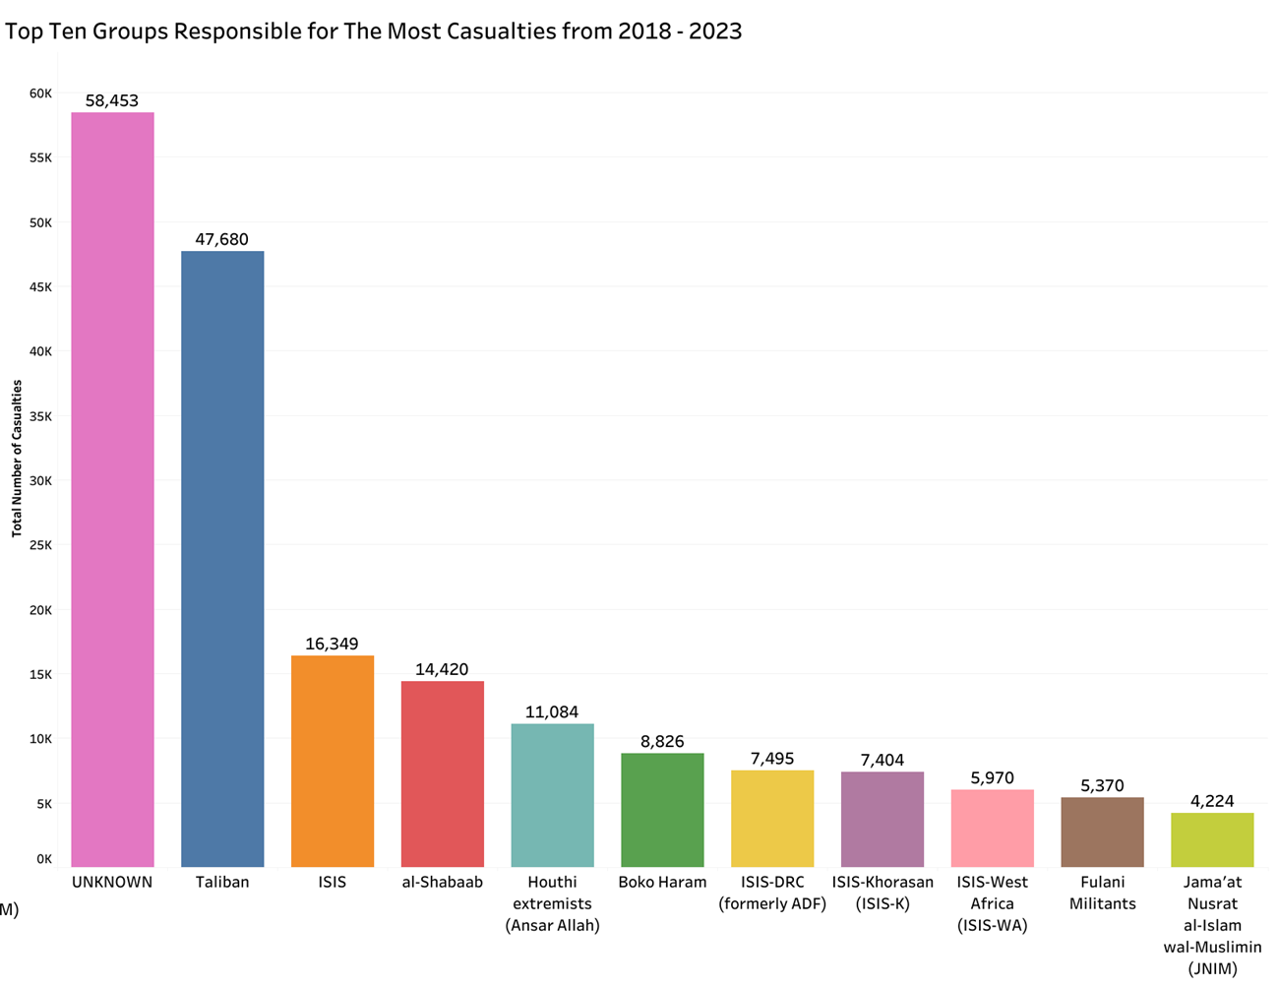
Figure 9:This figure shows the top 10 groups which made the highest causalities and their count from 2018 to 2023.

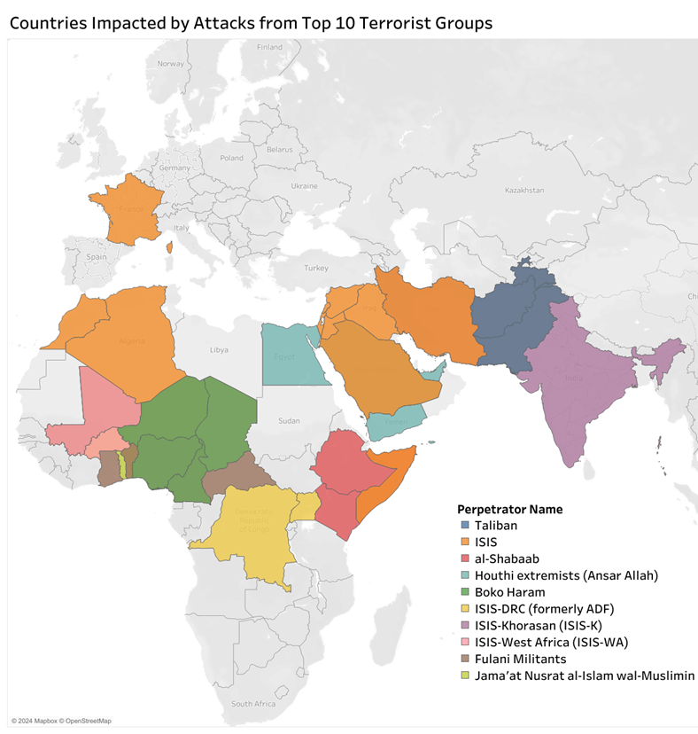
Figure 10: This figure shows the top 10 groups which made the highest causalities and areas affected by them from 2018 to 2023
These visuals collectively underscore the lethality and influence of these groups, revealing both their geographic reach and the human cost of their actions across several regions. This combined data aids in understanding the scale of impact from these groups, which continue to drive conflict and instability in their respective areas of operation.

Research question 3:

How many types of tactics (e.g., suicide attacks, kidnapping, car ramming, assassinations, stabbing, shooting, bombing, ambush, and planting mines/IEDs) were used from 2018 to 2023? Which ten groups employed these tactics the most, and how has their use of these tactics changed from 2018 to 2023?
To better understanding, we divided research question 3 into two sub-parts, each addressing a specific component of the question.
A) How many types of tactics (e.g., suicide attacks, kidnapping, car ramming, assassinations, stabbing, shooting, bombing, ambush, and planting mines/IEDs) were used from 2018 to 2023?
Our analysis identifies a wide variety of tactics used by terrorist groups from 2018 to 2023, with the data summarized in a stacked bar chart. The chart breaks down each tactic, showing both the total frequency and the specific groups that employed them. Shootings and bombings emerge as the most frequently used tactics, with shootings leading to over 13,000 incidents, followed by bombings with approximately 6,000 incidents. These high numbers reflect the preference for high-impact tactics that can cause significant casualties and disruption. Other tactics, such as planting mines/IEDs and ambushes, also appear frequently but with lower numbers, around 3,800 and 1,700 incidents respectively. Less commonly used tactics, including kidnappings, stabbings, and arson, show a variety of usage across different groups but at much lower frequencies. The chart color codes each group’s use of these tactics, showing that groups like ISIS, the Taliban, and al-Shabaab frequently employ these high-casualty methods, while other groups show more varied or selective tactic choices.
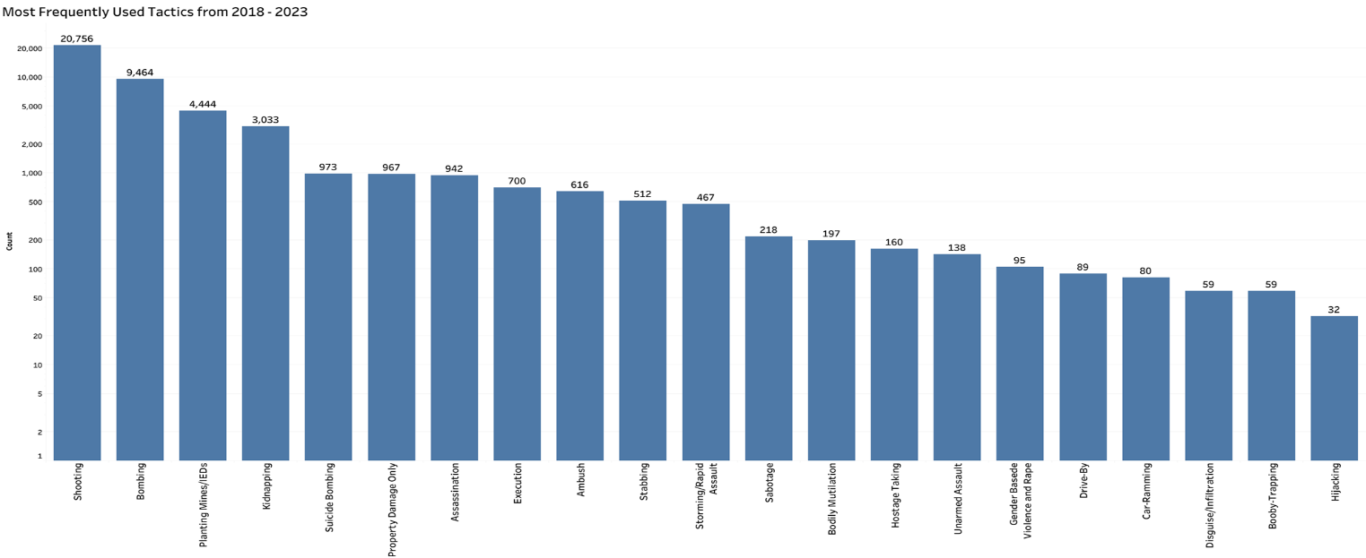
Figure 11: The figure shows the frequency of various tactics used by different groups from 2018 to 2023
This breakdown highlights the tactical diversity within terrorist operations, with a concentration on methods that maximize impact. Understanding these patterns provides insight into the operational strategies of various groups, emphasizing the need for counter-terrorism strategies that address these preferred methods of attack.

B) Which ten groups employed these tactics the most, and how has their use of these tactics changed from 2018 to 2023?
To answer this part, we have used stacked bar graphs for each group to visualize their use of tactics over the years.
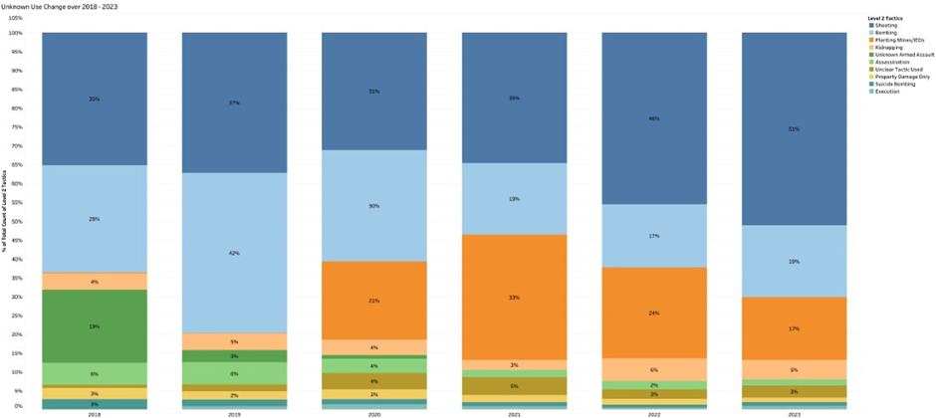
Figure 12: The figure shows the changing use of various tactics by” unknown” perpetrators from 2018 to 2023.
From 2018 to 2023, the unknown perpetrator's group primarily used shooting and bombing as their main tactics. Shooting incidents increased steadily, starting at 35% in 2018 and reaching 51% by 2023, indicating a growing preference for firearms. Bombing was the second most common tactic, peaking at 28% in 2019 but gradually decreasing to 19% by 2023. Planting mines/IEDs increased over the years and peaked in 2021 with 33% and then decreased to17% by the end of 2023. Kidnapping maintained a minor but consistent presence, each fluctuating around 4-6% over the years. Less frequently used tactics, such as executions and suicide bombings, accounted for only small portions annually. Overall, this group shows a clear shift toward simpler, high-impact tactics like shootings, possibly due to ease of execution in unpredictable environments.
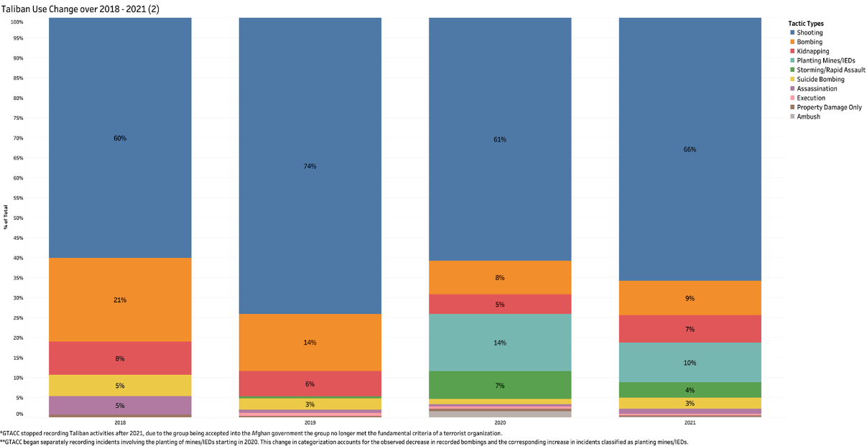
Figure 13:The figure shows the changing use of various tactics by Taliban group from 2018 to 2023.
The chart shows that from 2018 to 2023, the Taliban predominantly used shooting as their primary tactic, with its usage rising from 41% in 2018 to 100% in 2023, indicating a sharp focus on this method over time. In 2018, the Taliban also relied on bombing (14%) and kidnapping (6%), but these tactics gradually decreased in use. By 2022, all other tactics were phased out in favor of shooting. Tactics like ambushes and assassinations and suicide bombing had minor presence initially but disappeared by 2021. This clear shift toward exclusive use of shooting may reflect strategic changes or a preference for simpler, direct methods that are easier to execute in the Taliban’s operational environment.
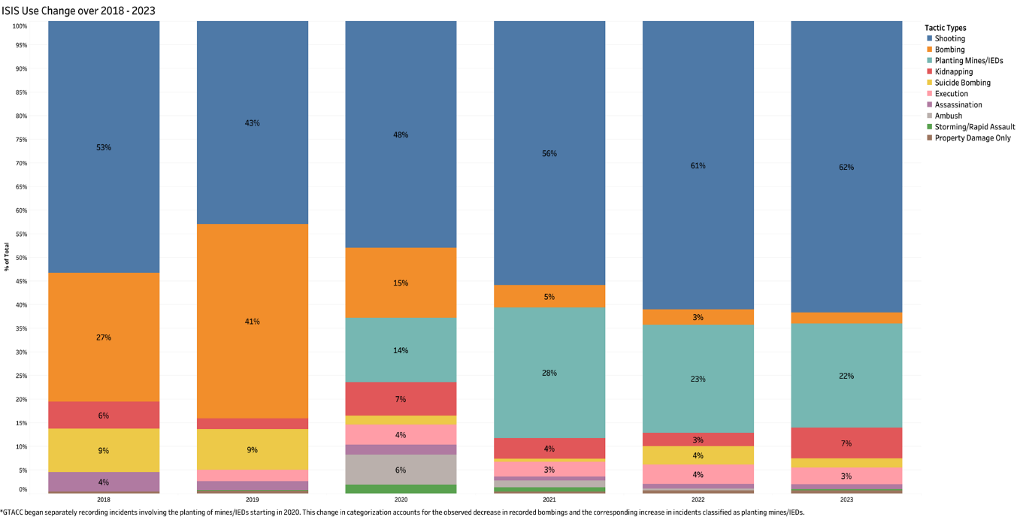
Figure 14: The figure shows the changing use of various tactics by ISIS group from 2018 to 2023
The chart illustrates that ISIS has primarily relied on shooting and bombing tactics from 2018 to 2023, with shooting consistently being the most used tactic. Shooting increased from 45% in 2018 to 61% in 2023, indicating a steady preference whereas bombing hasn’t remained significant, decreasing from 23% in 2018 to 2% in 2023 while peaking in 2019 with 40% Kidnapping had shown its continued role in ISIS's operations. But,the use of planting mines/IED’s had increased from 0% in 2018 to 22% in 2021 and maintained about the same in the following year. The group has employed other tactics like executions, unclear tactics, and assassination at lower rates, each contributing between 2% and 9% annually but without consistent trends. This pattern suggests that while ISIS has maintained a strong reliance on high-impact methods like shooting, they also incorporate varied tactics, likely to adapt to changing operational conditions or target types.
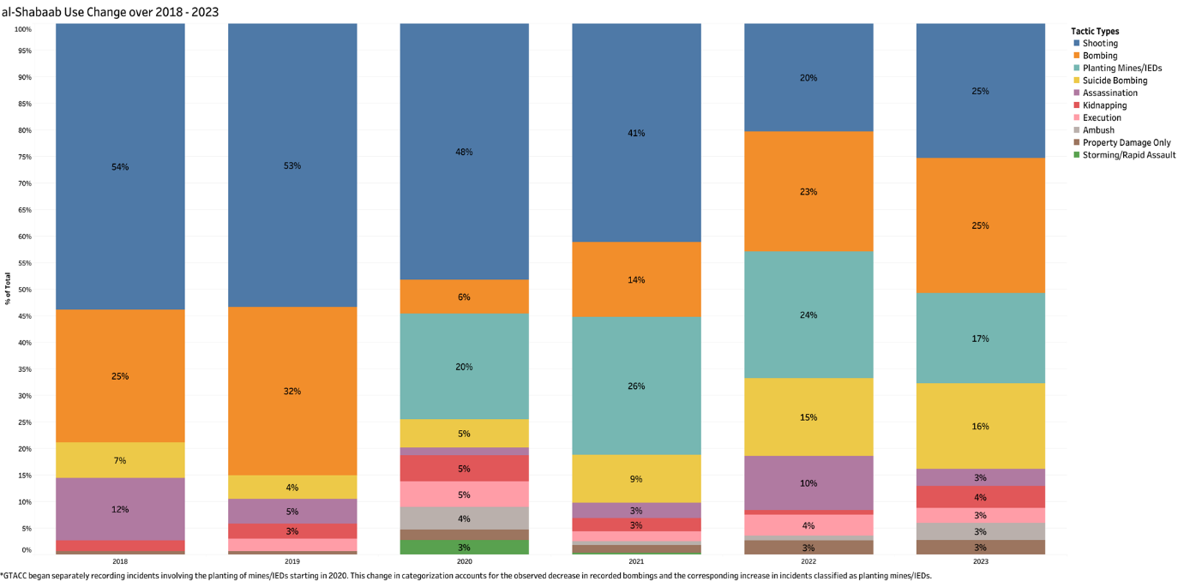
Figure 15: The figure shows the changing use of various tactics by Al-Shabaab group from 2018 to 2023.
The chart shows that al-Shabaab primarily used shooting and bombing as their main tactics from 2018 to 2023, with a notable shift in emphasis over time. Shooting was consistently the most used tactic, though its share decreased from 50% in 2018 to 25% in 2023, indicating a gradual diversification in tactics. Bombing saw a substantial increase, rising from 23% in 2018 to 25% in 2023, suggesting a growing reliance on explosives. Planting mines/IEDs and ambushes also featured prominently in al-Shabaab's tactics, fluctuating between 15% and 25% in the later years. Tactics such as suicide bombings and executions remained less common but were used intermittently throughout the period. This shift towards a more varied tactical approach reflects al-Shabaab’s adaptation to changing operational needs, utilizing a broader range of methods to maintain impact and versatility in their operations.
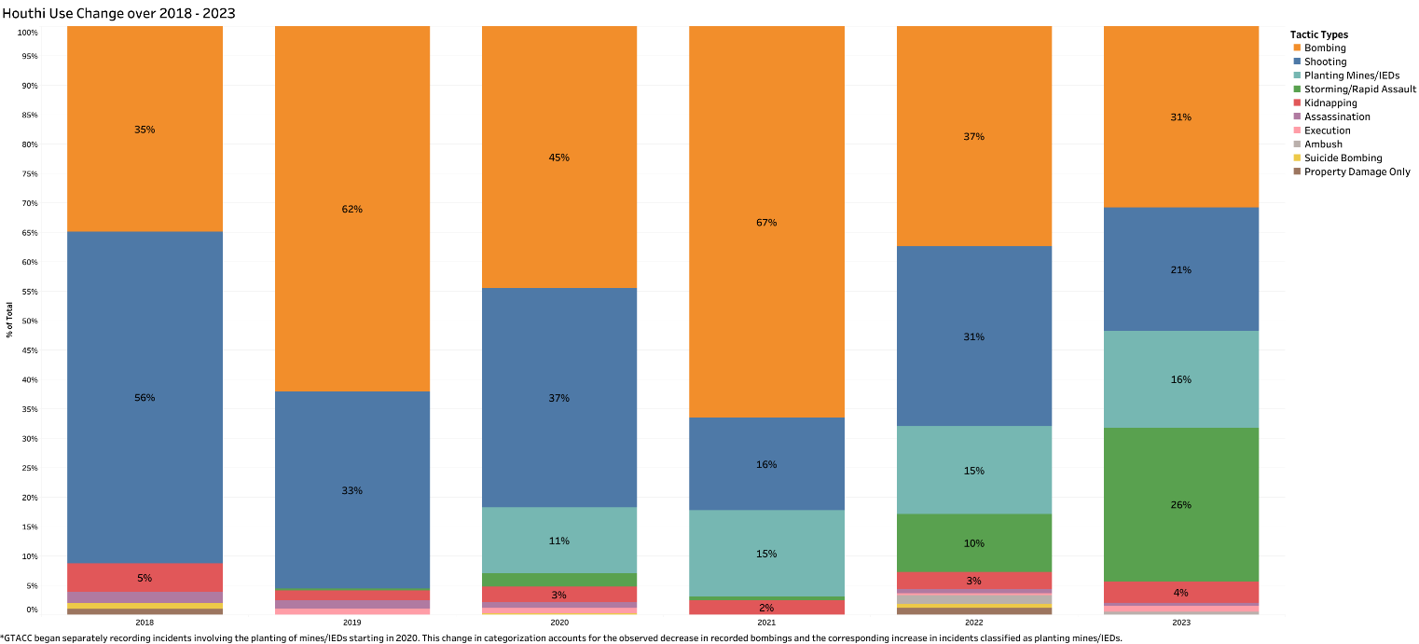
Figure 16: The figure shows the changing use of various tactics by Houthis group from 2018 to 2023
The graph shows that the Houthis predominantly shifted their tactics from unknown armed assault in 2018 to relying primarily on bombing and shooting in subsequent years. In 2018, unknown armed assault made up 52% of their tactics, marking it as the most used method that year. However, this tactic’s prominence declined drastically from 2019 onwards. From 2019, bombing emerged as the Houthis' primary tactic, constituting 58% in 2019 and remaining their top tactic with a steady increase to 66% in 2021, before stabilizing at 41% in 2022 and 2023. Shooting also gained importance, with a notable increase from 25% in 2018 to 31% by 2021, and maintained a steady usage at around 28-37% from 2021 to 2023. We can also see an increase in use of mines/IED’s from 2020. Other tactics, such as ambushes and kidnappings, consistently held minor shares throughout the period, rarely exceeding 5%. This tactical shift reflects a strategic change by the Houthis, transitioning from the extensive use of armed assault to a stronger reliance on bombings, shootings and IED’s possibly indicating adjustments in response to operational challenges and resource availability.
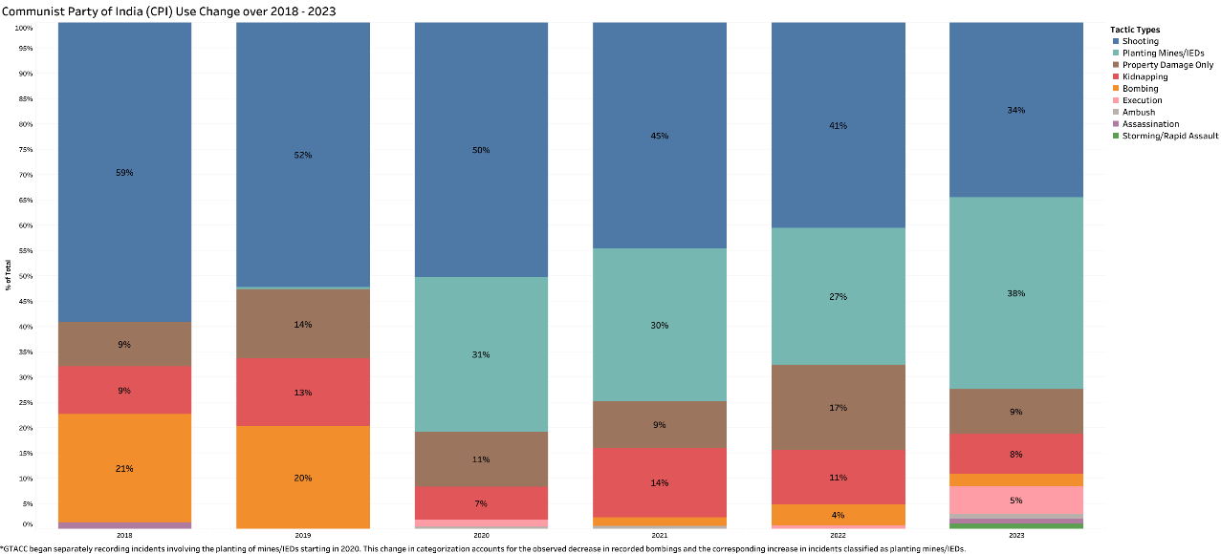
Figure 17: The figure shows the changing use of various tactics by CPI group from 2018 to 2023

The graph shows that the CPI’s tactics shifted notably over the years. In 2018, shooting was the primary tactic, accounting for 55% of their actions. By 2019, there was a marked rise in property damage, which grew from 8% in 2018 to 13%, while shooting slightly declined. This trend continued, and in 2020, property damage further increased to 28%, showing a significant shift toward indirect methods. Meanwhile, shooting decreased gradually, dropping to 37% by 2022 and stabilizing at 34% in 2023. Kidnapping maintained a steady share, around 9-13%, and mines/IEDs saw massive increases, with their usage peaking at 30% in 2023. This evolution suggests a strategic transition by the CPN, moving from direct confrontations through shooting to a more diversified approach emphasizing planting mines and IED’s and supporting tactics like kidnapping and explosives.
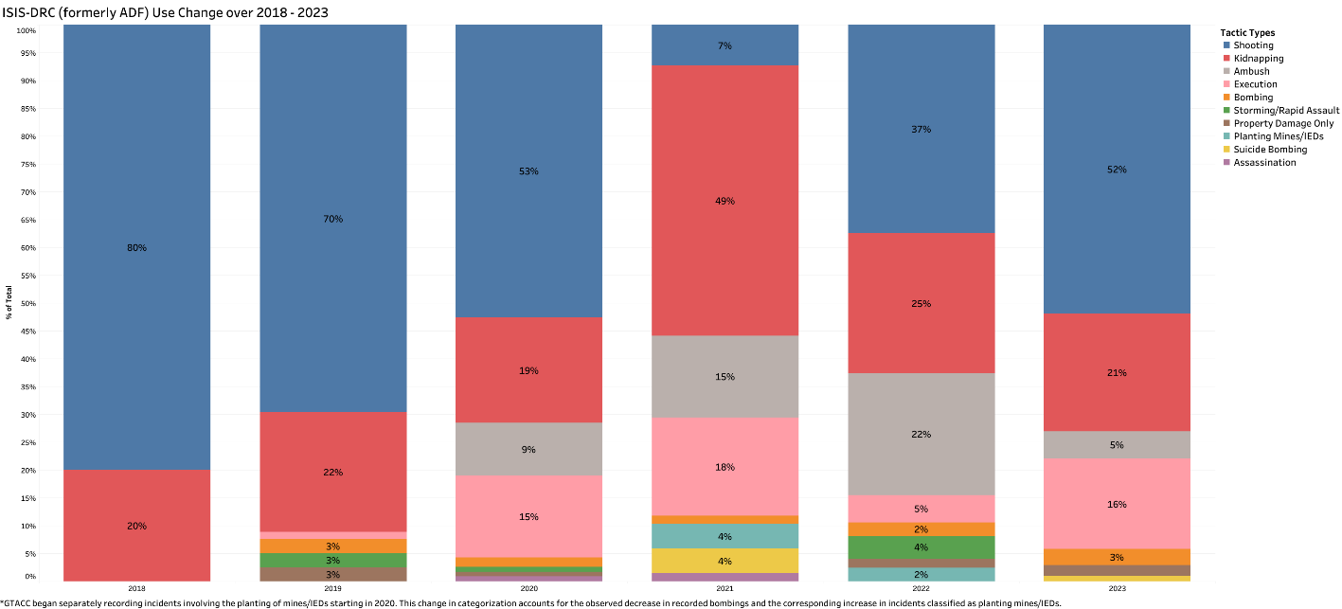
Figure 18: The figure shows the changing use of various tactics by ISIS DRC group from 2018 to 2023
The graph shows a significant shift in tactics used by ISIS DRC from 2018 to 2023. In 2018, shooting was the dominant tactic, making up 73% of actions, while property damage only and kidnapping held smaller shares at 18% and 5%, respectively. Starting in 2020, "Unknown Tactic Used" became the predominant method, surging to 54% that year and increasing to 81% by 2021. Shooting declined drastically, dropping to 20% by 2022 and stabilizing at 24% in 2023. Property damage only maintained a presence but remained secondary. This trend suggests a tactical shift by ISIS DRC towards more unspecified or covert actions, reducing direct confrontational methods like shooting and changing their approach with other tactics.
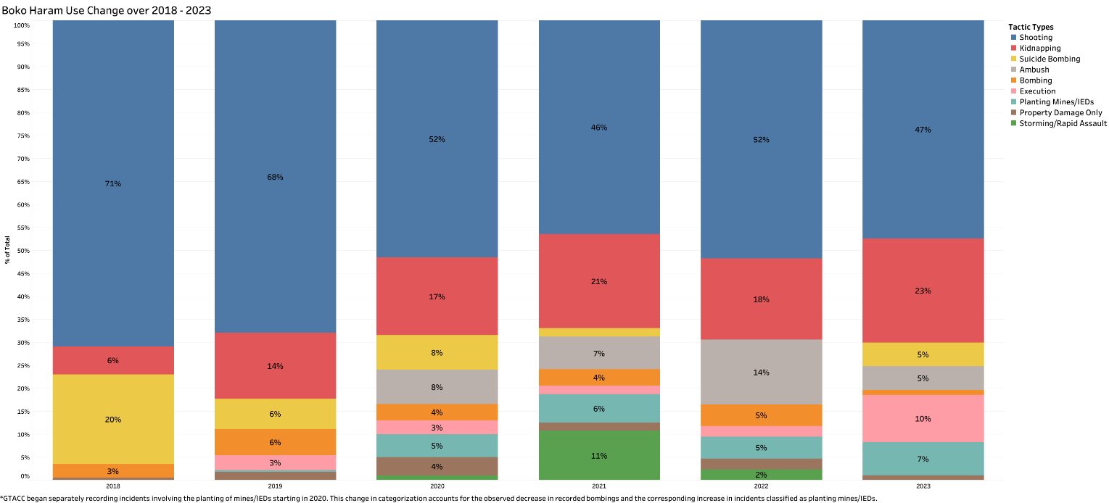
Figure 19: The figure shows the changing use of various tactics by Boko Haram group from 2018 to 2023
The graph indicates that Boko Haram's tactics from 2018 to 2023 were primarily dominated by shooting, which consistently represented the largest share, peaking at 67% in 2019. However, starting in 2020, there was a slight decline in shooting, stabilizing around 48% from 2020 to 2023. Suicide bombings and kidnappings maintained secondary roles, each ranging between 5% and 18% over the years. Notably, the use of property damage and planting mines/IEDs saw modest increases in recent years, with property damage reaching 10% in 2023. This shift suggests a strategic adaptation, with Boko Haram balancing direct confrontations with other disruptive tactics to diversify their approach to other tactics like kidnapping which increased to 23% by the end of 2023.
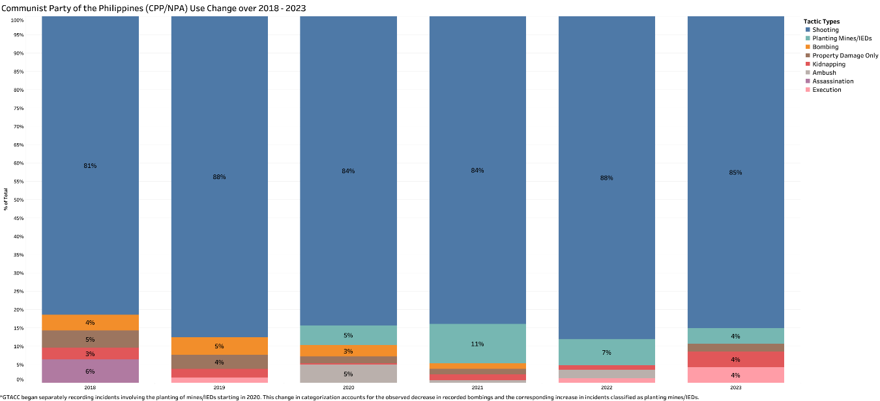
Figure 20: The figure shows the changing use of various tactics by CPP group from 2018 to 2023
The graph shows that from 2018 to 2023, CPP heavily relied on shooting as their primary tactic, consistently making up 77% to 89% of their actions each year. This indicates a strong preference for direct engagement. Other tactics, such as kidnapping, property damage, and the use of mines/IEDs, remained minimal, each staying below 10% across the period. In 2021 and 2022, property damage saw a slight rise, peaking at 10% and 7%, but these methods were still secondary. Overall, CPP’s approach stayed consistent, with shooting as their dominant tactic and little shift towards alternative strategies.
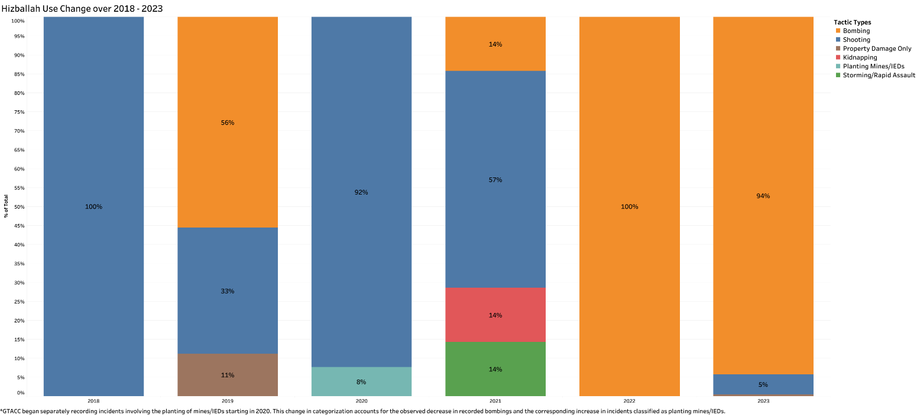
Figure 21: The figure shows the changing use of various tactics by Hizballah group from 2018 to 2023
The graph tells an interesting story about Hizballah's tactics which evolved significantly between 2018 and 2023. In 2018, the group relied exclusively on shooting, which accounted for 100% of their actions. By 2019, Hizballah diversified their approach, with shooting decreasing to 30%, and a mix of other tactics emerging, including bombing (50%) and property damage (10%). In 2020, shooting remained dominant at 92%, but there was an increase in planting mines/IED’s, reaching 8%. While kidnapping also appeared minimally (13%) in 2021. Also in 2021, the reliance on shooting decreased slightly to 50%, balanced by unclear tactics used at 25% and a resurgence of kidnapping at 13%. In 2022, shooting and unknown tactics each represented 50% of their actions, indicating a notable shift towards less defined or covert methods. By 2023, bombing became overwhelmingly dominant, making up 94% of the group's actions, with shooting reduced to just 5%. This progression reflects Hizballah’s strategic adaptation over time, moving from direct confrontational tactics to more covert and explosive-based methods in recent years.

Research question 4:

What are the most used weapon types (e.g., firearms, explosives, UAVs, incendiary devices, and melee weapons)? Which five group use firearms, IEDs, rockets, mortars, grenades, missiles, and UAVs the most?
We can see that the bubble chart provides a clear overview of the distribution of weapon types used in terrorist incidents. The size of each bubble reflects the frequency of each weapon type, while percentages and counts give additional context on usage prevalence
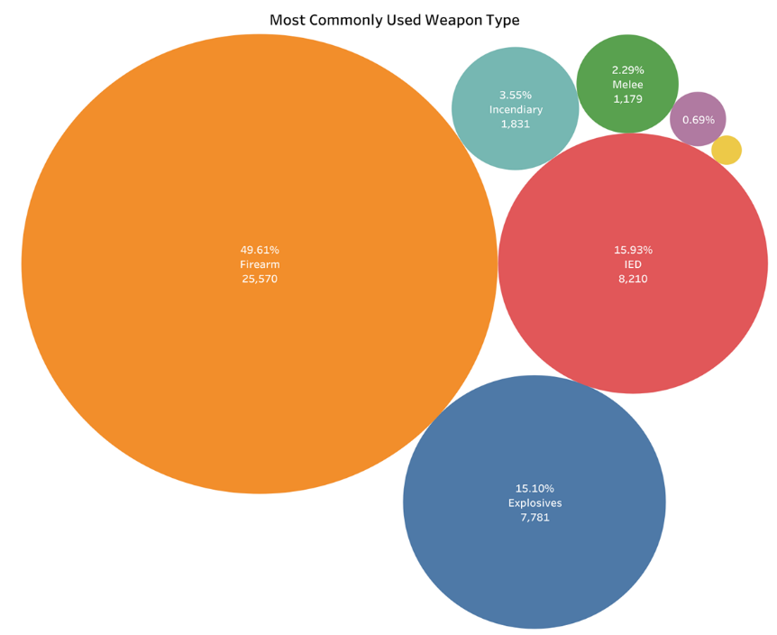
Figure 22: The figure shows the most used weapon types using a bubble chart
Firearms emerge as the dominant weapon type, accounting for 49.61% of incidents, with a total of 25,570 occurrences. This suggests that firearms are the most accessible and widely used weapon in terrorist activities, likely due to their ease of use and effectiveness in direct engagement tactics. Following firearms, Improvised Explosive Devices (IEDs) represent 15.93% of incidents (8,210 occurrences). The prominence of IEDs highlights their versatility, as they can be assembled with available materials and used in a variety of attack scenarios, including covert or high-impact operations. Explosives, excluding IEDs, also hold a significant share at 15.10% (7,781 occurrences), emphasizing their role in causing large-scale destruction or psychological impact. Unknown Weapons account for 12.64% (6,513 occurrences), indicating that in a substantial number of incidents, the weapon type could not be clearly identified, possibly due to lack of information or forensic challenges. Other weapon types include Incendiary devices (3.55% or 1,831 occurrences), which are often used for visual impact or to instil fear; Melee weapons (2.29% or 1,177 occurrences), typically for close-range confrontations; and smaller proportions of UAVs (Unmanned Aerial Vehicles) and other categories. The minor presence of UAVs and melee weapons suggests they are used in specific, limited scenarios rather than widespread attacks. At last, we can say that firearms, IEDs, and explosives dominate as the most commonly used weapons in terrorist activities, likely due to their effectiveness, availability, and adaptability to various tactical goals.
To answer the next part of the question which is “Which five group use firearms, IEDs, rockets, mortars, grenades, missiles, and UAVs the most?,” we have used bar plots. In our analysis of the weapon types and tactics used by the top five terrorist groups—Taliban, ISIS, Al-Shabaab, Houthi, and CPI (Communist Party of India - Maoist)—we observed unique preferences in weaponry that reflect each group’s tactical strategies.
Firearms are predominantly used by the Taliban, with 3,091 recorded incidents, making it their primary weapon of choice. This reliance on firearms supports their focus on Assault tactics, suggesting a preference for direct, traditional combat, especially in regions where they seek territorial control. ISIS follows with 1,768 firearm uses, reflecting its extensive use of Assault and Exploitative tactics for both direct confrontation and impactful engagements. Al-Shabaab (1,184 uses), Houthi (670 uses), and CPI (585 uses) also employ firearms to a lesser extent, using them for direct engagements where they can maximize visibility and exert control.
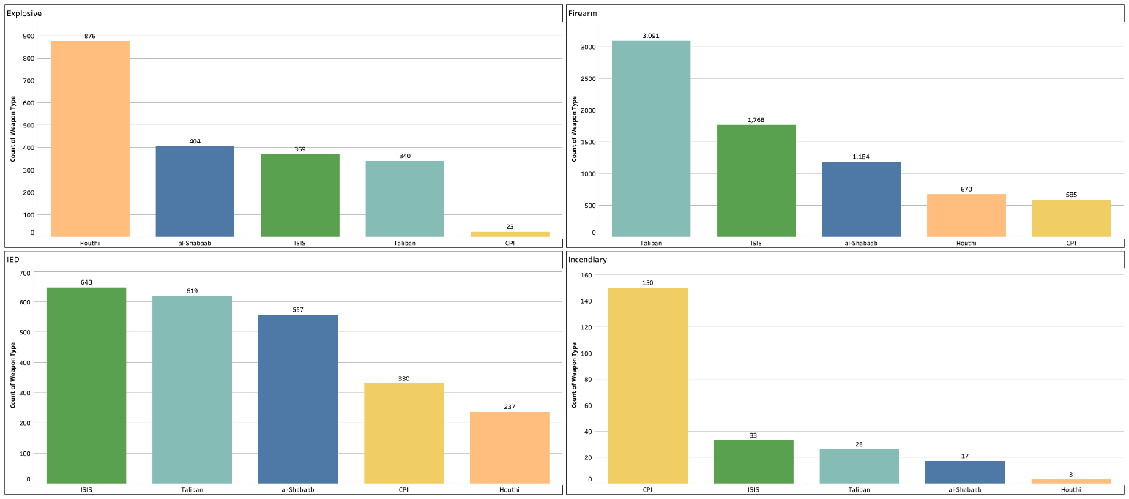
Figure 23: The figure shows a bar graph representing different weapon types against the perpetrator groups
Improvised Explosive Devices (IEDs) are notably used by ISIS (648 incidents) and the Taliban (619 incidents). These groups use IEDs for Covert and Trauma tactics, focusing on psychological impact and surprise attacks that are difficult to predict. IEDs allow for both hidden and high-casualty attacks, supporting their strategic goals. Al-Shabaab (557 uses) also relies on IEDs, often for Exploitative and Coordinated tactics that disrupt civilian life and government functions. CPI (330 uses) and Houthi (237 uses) use IEDs as well, particularly for Covert operations in rural or strategically important areas. When it comes to explosives (excluding IEDs), Houthi leads with 876 incidents, indicating their focus on Trauma and Exploitative tactics aimed at creating psychological impact and drawing attention, especially against government and coalition forces. Al-Shabaab (404 uses) and ISIS (369 uses) also use explosives frequently, aligning with Assault and Trauma tactics to instill fear and cause large-scale destruction. Taliban (340 uses) and CPI (23 uses) employ explosives more selectively, deploying them in situations requiring impactful destruction. Incendiary devices are primarily used by CPI with 150 recorded incidents, supporting Exploitative and Trauma tactics aimed at creating significant visual and psychological impact. These tactics target symbols of governance or infrastructure to maximize fear and destabilization. ISIS and Taliban also use incendiaries on a smaller scale, primarily to instill fear and cause visible damage, while Al-Shabaab and Houthi show minimal use of incendiaries, indicating that incendiaries are less central to their tactical approach. Melee weapons are most used by CPI, with 147 recorded incidents, reflecting Assault tactics for close-quarter engagements, particularly in rural areas. ISIS and Taliban also use melee weapons, mainly in ambushes or low-profile attacks where close combat is feasible. Al-Shabaab (10 uses) and Houthi (4 uses) use melee weapons sparingly, favoring firearms and explosives for higher-impact operations. UAVs (Unmanned Aerial Vehicles) are predominantly used by Houthi, with 117 recorded incidents, supporting Covert and Coordinated tactics for remote, high-precision attacks on high-risk or hard-to-reach targets. Taliban, Houthi, and Al-Shabaab have limited additional UAV use, indicating UAVs are reserved for select, high-stakes operations that require precision. Lastly, Other weapons see minor usage, with the Taliban, Houthi, and Al-Shabaab each having a few incidents recorded. These are likely unconventional or opportunistic weapons used in unique circumstances.
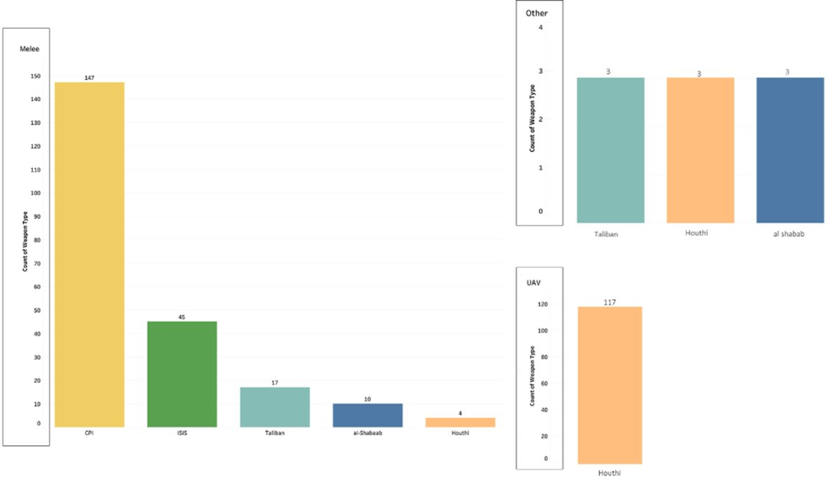
Figure 24: The figure shows a bar graph representing different weapon types against the perpetrator groups
In summary, each group’s weapon preferences reflect their strategic objectives and tactical focus. The Taliban and ISIS prioritize firearms and IEDs for Assault and Covert tactics, while Houthi emphasizes explosives and UAVs for Trauma and Covert operations. CPI leans heavily on incendiaries and melee weapons, supporting Assault and Exploitative tactics aimed at destabilizing targets. Al-Shabaab uses a balanced mix of firearms, IEDs, and explosives, aligning with Assault and Covert tactics to create both immediate and psychological impact.

Research question 5:

Which victims categories are most frequently targets (e.g., general population/civilians, government officials, professionals, political figures)? Which five groups primarily target civilians, military personnel, politicians, government officials, and professionals?
The General Population are the most commonly targeted. The None category, representing 38.28% (19,733 incidents), likely includes attacks with no specific, identified victim or cases where the target is broad, such as infrastructure or symbolic locations. General Population follows closely at 26.83% (13,830 incidents), indicating that civilians and public areas are heavily impacted by terrorist activities, reflecting an intent to cause widespread psychological and social disruption.
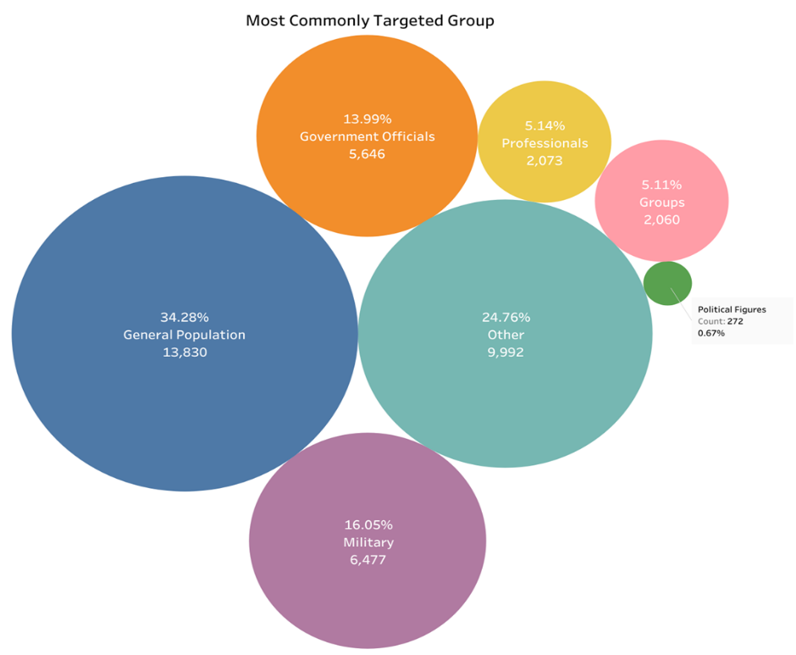
Figure 25: The figure shows a bubble chart with most targeted groups
The Other category accounts for 19.38% (9,992 incidents), suggesting that there are diverse, less-defined victim types affected by these attacks. Government Officials make up 10.95% (5,646 incidents), highlighting that political and administrative figures are also common targets, likely due to their symbolic and influential roles. Professionals are targeted in 4.02% (2,073 incidents), which may reflect attacks on individuals in specific occupations that can disrupt societal functions. Political Figures represent a very small portion of targeted incidents, indicating that attacks specifically directed at high-ranking political individuals are relatively rare but strategically significant when they occur.
The next part of the question is answered by a series of bar plots for each targeted group starting with General Population.
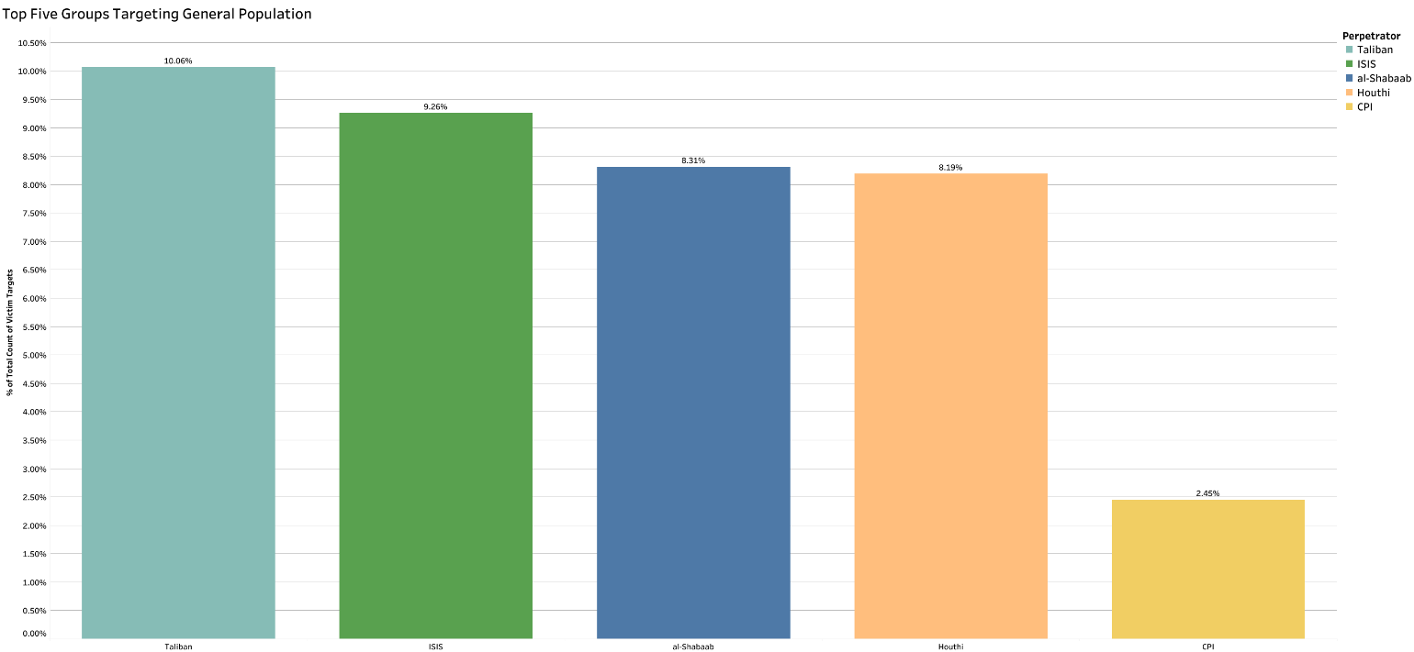
Figure 26: The figure shows a bar graph representing top 5 groups targeting general population
The bar chart illustrates the top five groups targeting the general population, showing the percentage of total incidents directed at civilians for each group. Taliban emerges as the primary perpetrator, with 10.06% of its incidents targeting the general population. ISIS follows closely at 9.26%, indicating a substantial focus on civilian targets. Al-Shabaab is next, with 8.31% of its attacks aimed at the general population, demonstrating its significant targeting of civilians. Houthi also shows a high percentage, at 8.19%, closely aligning with Al-Shabaab in its focus on civilian targets. Lastly, CPI rounds out the top five groups, with 2.45% of its incidents targeting the general population, which is considerably lower than the other four groups. This chart emphasizes that while Taliban and ISIS lead in attacks on civilians, Al-Shabaab and Houthi also have high proportions of civilian-targeted incidents, with CPI showing a relatively lesser focus on this group.
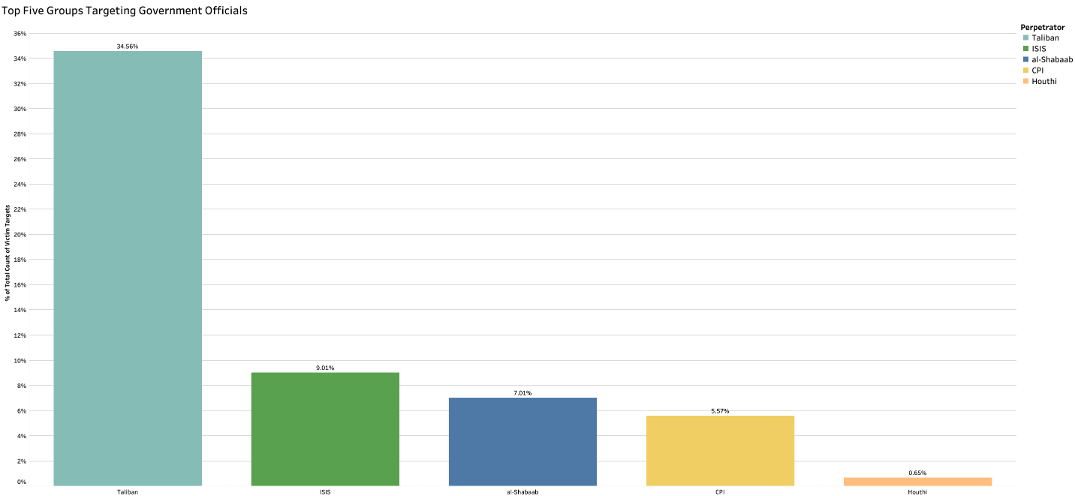
Figure 27: The figure shows a bar graph representing top 5 groups targeting government officials
The bar chart illustrates the top five groups targeting government officials, with a clear emphasis on the Taliban, which leads significantly by directing 34.56% of its incidents at government officials. This high percentage underscores the Taliban's focus on undermining governmental authority as a central part of its strategy. ISIS follows with 9.01% of its attacks aimed at government figures, showing a substantial, though smaller, emphasis compared to the Taliban. Al-Shabaab is next, with 7.01% of its incidents targeting government officials, reflecting its intent to weaken local governance structures. The CPI (Communist Party of India - Maoist) records 5.57% of its attacks against government officials, suggesting a focus on disrupting state structures within its areas of influence. Lastly, Houthi has a minimal share, with 0.65% of its incidents targeting government officials, indicating a relatively minor emphasis on this group. Overall, the chart highlights the Taliban’s predominant focus on government officials, while other groups like ISIS, Al-Shabaab, and CPI also prioritize these targets, albeit to a lesser degree.
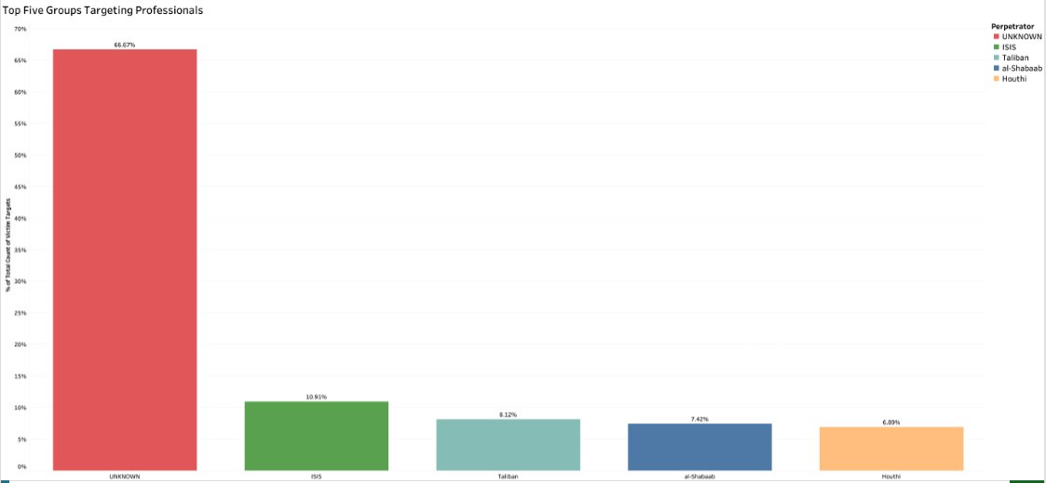
Figure 28: The figure represents top 5 groups targeting professionals
The bar chart displays the top five groups targeting professionals, with a significant emphasis on the Unknown category, which accounts for 66.67% of incidents targeting this group. This large percentage suggests that many attacks on professionals lack clear attribution to a specific group. Following this, ISIS is the next most prominent group targeting professionals, with 10.91% of incidents, reflecting its focus on disrupting specific occupational roles that may influence societal stability. Taliban ranks third, with 8.12% of its attacks aimed at professionals, likely as part of its strategy to destabilize essential services within controlled regions. Al-Shabaab targets professionals in 7.42% of incidents, indicating its intent to disrupt professional activities, possibly as a tactic to weaken community structures. Houthi completes the list with 6.89%, showing a relatively smaller but notable focus on targeting professionals. This chart highlights the lack of clarity in attribution for many attacks on professionals, with ISIS, Taliban, Al-Shabaab, and Houthi also contributing to the targeting of this category, although to a lesser extent.

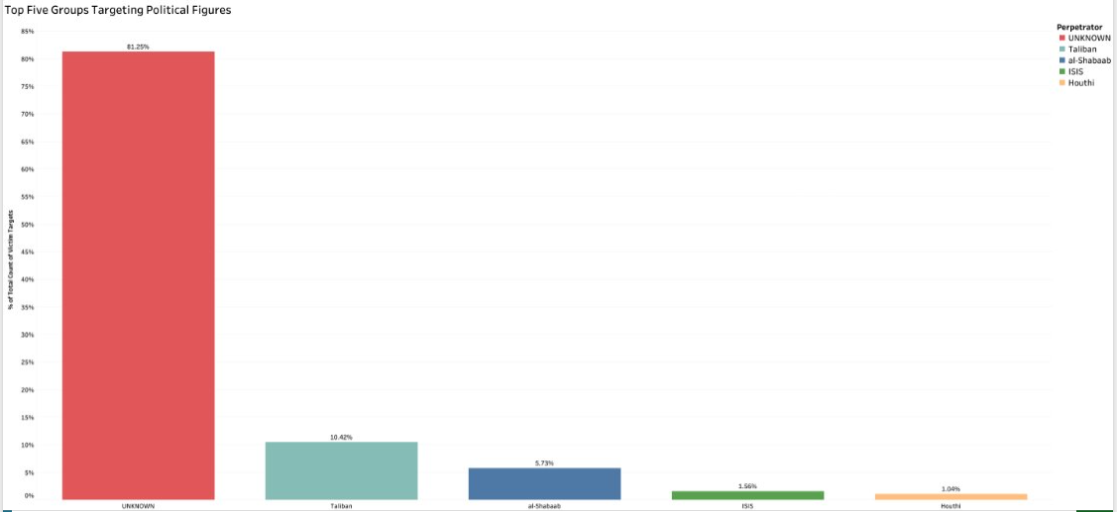
Figure 29: The figure represents top 5 groups targeting political figures.
The bar chart shows the top five groups targeting political figures, with a significant majority falling under the Unknown category, accounting for 81.25% of incidents. This large proportion indicates that most attacks on political figures lack clear attribution, suggesting either limited information on the perpetrators or deliberate concealment of the attackers’ identities. Among the identified groups, the Taliban leads with 10.42%, reflecting its targeted approach towards political figures, likely to destabilize political structures and exert influence. Al-Shabaab follows with 5.73%, indicating its intent to disrupt political entities, potentially as a tactic to weaken governance and authority in regions where it operates. ISIS is responsible for 1.56% of incidents targeting political figures, showing a relatively minor but notable focus in this area. Houthi has the smallest share, at 1.04%, reflecting a minimal emphasis on political figures in its operations. Overall, while most attacks on political figures remain unattributed, the Taliban, Al-Shabaab, ISIS, and Houthi show varying degrees of focus on these high-profile targets, aligning with their broader strategic goals.
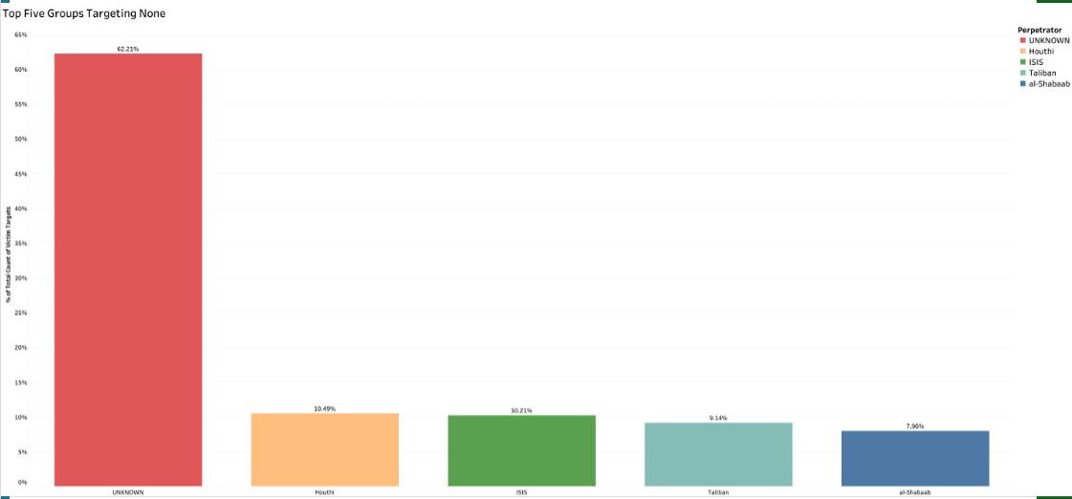
Figure 30: The figure shows top 5 groups targeting None.
This bar chart provides a detailed analysis of the top five perpetrator groups involved in terrorist incidents where there were no recorded victims. The category "None" serves as a parent classification, representing events in which no individuals were directly harmed or targeted. The chart reveals that the majority of these incidents—62.22%—fall under the UNKNOWN category. This signifies that the identity of the perpetrator group could not be determined, reflecting the challenges of attribution in terrorism-related incidents. Such cases might result from insufficient evidence, lack of claims of responsibility, or difficulties in investigative reporting.
Among the known perpetrator groups, the Houthis emerge as the second most prominent, accounting for 10.49% of these incidents. The group is followed closely by ISIS, which is responsible for 10.21% of such attacks. The Taliban is associated with 9.14% of these events, while al-Shabaab contributes to 7.94%, rounding out the top five. This visualization underscores the dominance of incidents with unknown perpetrators, highlighting the opacity and complexity of global terrorism data. At the same time, it illustrates the significant involvement of prominent extremist groups, such as the Houthis, ISIS, the Taliban, and al-Shabaab, in events classified as having no victims. The presence of these well-known groups in this category may reflect failed or disrupted attacks, instances where victims were not intended, or gaps in data collection and reporting.
Overall, this analysis sheds light on the dynamics of victimless terrorism incidents, emphasizing the need for improved investigative and reporting mechanisms to better understand and address such cases.
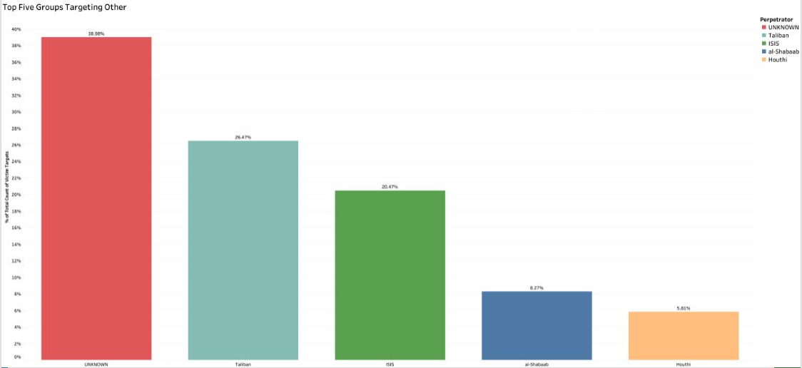
Figure 31: The figure represents top 5 groups targeting others.
This bar chart displays the top five groups targeting the "Other" category, which includes diverse victim types like informants, pro-government forces or labor unions. The Unknown category leads with 38.96%, suggesting that a substantial number of these incidents lack clear information on the perpetrating group. Taliban is the most prominent among identified groups, accounting for 26.47% of incidents in this category, indicating their involvement in a broad range of targets beyond typical classifications. ISIS follows with 20.47%, showing a similar pattern of targeting diverse groups that don’t fit into conventional categories. Al-Shabaab and Houthi contribute 8.27% and 5.81% respectively, reflecting a lower but notable level of targeting within the "Other" category. This chart highlights that while a large portion of these incidents are unattributed, the Taliban and ISIS engage frequently in attacks on unspecified or unconventional target groups, suggesting flexibility in their target selection.

Research question 6:

What are the similarities and differences between Iran-backed and jihadist terrorist groups?
The comparison between Iran-backed and religious jihadist terrorist groups reveals distinct strategic patterns in their tactics, target choices, and weaponry, with some interesting overlaps. By analyzing their geographic reach and operational behaviors, we gain insight into how each group type maneuvers to achieve its ideological and political objectives, often shaped by their respective sponsors, ideologies, and regional priorities.
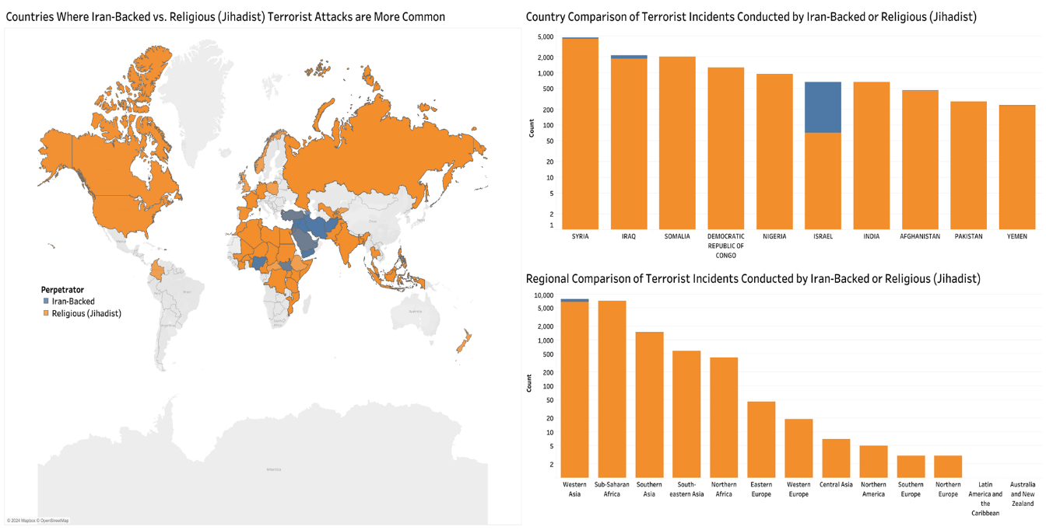
Figure 32: The figure represents Iran-backed vs. religious jihadist incidents worldwide.
The above visualization is a world map, contrasting where Iran-backed groups and religious jihadists operate. Iran-backed organizations are heavily concentrated in the Middle East, with primary activity in Syria, Iraq, and Yemen, regions where Iran holds significant political interest. This distribution aligns with Iran’s goal of using proxies to strengthen its influence and challenge rival states in specific areas. Religious jihadist groups, however, have a broader presence, with a stronghold not only in the Middle East but also in Sub-Saharan Africa and South Asia. This wider spread reflects their ideological mission, aiming to extend influence globally by mobilizing support and destabilizing regions far beyond their origins. This geographic focus reveals how Iran-backed groups pursue a regional agenda, whereas jihadist groups operate transnationally, aiming for a far-reaching ideological impact.
In another view, a country-level comparison provides deeper insight into where each group’s incidents are most frequent. For Iran-backed groups, the highest concentrations are in Syria and Iraq, areas with strong political ties to Iran. In contrast, religious jihadist groups are most active in countries like Somalia, Nigeria, and Afghanistan, often taking advantage of regions with less governmental control. This pattern shows that while Iran-backed groups operate in areas aligned with Iranian interests, religious jihadist groups gravitate toward weakly governed regions, where they can establish footholds with less resistance. This distinction in geographic concentration points to how each group adapts its strategy to its operational environment, shaped by political alliances for Iran-backed groups and by accessible, vulnerable territories for jihadist groups.
The regional breakdown of incidents adds another layer, highlighting how each group’s activities vary across broader geographic areas. Iran-backed groups focus mainly on Western Asia, reinforcing Iran’s local influence. Religious jihadist groups are more spread out, with substantial activity in Sub-Saharan Africa and Southern Asia. This regional distribution demonstrates the regional focus of Iran-backed groups in areas closely connected to Iranian state interests, contrasting with the expansive ideology-driven goals of jihadist groups. This difference suggests that Iran-backed groups are more contained to areas of immediate interest to Iran, while religious jihadists work across diverse regions to propagate their beliefs widely.

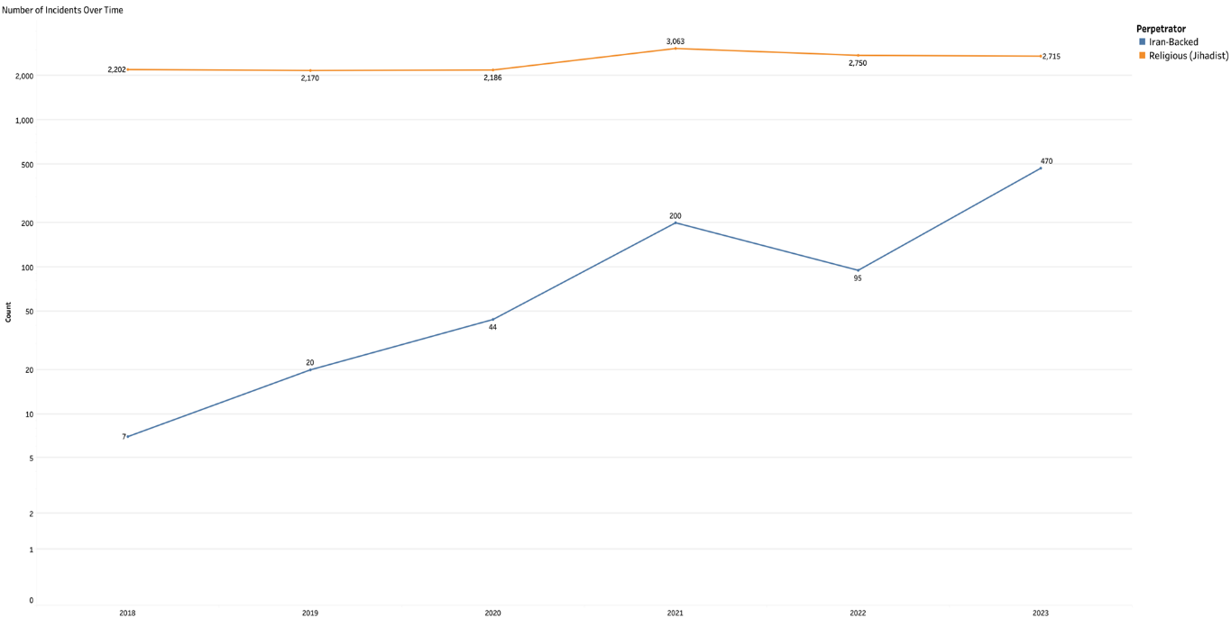
Figure 33: The figure represents Iran-backed vs. religious jihadist incident tends from 2018 to 2023.
This line chart illustrates the distinct operational patterns between Iran-backed and religious jihadist groups from 2018 to 2023, providing a comparison of their incident levels over time. Religious jihadist groups maintain a consistently high number of incidents each year, reflecting a well-entrenched network and sustained capacity to conduct attacks. Their steady operational tempo suggests a robust structure with reliable recruitment, resources, and logistical support that enables continuous activity, regardless of shifts in regional or global conditions. This persistence points to a deeply rooted ideological commitment, allowing these groups to keep up a constant presence in conflict zones.
In contrast, Iran-backed groups show a different pattern, marked by a gradual increase in incidents starting from 2018 and reaching a peak in 2021. This upward trend, followed by a minor dip in 2022 before rising again in 2023, suggests a more responsive approach aligned with Iran’s geopolitical priorities. Their fluctuating activity likely reflects Iran's strategy to exert influence through proxies, intensifying support based on regional needs or political opportunities. This contrast highlights the diverging motivations behind each group's operations: while religious jihadist groups aim for sustained ideological impact, Iran-backed groups adjust their actions to align with state-driven objectives, responding to external political pressures and strategic calculations.

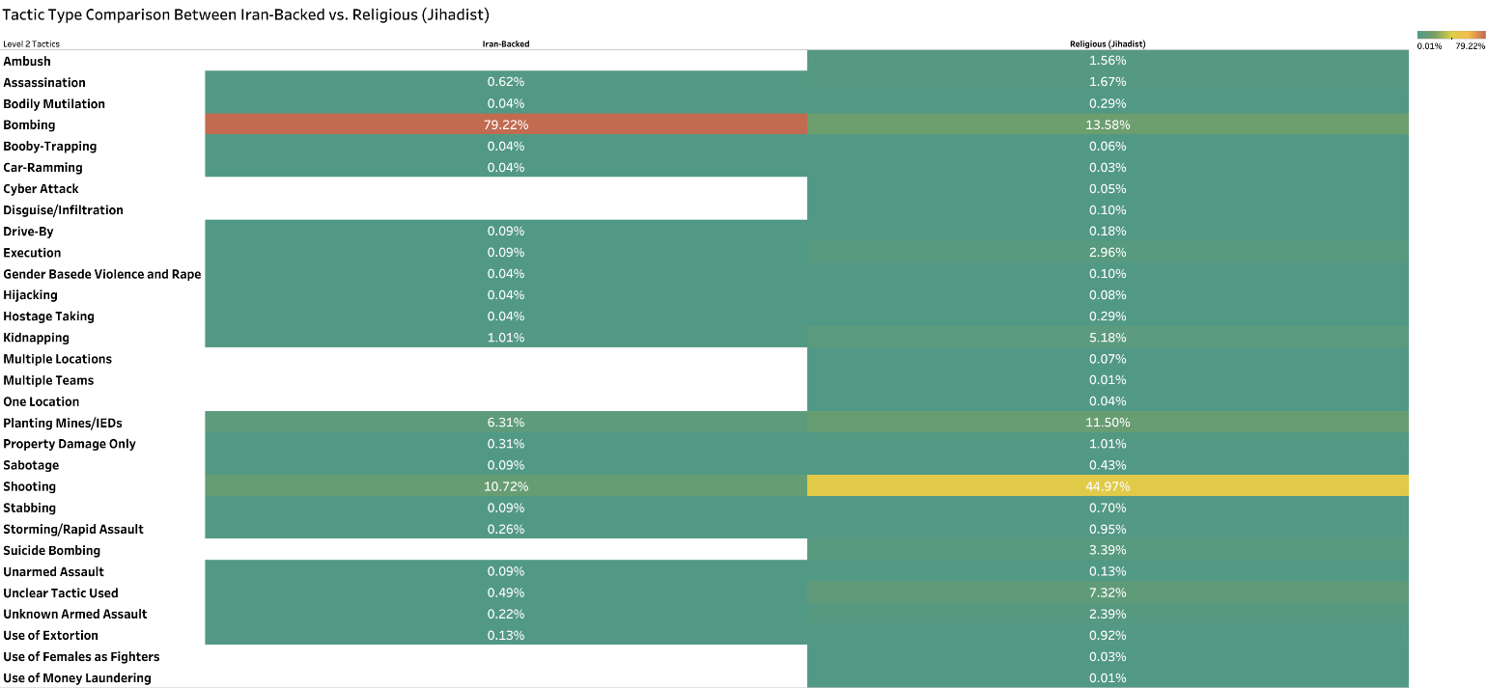
Figure 34: The figure represents Tactic Type Comparison between Iran-Backed vs Religious (Jihadist).
This chart provides a comprehensive look at the differing tactic preferences between Iran-backed and religious jihadist groups. The data highlights a striking contrast in strategy, with Iran-backed groups overwhelmingly favouring bombing, as indicated by the dominant 79.22% usage rate. This heavy reliance on bombing reflects their aim for maximum impact and visibility, aligning with state-sponsored strategies that often prioritize large-scale, attention-grabbing actions. Shooting and planting mines/IEDs appear as secondary choices, but they are still used significantly less than bombings, emphasizing a focused approach on explosive tactics for these groups.
On the other hand, religious jihadist groups display a broader distribution of tactics. While bombings also feature in their strategy, they are employed much less frequently (13.58%) compared to Iran-backed groups. Instead, religious jihadists show a higher propensity for shootings (44.97%) and planting mines/IEDs (11.50%), suggesting a more diverse approach in their operations. This variety could indicate a more adaptive or opportunistic approach, allowing jihadist groups to leverage a range of tactics depending on resources, targets, and situational factors. The contrasting patterns in tactic selection underscore the differences in operational philosophies and objectives between these two types of groups.
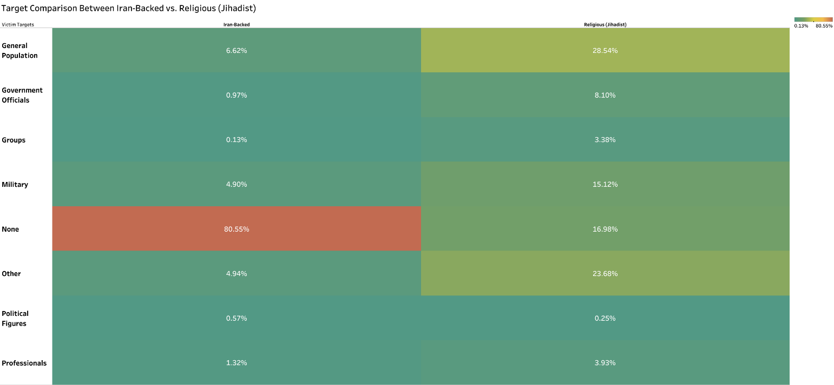
Figure 35: The figure represents Target Comparison between Iran-Backed vs Religious (Jihadist).
This image highlights the differences in target preferences between Iran-backed and religious jihadist groups, offering a glimpse into their strategic choices and motivations. Iran-backed groups predominantly target "None," implying they focus more on infrastructure or symbolic sites rather than specific individuals or populations. This tendency aligns with Iran's broader regional strategy, which often emphasizes destabilizing structures over direct civilian impact. On the other hand, religious jihadist groups show a significant preference for targeting the general population, government officials, and various "Other" groups. This focus reflects a strategy designed to spread fear across society and exert pressure on political entities. Such a contrast underscores how Iran-backed groups adopt a more calculated, less publicly targeted approach, while jihadist groups aim to create widespread social and political upheaval by focusing on visible, vulnerable civilian and governmental targets. This breakdown reveals how target selection mirrors each group’s ideological framework and ultimate objectives. 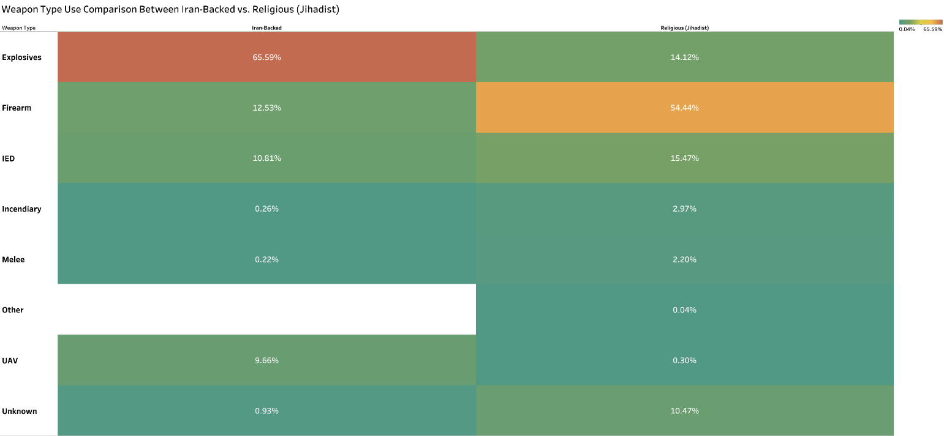
Figure 36: The figure represents Weapon Type use Comparison between Iran-Backed vs Religious (Jihadist).

This chart provides a clear comparison of weapon choices between Iran-backed and religious jihadist groups, highlighting the unique tactical approaches each group employs. Iran-backed groups overwhelmingly favor explosives, with a significant 65.59% usage rate, reflecting their preference for high-impact, infrastructure-focused attacks. In contrast, religious jihadist groups rely heavily on firearms, with 54.44% of their operations involving this weapon type, indicating a more direct, combat-style engagement. Additionally, while both groups make use of improvised explosive devices (IEDs), jihadist groups employ them more frequently, emphasizing their adaptability and willingness to leverage locally sourced or self-made devices. These weapon preferences not only reveal each group's operational strengths but also underscore their different objectives: Iran-backed groups aim for structural disruption, whereas religious jihadists focus on confrontational and fear-inducing tactics. Together, these distinctions provide insights into the varying strategies and priorities that shape their respective methods of violence.
Overall, the data paints a clear picture of two distinct operational models. Iran-backed groups, with a concentrated, high-impact approach, operate mainly within the Middle East to advance Iran’s political interests. In contrast, religious jihadist groups use diverse tactics across wider regions, targeting civilians to spread ideological influence. Understanding these strategic differences is essential for developing tailored counterterrorism approaches that address each group’s specific threats and goals. By targeting the unique operational methods of these groups, security agencies can better respond to the varied challenges they present.

Research question 7:

What tactics have lone actors used from 2018 to 2023? Which ideologies (jihadist, far right, or nationalist) most influence lone actors?
Uncovering the specific tactics used by lone actors over recent years provides a window into the motivations and ideologies driving their actions. This analysis isn’t just about cataloging methods; it delves into the mindset behind these choices, seeking to understand the ideological forces that most shape lone actors’ decisions. By exploring these details, we gain insights that could help predict and potentially counter future threats more effectively.
This research question is divided into two parts:
- What tactics have lone actors used from 2018 to 2023?
- Which ideologies (jihadist, far right, or nationalist) most influence lone actors?
Each part is addressed separately using different methods and approaches.
- What tactics have lone actors used from 2018 to 2023?
This part of the research question is answered using the below graph.

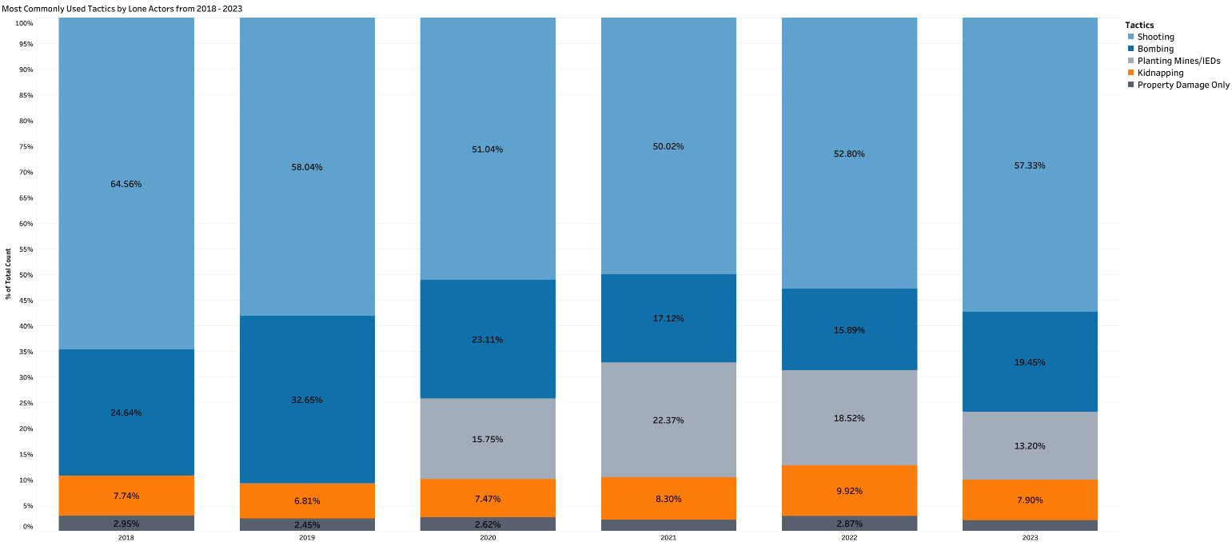
Figure 37: The figure represents the most used Tactics by Lone Actors from 2018 to 2023
The data reveals that shooting is overwhelmingly the preferred tactic among lone actors from 2018 to 2023. This method consistently dominates, largely because of its accessibility and immediate impact. Firearms are often relatively easy to obtain and require minimal preparation, making them a practical choice for individuals acting without the support of a larger organization. The prevalence of shooting as a tactic is clearly depicted in the stacked bar chart, where it occupies the largest segment each year, underscoring its persistent appeal across various ideological background. This preference for firearms reflects a desire among lone actors to inflict direct and substantial harm, often targeting crowded public spaces to amplify the impact of their actions. Additionally, the accessibility of firearms in certain regions likely contributes to this trend, as lone actors gravitate toward tactics that align with their capabilities and resources.
While shooting remains the dominant method, other tactics—such as bombing, planting mines/IEDs, kidnapping, and property damage—also appear in the data, albeit less frequently. These tactics typically require greater planning and resources, which may limit their use by lone actors who lack organizational backing. The relative rarity of these methods highlights the practical limitations faced by lone actors, who often resort to simpler tactics that do not require extensive logistical support.
- Which ideologies (jihadist, far right, or nationalist) most influence lone actors?
This is the other part of the research question. This question is an extended version of the previous part where it expands to the ideologies that influence the lone actors.

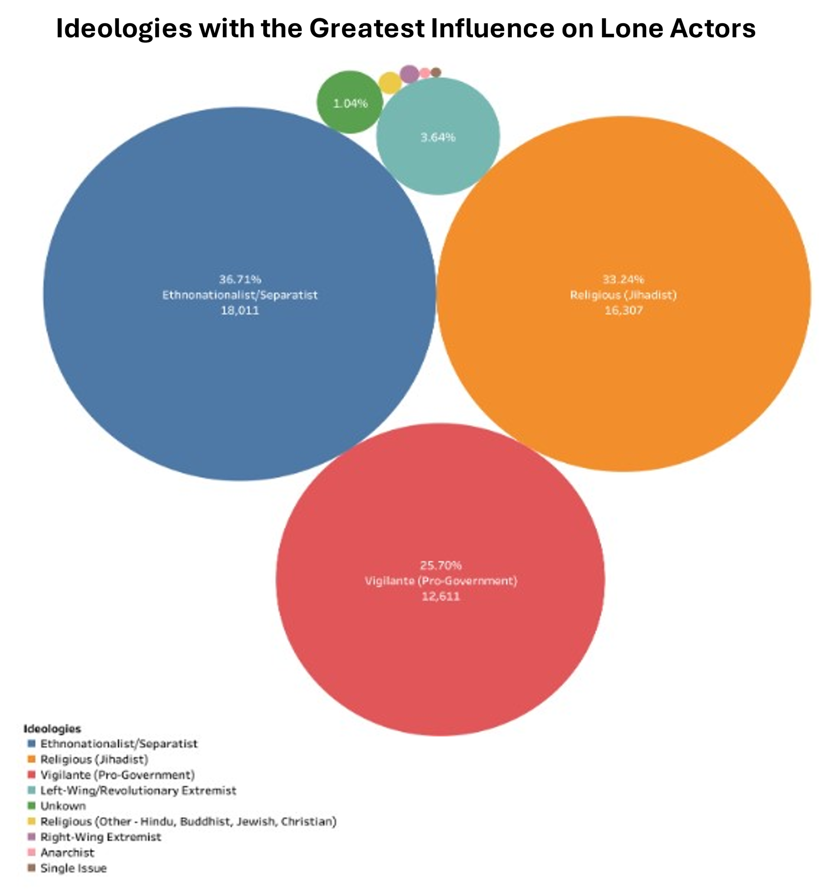
Figure 38: The figure represents what ideologies had the greatest influence on the lone actors.
Examining the ideological influences on lone actors reveals three main driving forces: Ethnonationalist/Separatist, Religious (Jihadist), and Vigilante (Pro-Government) motivations. Ethnonationalist/Separatist ideologies stand out as the leading influence, followed closely by Jihadist beliefs. This trend is illustrated in the bubble chart, where the size of each circle represents the extent of each ideology’s influence on lone actor. The prominence of Ethnonationalist/Separatist motivations suggests a strong connection between lone-actor incidents and nationalist or separatist sentiments, likely fueled by historical or cultural grievances. Individuals motivated by these ideologies often view their actions as part of a broader struggle for self-determination or defense of their ethnic or national identity.
Religious (Jihadist) ideology, while slightly less prevalent than Ethnonationalist/Separatist motivations, remains a significant influence on lone actors. Individuals driven by Jihadist beliefs often adopt tactics aimed at causing widespread fear to further their ideological goals. Lone actors motivated by this ideology typically see themselves as part of a larger spiritual or ideological battle, even when they act independently. Finally, Vigilante (Pro-Government) motivations, though less common, still play a notable role. Lone actors influenced by this ideology tend to view themselves as defenders of a particular political or governmental system, taking unilateral action to address perceived threats or instability.
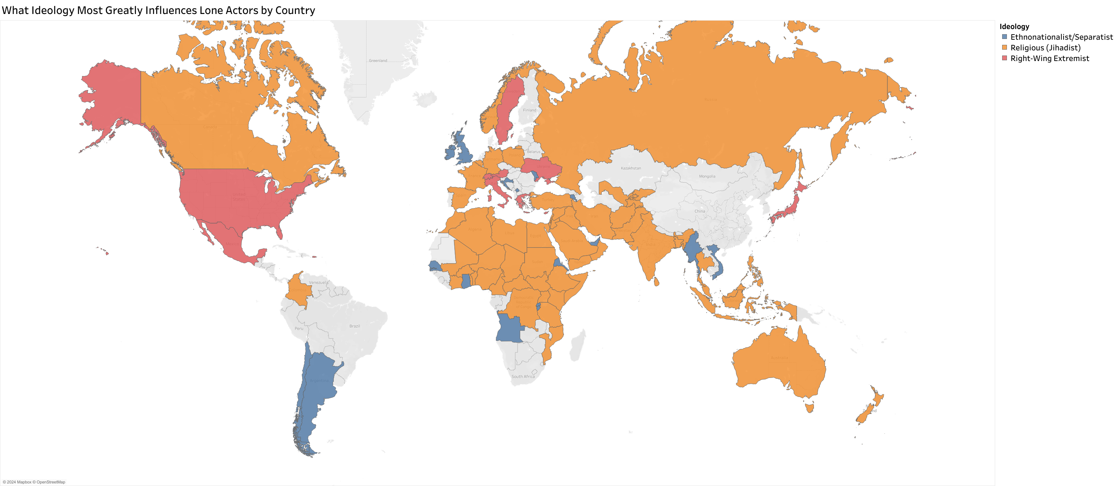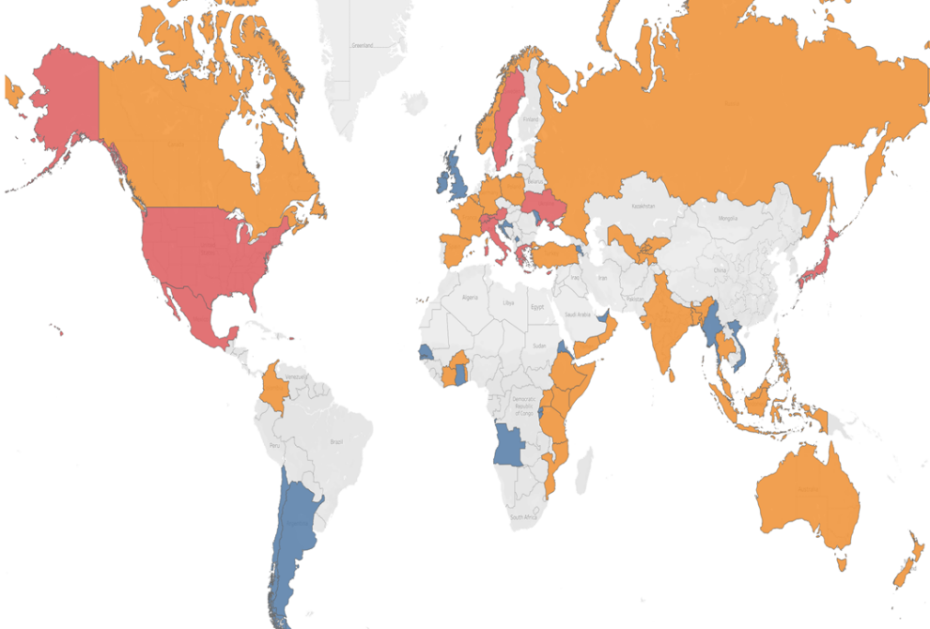
Figure 39 :The figure represents what ideologies influence the lone actors by country.
A geographic breakdown of these ideologies reveals regional patterns that further illuminate the connection between ideology and lone-actor incidents. Ethnonationalist/Separatist ideologies are particularly prominent in areas with ongoing political conflicts, reflecting the strong link between local tensions and lone-actor motivations. Jihadist ideologies are most influential in regions associated with religious radicalization, suggesting that local ideological environments may significantly impact lone actors’ choices. Vigilante (Pro-Government) influences, meanwhile, are often found in regions experiencing political instability, where individuals may feel compelled to take matters into their own hands.
In answering the questions at the heart of this analysis, shooting stands out as the most used tactic among lone actors, favored for its accessibility, immediacy, and effectiveness in creating visible impact. The primary ideological influences on lone actors include Ethnonationalist/Separatist, Religious (Jihadist), and Vigilante (Pro-Government) motivations, with Ethnonationalist/Separatist ideologies emerging as the most common driving force. These findings illustrate that the tactical choices of lone actors are not random but are instead shaped by their underlying beliefs, resources, and access to certain tools.
This knowledge is valuable for law enforcement and security agencies seeking to prepare for and prevent similar incidents. Understanding that lone actors predominantly choose shooting as their method could lead to enhanced security measures in public spaces and stricter controls on firearm access. The strong influence of Ethnonationalist/Separatist ideologies suggests that monitoring areas with known nationalist or separatist sentiments may help identify potential lone-actor threats. Similarly, understanding the geographic spread of Jihadist and Vigilante ideologies allows for more targeted interventions in regions most at risk.
In sum, the analysis highlights the tactical preferences and ideological motivations of lone actors, emphasizing the importance of a proactive, informed approach to countering these threats. By recognizing the patterns in lone-actor behaviors, security efforts can become more strategic, focusing on the regions, ideologies, and tactics that present the greatest risks. This approach not only enhances the allocation of resources but also improves the chances of preventing lone-actor incidents before they occur.

Research question 8:

Is there a positive correlation between the types of terrorist perpetrators and the types of tactics used?
The research question investigates whether specific terrorist perpetrator groups exhibit a positive correlation with tactics they employ. To examine this, we leveraged two distinct levels of tactical classifications. Level 1 tactics encompass broader categories such as Trauma, Assault, and Exploitive, while Level 2 tactics provide more detailed insights into specific actions, such as Bombing, Shooting, and Kidnapping. By analyzing these two levels, we aimed to uncover both overarching patterns and finer details of tactical preferences among the groups.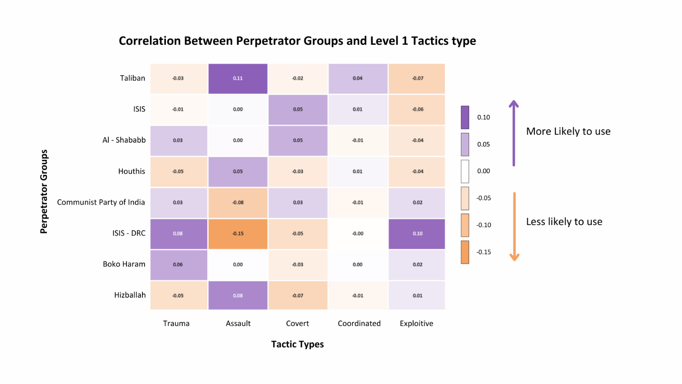
Figure 40: Heatmap depicting correlations between perpetrator types and tactics.
In the Level 1 analysis, we observed distinct patterns in the alignment of various perpetrator groups with broad tactical categories, shedding light on their general strategic preferences. For instance, the Taliban displayed a significant positive correlation with "Assault" tactics, suggesting a clear inclination toward physically aggressive methods such as armed confrontations or direct attacks. This pattern highlights their operational focus on employing violence as a primary means of achieving their objectives. Similarly, ISIS-DRC demonstrated a strong preference for "Trauma" and "Exploitive" tactics, indicating a strategic reliance on actions that aim to instill fear, create psychological distress, or exploit individuals or communities for their resources or vulnerabilities. These tendencies underline how groups prioritize certain tactics to achieve their broader goals, whether through overt violence or indirect methods of manipulation and fear.
Conversely, some groups exhibited a lack of alignment with physically aggressive tactics. The Communist Party of India, for example, showed a negative correlation with "Assault" tactics, highlighting their apparent disinclination toward direct physical aggression. This could suggest a reliance on more covert or politically motivated approaches rather than outright violent engagements. Such findings provide valuable insights into the operational strategies of different groups, revealing that not all perpetrators resort to overt violence as their primary mode of operation. Instead, their choices are influenced by their ideological goals, available resources, and the environments in which they operate. These observations from the Level 1 analysis provide a foundational understanding of the broader tactical preferences of terrorist groups, setting the stage for deeper investigation into more specific patterns in Level 2 tactics.
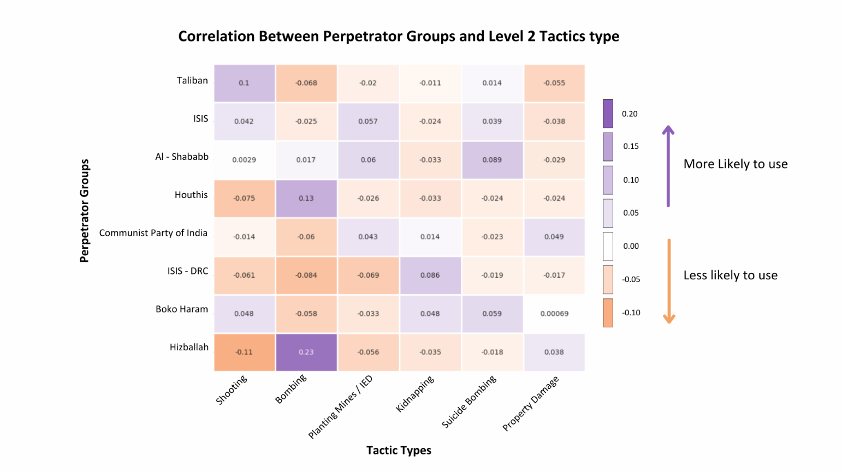
Figure 41: Figure represents a Line Chart showing each perpetrator type’s correlation.
The deeper exploration into Level 2 tactics revealed specific tactical preferences that provide a more detailed view of how different perpetrator groups operate. Hizballah, for example, exhibited a strong positive correlation with "Bombing," suggesting that explosive methods play a central role in their operational strategy. This reliance on bombings highlights their focus on creating large-scale destruction or disruption, often aimed at instilling fear or making a political statement. Similarly, the Taliban showed a notable affinity for "Shooting" as a primary tactic, emphasizing their preference for direct and confrontational methods, often involving armed attacks against both civilian and military targets. These findings highlight the diverse tactical approaches utilized by different groups, tailored to their objectives and capabilities.
In contrast, ISIS demonstrated a moderate positive association with "Kidnapping," pointing to its strategic use of abduction as a method to gain leverage, whether for propaganda, ransom, or psychological intimidation. This reflects their calculated use of tactics that extend beyond direct violence to exploit human vulnerabilities and create broader impacts. Despite these distinct preferences, some tactical methods displayed overlapping tendencies among groups. For instance, "Covert" and "Coordinated" tactics showed mild positive correlations across multiple groups, indicating a shared reliance on clandestine planning and collaboration in executing operations. These overlapping strategies suggest that while each group may have its unique tactical focus, certain methods are universally adopted to achieve operational success, demonstrating a blend of distinctiveness and commonality in their behaviors.
Comparing the findings across both levels, we identified similarities and unique preferences among the groups. While some groups share common methods, their distinct tactical inclinations reinforce the idea that each perpetrator group operates with a specific strategic focus. This layered analysis provides a comprehensive answer to the research question, confirming that there is indeed a positive correlation between the types of terrorist perpetrators and the tactics they use. Such insights are critical for designing counter-terrorism strategies tailored to the unique behavioral patterns and operational methods of each group, ensuring a more targeted and effective approach.

Research question 9:

Do weapon types influence the tactics used by terrorist organizations? Do target types influence the tactics used by terrorist organizations?
To better understand this question, we can break it down into 2 parts.
- 9 A) Do weapon types influence the tactics used by terrorist organizations?
- 9 B) Do target types influence the tactics used by terrorist organizations?
To answer them we have used Sankey plots to visualize the relationship between targets or according to the codebook, victims and tactic types used in the terrorist incidents.
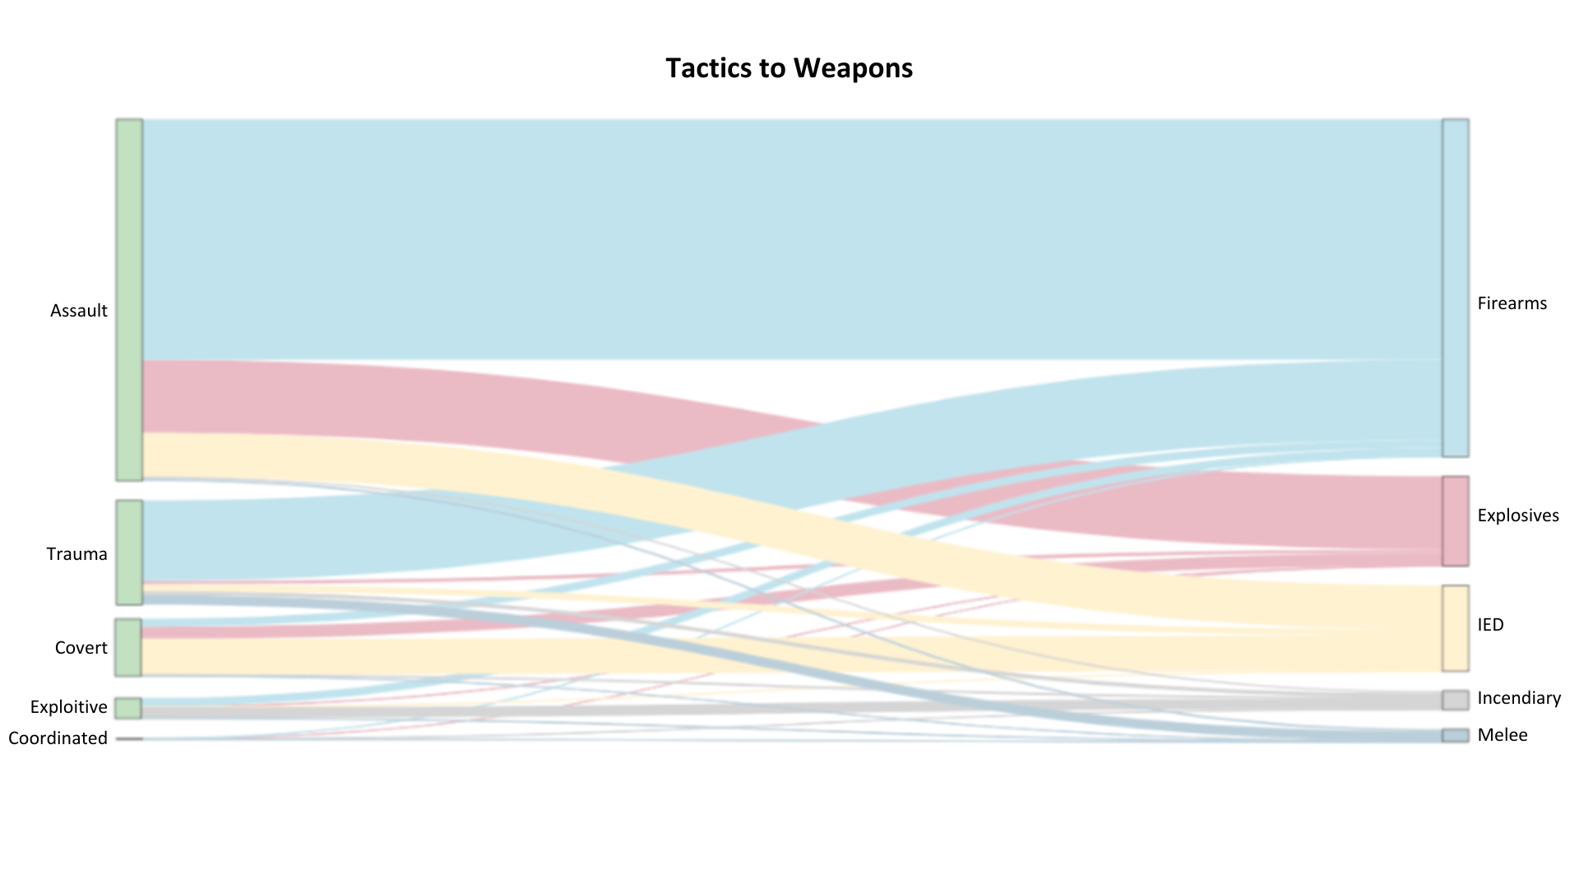
Figure 42: The figure represents a Sankey plot to visualize the tactics influence on weapon type.
In examining the "Weapons to Tactics" Sankey plot, our team has analyzed how different weapon types influence the tactics chosen by terrorist organizations. Firearms emerge as the most used weapon and are heavily linked to Assault tactics, suggesting that firearms are primarily employed in direct attacks that involve close or sustained engagement. This direct association implies that firearms are the preferred choice for confrontational tactics, likely due to their accessibility and effectiveness in assault scenarios. Explosives and Improvised Explosives demonstrate a wider distribution across multiple tactics, including Covert, Trauma, and Exploitative approaches. Explosives show strong links to both Assault and Trauma tactics, indicating that they are used not only for direct attacks but also to inflict psychological impact and instill fear. Improvised Explosives are often associated with Covert tactics, suggesting a strategic application where attacks are intended to be concealed or deployed with an element of surprise. This may reflect the adaptability of improvised explosives in both unexpected and highly targeted operations.
Unarmed and Melee weapon types have limited connections across tactics, but they are most closely associated with Assault tactics. This likely reflects close-combat or spontaneous attacks where these weapons are available. Their lack of connection to other tactics may indicate that these weapons are more opportunistic or situational. Incendiaries show moderate links to Exploitative and Trauma tactics, pointing toward their use in causing fear, destruction, or creating a significant visual impact. The Exploitative association suggests that incendiaries are used when there is an intent to maximize attention or media coverage. Similarly, Unknown Weapons are spread across multiple tactics, reflecting their versatility or the unpredictability of attacks where the weapon type cannot be clearly identified.
In summary, our analysis indicates that weapon choice plays a significant role in tactical decisions. Firearms are primarily associated with Assault tactics, while explosives, due to their versatility, are linked to a range of tactics including Trauma and Covert approaches. Melee and unarmed options appear to be limited to direct engagement, while incendiaries are often used in ways that emphasize psychological and exploitative impact. This analysis highlights how different weapons support specific tactical goals, with versatility, accessibility, and intended impact guiding these choices.
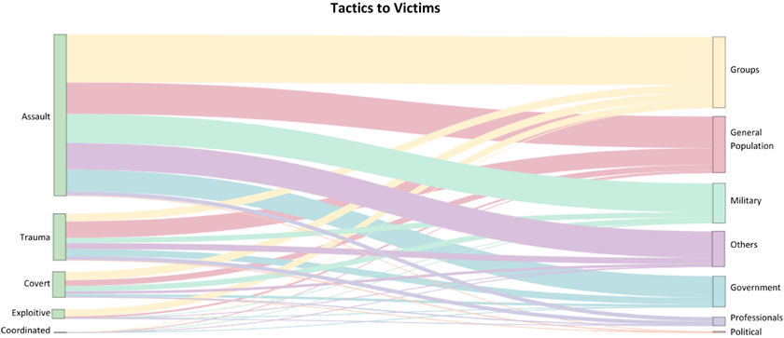
Figure 43: The figure represents a Sankey plot to visualize the tactics influence on victim types.
In analysing the "Tactics to Victims" Sankey plot, we observed distinct patterns that reveal how different target types influence the tactical choices of terrorist organizations. For Military targets, we noted a strong connection with Assault tactics, indicating a preference for direct confrontation. Additionally, military targets are often associated with Coordinated and Exploitative tactics, reflecting organized, high-profile operations. When it comes to Government targets, we saw a significant link to Exploitative tactics, likely because attacks on government entities are intended to be highly visible or symbolically impactful. Assault, Covert, and Coordinated tactics were also prevalent, indicating a mix of direct engagement and strategic planning.
For the General Population, we found a prominent use of Trauma tactics, highlighting an intent to instill fear and cause psychological impact. Assault and Exploitative tactics were also frequently used, suggesting attacks designed for both immediate harm and maximum visibility. Groups (such as social or ethnic collectives) are mainly targeted through Coordinated and Exploitative tactics, reflecting organized efforts to disrupt community structures. We also noticed that Political figures are frequently associated with Covert tactics, indicating a need for secrecy and precision in these high-stakes attacks, often to avoid immediate detection. The Professions category, representing individuals in specific occupations, showed strong links to Exploitative and Trauma tactics, implying that these attacks are intended to destabilize or disrupt societal functions within certain professions.
Overall, our analysis of the Sankey plot tells us that victim type strongly influences tactical choices. High-profile targets, such as military and government entities, often face direct and coordinated tactics, while civilians and professionals are more likely to be subjected to exploitative and trauma-inducing tactics. This indicates that terrorist organizations carefully select tactics based on the symbolic or societal role of their targets, balancing high-visibility attacks with covert or coordinated operations to achieve maximum impact.

Findings
The findings of this project provide a detailed analysis of global terrorism trends from 2018 to 2023, utilizing the GTTAC dataset. Western Asia and Sub-Saharan Africa emerged as the most affected regions, with Syria, Afghanistan, and the Democratic Republic of Congo experiencing the highest frequencies of incidents. Temporal patterns revealed significant shifts, with heightened casualties during specific geopolitical events. Groups such as the Taliban, ISIS, and Boko Haram played prominent roles, employing diverse tactics and strategies to maximize their impact. Civilians and government officials were consistently identified as the most targeted victim categories, reflecting a dual focus on instilling fear and destabilizing governance. The reclassification of bombings in 2020 into distinct subcategories, as well as the increased use of advanced technologies such as UAVs by groups like Hizballah, underscored the evolving nature of terrorist tactics and the adaptability of these organizations.
This project emphasized the importance of structured analysis and expert guidance in interpreting complex data on terrorism. Regular sessions with Dr. Mahmut Cengiz were instrumental in validating findings and ensuring that conclusions drawn from the data were both accurate and actionable. By highlighting critical distinctions—such as the regional focus of Iran-backed groups like Hizballah versus the global reach of jihadist organizations—the project illuminated key trends that are vital for counterterrorism efforts. These findings contribute to a deeper understanding of terrorism’s operational and ideological dimensions, offering valuable insights for researchers, policymakers, and security analysts in their ongoing efforts to combat and mitigate the global threat of terrorism.

Summary
This project provided a comprehensive examination of global terrorism trends from 2018 to 2023, leveraging the GTTAC dataset to address critical research questions about the geographical, tactical, and ideological dimensions of terrorist activities. The analysis identified Western Asia and Sub-Saharan Africa as regions with the highest levels of terrorist activity, with specific hotspots in Syria, Afghanistan, and the Democratic Republic of Congo. Insights into the operational patterns of groups like the Taliban, ISIS, Boko Haram, and Hizballah revealed the diverse strategies employed to achieve their objectives, from bombings and shootings to the use of advanced technologies like UAVs. Temporal trends indicated shifts in tactics and heightened casualties during periods of geopolitical unrest, emphasizing the evolving nature of terrorism and its significant societal impact.
The project highlighted the challenges of analyzing complex and sensitive data, particularly in the context of limited domain knowledge. This risk was effectively mitigated through structured learning and guidance from Dr. Mahmut Cengiz, whose expertise ensured the validity of the findings. The team’s iterative learning process allowed for the development of robust methodologies to interpret data accurately and draw actionable insights. These efforts culminated in a nuanced understanding of terrorism's multifaceted nature, including the distinct ideological and operational approaches of Iran-backed and jihadist groups. The project’s findings serve as a critical resource for policymakers, researchers, and security analysts, offering data-driven insights to inform counterterrorism strategies and improve global security measures.

Future Work
Building on the current analysis, future work will focus on a deeper exploration of Al-Qaeda in Syria (HTS) and Iran-backed militia groups. These groups represent unique challenges due to their distinct operational strategies and regional impacts. Al-Qaeda in Syria, also known as Hay’at Tahrir al-Sham (HTS), has evolved significantly in response to geopolitical pressures and civil unrest in the region. Examining their shifting tactics, recruitment strategies, and increasing use of advanced technologies such as drones will provide valuable insights into their adaptability and long-term objectives.
Similarly, Iran-backed militia groups play a pivotal role in state-sponsored terrorism, often operating as extensions of Iran’s geopolitical ambitions. Future work will analyze their operations in destabilized regions such as Western Asia, assessing how their activities align with or diverge from Iran’s broader strategic goals. Understanding their funding mechanisms, alliances with other non-state actors, and their role in regional destabilization will be essential to comprehending their overall impact.
To support these efforts, expanding data sources from intelligence agencies, local governments, and independent watchdogs will enhance the granularity of the analysis. Predictive modeling will also be employed to identify emerging hotspots of terrorism and anticipate future threats. By focusing on these areas, the research aims to provide actionable insights for policymakers and security agencies, enabling the development of targeted and effective counterterrorism strategies.

This page intentionally left blank

Appendix
Appendix A: Domain Background
Introduction to Terrorism and Its Global Impact
Terrorism, which is the deliberate use of violence to instil fear and pursue political, religious, or ideological objectives, has been a persistent challenge throughout human history. The term "terrorism" first appeared during the French Revolution in the late 18th century, but its forms and methods have dramatically evolved over time [9]. As technology, geopolitics, and societal structures have changed, so too have the strategies and tactics employed by terrorists.
The events of September 11, 2001, marked a significant shift in the global perception of terrorism, emphasizing its impact on international security. Although there haven't been major attacks on U.S. soil since then, terrorism has intensified in regions such as Africa, the Middle East, and Asia. This surge has led to extensive loss of life, economic disruptions, and social instability.

The Role of GTTAC and TraCCC
The Global Terrorism Trends and Analysis Center (GTTAC) and the Terrorism, Transnational Crime and Corruption Center (TraCCC) at George Mason University are instrumental in monitoring and analysing global terrorist incidents. Partnering with the U.S. Department of State, these centres produce an annual report.
Since 2018, GTTAC has documented between 7,000 and 10,000 terrorist incidents each year, resulting in roughly 25,000 deaths annually. The comprehensive dataset, which includes detailed information on over 53,000 incidents, covers aspects such as perpetrators, tactics, targets, weapons, victims, facilities, and logistics. This data is accessible to the public through the GTTAC Data Portal.

Project Overview
This project aims to utilize the Global Terrorism Trends and Analysis Center (GTTAC) data to tackle several critical research questions concerning global terrorism trends from 2018 to 2023. The objectives of the project are twofold. First, we plan to conduct a thorough analysis to address nine key research questions. These questions will focus on identifying regions with the highest number of terrorist incidents, examining the tactics and weapons used, and understanding the demographics of victims targeted by different terrorist groups. This comprehensive data analysis will provide valuable insights into the patterns and dynamics of terrorism across various geographic and social contexts.
Next, we will be creating visualizations for those research questions using softwarelike Tableau and Python. By integrating these elements into a cohesive visual platform, we aim to enhance accessibility and usability for researchers, policymakers, and analysts who are seeking to understand and address the challenges posed by terrorism in today's world.

Research Questions
- Which regions or countries recorded the most terrorist incidents from 2018 to 2023? Which months saw the highest number of people killed and wounded during the same period?
- Which ten groups had the highest number of casualties (people killed and wounded) from 2018 to 2023?
- How many types of tactics (e.g., suicide attacks, kidnapping, car ramming, assassinations, stabbing, shooting, bombing, ambush, and planting mines/IEDs) were used from 2018 to 2023? Which ten groups employed these tactics the most, and how has their use of these tactics changed from 2018 to 2023?
- What are the most commonly used weapon types (e.g., firearms, explosives, UAVs, incendiary devices, and melee weapons)? Which five groups use firearms, IEDs, rockets, mortars, grenades, missiles, and UAVs the most?
- Which victim categories are most frequently targeted (e.g., general population/civilians, government officials, professionals, political figures)? Which five groups primarily target civilians, military personnel, politicians, government officials, and professionals?
- What are the similarities and differences between Iran-backed and jihadist terrorist groups?
- What tactics have lone actors used from 2018 to 2023? Which ideologies (jihadist, far right, or nationalist) most influence lone actors?
- Is there a positive correlation between the types of terrorist perpetrators and the types of tactics used?
- Do weapon types and target types influence the tactics used by terrorist organizations?

Importance of Data Analysis in Counterterrorism
Data analysis of terrorist attacks is important for effective counterterrorism strategies. By identifying patterns and trends, policymakers and security agencies can gain valuable insights into emerging terrorist methods, preferred targets, and active regions. This understanding allows for the development of targeted strategies and resource allocation.
Moreover, evidence-based policymaking is enhanced through data analysis, leading to more effective counter-terrorism initiatives and leading to international collaboration by providing a shared platform for information exchange. This will in turn deepen the understanding of global terrorist networks.

Project Goals and Success Criteria
The success of this project will be measured by several criteria that align with our overall objectives. First, is the depth of Analysis. This criterion will evaluate the thoroughness and accuracy of the research conducted to answer the specified questions. We will assess the quality of the findings through high-quality visualizations and well-crafted narratives that not only present data but also provide context and interpretation. The ability to identify meaningful patterns and trends in the GTTAC data will be crucial for demonstrating the project's analytical capability.
The effectiveness and user-friendliness of our graphs will be evaluated based on how easily it allows users to navigate and interact with the data. Key metrics for this will include the clarity and consistency of visualizations, the intuitiveness of the user interface, and the overall user experience. We aim to create an engaging platform that not only meets the needs of researchers and policymakers but also encourages exploration and discovery of insights.

Data Sources and Engineering
The primary data source for this project will be the GTTAC terrorism database, maintained by TraCCC at George Mason University. The database is updated weekly, and the project team will implement a data engineering solution to regularly access and update the data for analysis.

Conclusion
By applying advanced data analytics and visualization techniques, this project seeks to offer a detailed understanding of global terrorism trends. The insights gained will enhance the comprehension of terrorism's evolving patterns and aid in developing more effective counterterrorism strategies. Ultimately, the goal is to contribute to global security efforts by providing actionable intelligence and a deeper understanding of the complex dynamics of terrorism.

Appendix B: Glossary
Term | Definition
GTTAC | Global Terrorism Trends and Analysis Center
TraCCC | GMU Terrorism, Transnational Crime and Corruption Center
Terrorism | Deliberate use of violence to instil fear and pursue political, religious, or ideological objectives
GRID | It is short of Global Terrorism Trends and Analysis Center (GTTAC) Record of Incident Database. It is the Database that uses open-source information to record terrorist incidents in the United States and other locations around the world.
Codebook | Manual to understand GRID database
Table 2: Glossary Table

Appendix C: GitHub Repository
Overview
The Global Terrorism project leverages data from the Global Terrorism Trends and Analysis Center (GTTAC) to provide an interactive visualization tool that highlights critical trends in terrorism from 2018 to 2023. This project addresses vital research questions about terrorist activities, including regional incident frequencies, tactics employed, and victim demographics. The goal is to create an intuitive visualizations that empowers researchers, policymakers, and analysts with actionable insights into the complexities of global terrorism.

GitHub Repository Link
https://github.com/TraCCC-Stats/Terrorism-Research-and-Dashboard

Appendix D: Risks

Sprint 1 Risks
Risk | Description | Probability | Impact | Mitigation
Domain Knowledge | Gather background knowledge about Terrorism and Transaction Crimes | High | Low | Lectures by Dr. Cengiz and Online research
Tableau Knowledge | Learning the functionalities of Tableau | Low | Low | Working with our partner to gain access to the full dataset
Dataset Access | Gaining access to the new data weekly | High | Low | Working with our partner to gain access to the full dataset.
Dashboard Presentation | Learning the Best Practice for Creating an Effective Dashboard | Medium | Medium | Reviewing and learning the requirements of the Best Practices of Dashboard
Agile Scrum | Gather background on the best practices for Agile Scrum | High | Medium | Research Agile scrum method
Table 3: Sprint 1 Risks
In our project, we identified several key risks that could impact our success, particularly in areas such as domain knowledge, tool proficiency, data access, and project management methodologies. One of the most significant risks is the lack of domain knowledge regarding terrorism and transaction crimes, rated as high due to its importance for accurate data analysis. A misunderstanding of these concepts could lead to misinterpretations and insufficient insights. To mitigate this risk, we are utilizing meetings from Dr. Cengiz and conducting online research to deepen our understanding. Additionally, proficiency in Tableau is essential for effective data visualization, yet our current familiarity with the tool is medium, which poses another challenge. Collaborating closely with our partner to gain access to the full dataset will be critical for maximizing Tableau's capabilities and ensuring we can create meaningful visualizations.
Another notable risk is related to dataset access, which is important for maintaining the reliability of our analyses. This risk is rated high because delays in receiving updated data could hinder our progress. Establishing a clear communication channel with our partner is essential to ensure timely access to the dataset. Furthermore, our understanding of best practices for dashboard presentation is rated medium; while the team has some familiarity with dashboard design, reviewing guidelines and learning from existing examples will be key to enhancing our user interface. Lastly, our understanding of Agile Scrum methodologies is currently at a medium level, which may result in inefficiencies in project management. To address this, we are conducting research on Agile principles to better integrate them into our workflow, improving collaboration and project execution. By proactively addressing these risks, we aim to strengthen our project outcomes and deliver a comprehensive dashboard and analysis.

Sprint 2 Risks
Risk | Description | Probability | Impact | Mitigation
Domain Knowledge | Gather background knowledge about Terrorism and Transaction Crimes | High | Low | Lectures by Dr. Cengiz and Online research
Table 4: Sprint 2 Risks
In this Sprint, the primary risk was the team’s limited domain knowledge in terrorism, which could have significantly impacted our ability to understand, interpret, and accurately present insights from complex datasets. To mitigate this, we relied on our client, Dr. Mahmut Cengiz, a terrorism expert, for foundational guidance and nuanced understanding of the data’s context. This approach proved highly effective, as Dr. Cengiz provided critical insights that improved our interpretation and added value to the project’s output. While the team accurately identified this as a core risk from the beginning, in hindsight, we could have benefited from additional preparation, such as preliminary readings or introductory sessions on terrorism trends, to accelerate the learning process. Overall, our risk identification was precise, and our mitigation plan directly addressed the challenge. No unanticipated risks arose during the Sprint, suggesting that focusing on close collaboration with subject matter experts early on can be a strong strategy in tackling projects requiring specialized knowledge. This experience reinforces the importance of domain expertise and serves as a valuable lesson for future teams engaging with complex or specialized data topics.

Sprint 3 Risks
Risk | Description | Probability | Impact | Mitigation
Domain Knowledge | Gather background knowledge about Terrorism and Transaction Crimes | High | Low | Lectures by Dr. Cengiz and Online research
Table 5: Sprint 3 Risks
The risk of limited domain knowledge regarding terrorism and transaction crimes, first identified in Sprint 1 and carried over into Sprint 2, remains the only risk in Sprint 3. While we are continuing to mitigate this risk through regular lectures and guidance from Dr. Cengiz, an expert in the field, we expect this risk to persist throughout the project. To address this, the team is making significant efforts to understand the subject matter thoroughly, and every conclusion we draw from the data is carefully checked and confirmed by Dr. Cengiz. His expertise ensures that our interpretations and insights remain accurate and reliable, reducing the potential impact of this risk on our overall project.

Sprint 4 Risks
Risk | Description | Probability | Impact | Mitigation
Domain Knowledge | Gather background knowledge about Terrorism and Transaction Crimes | High | Low | Lectures by Dr. Cengiz and Online research
Table 6: Sprint 4 Risks
In Sprint 4, the team continued to address the significant risk of limited domain knowledge regarding terrorism and transaction crimes, which remains a high probability concern due to the complexity of the subject. While previous mitigation efforts, including lectures by Dr. Mahmut Cengiz and extensive online research, have improved the team’s understanding, the evolving nature of the data necessitates ongoing learning. This risk’s impact remains low, as the team has implemented effective measures to ensure accurate data interpretation and analysis by validating insights through expert guidance and structured research. Building on prior progress, the team focused on applying their knowledge directly to the dataset in this sprint, further minimizing potential misinterpretations and strengthening the overall analysis.

Sprint 5 Risks
Risk | Description | Probability | Impact | Mitigation
Domain Knowledge | Gather background knowledge about Terrorism and Transaction Crimes | High | Low | Lectures by Dr. Cengiz and Online research
Table 7: Sprint 5 Risks
In Sprint 5, the team continued to address the persistent risk of limited domain knowledge regarding terrorism and transaction crimes. The impact of this risk has remained low due to consistent mitigation efforts, including weekly learning sessions, regular lectures, and guidance from Dr. Mahmut Cengiz. These measures have significantly enhanced the team's understanding and ability to interpret the data accurately. Building on the progress made in previous sprints, the team has applied their growing domain knowledge to the dataset and analysis processes, ensuring that conclusions drawn are well-informed and validated. This structured and iterative learning process has minimized potential misinterpretations, maintained the reliability and quality of the project outcomes while emphasizing the importance of expert guidance and continuous education.
Appendix E: Agile Development
Scrum Framework Team Approach
Adapting the Scrum framework for our data analytics engineering project was a new experience for our team, providing structure and focus to our work. While the transition came with its challenges, the overall impact was positive, leading to improved collaboration and enhanced project visibility.
Initially, we faced some difficulties in fully grasping the Scrum principles, particularly in defining our roles and responsibilities within the framework. The iterative nature of Scrum required us to rethink our workflow, moving away from traditional project management methods that relied heavily on linear timelines. We found ourselves needing to educate each other about Scrum practices, which took some time but ultimately led to us better understanding the agile methodologies across the team.
To facilitate regular communication and keep the project on track, we implemented daily stand-ups. These quick, focused meetings allowed team members to share updates on their progress, discuss any obstacles they were facing, and plan their tasks for the day. While we initially struggled with time management during these stand-ups, we quickly learned to keep them brief. As the project progressed, we found that these daily check-ins significantly improved our accountability and alignment as a team.
In terms of project management, we use YouTrack as our primary tool for managing tasks and tracking progress. While YouTrack offers powerful features, such as issue tracking and sprint planning, we found the learning curve to be somewhat steep. Setting up the project and familiarizing ourselves with its interface required more effort than we initially thought. However, once we became accustomed to the tool, it proved invaluable for managing our backlog and visualizing our sprint progress. The ability to customize workflows and dashboards in YouTrack ultimately helped us streamline our processes, although we did encounter occasional technical glitches that could disrupt our workflow.
One significant takeaway was the value of open communication and collaboration. As we navigated challenges, we encouraged each other to voice their concerns and share insights, which led to innovative solutions and better team cohesion. This culture of transparency also made it easier to pivot when we faced unexpected hurdles, such as data issues or changing project requirements.
In summary, while adapting the Scrum framework presented its share of challenges, the benefits of improved collaboration, accountability, and project visibility were well worth the effort. Our experience with daily stand-ups and the YouTrack tool provided valuable insights that we would pass along to any project team considering a similar approach.

Figure 44: Sprint project dates.
Our project was structured into five distinct sprints, each designed to facilitate focused progress on specific objectives while allowing for iterative refinement based on our findings and feedback. Below is an overview of each sprint, highlighting the goals and outcomes achieved during those periods.
The primary focus of Sprint 1 was on familiarization with the GTTAC data and the research questions. During this sprint, the team conducted an in-depth analysis of the dataset to identify key patterns and areas of interest related to global terrorism trends. We also established our initial dashboard framework, outlining the key metrics we aimed to visualize. Regular stand-ups helped us maintain momentum and ensure alignment with our objectives.
In Sprint 2, the team will dig deeper into the data analysis, preparing to answer the nine key research questions identified in the previous sprint. This involved performing statistical analyses to uncover insights about terrorist incidents, tactics, and victim demographics. We also began to develop the initial components of the dashboard using Tableau, focusing on the user interface and experience. The daily stand-ups continued to help our communication, allowing us to address challenges promptly. By the end of this sprint, we had a significant portion of our data analysis completed and initial visualizations in place.
Sprint 3 was dedicated to refining our analyses and enhancing the dashboard features. Based on the insights gained from Sprint 2, we adjusted our visualizations to better convey our findings. During this sprint, we faced challenges with data integration, but our collaborative approach helped us find effective solutions. By the end of this sprint, we had a more refined dashboard prototype and a clearer narrative to accompany our findings.
In Sprint 4, our attention shifted to finalizing the dashboard and preparing for stakeholder presentations. The team conducted extensive testing to ensure that the dashboard was user-friendly and effectively communicated the intended insights. We gathered feedback from potential users to refine the interface and enhance usability. Additionally, we began drafting reports that encapsulated our analysis and visualizations, aligning our narrative with the dashboard features. By the end of this sprint, we had a nearly complete dashboard and comprehensive documentation ready for review.
The final sprint focused on refining the dashboard and delivering our final presentation. The team implemented the feedback received during the previous sprint, making necessary adjustments to improve clarity and functionality. We also prepared a comprehensive user guide to accompany the dashboard, ensuring that users could navigate and interpret the visualizations effectively. Final testing confirmed the accuracy of our analyses and the reliability of the dashboard. By the conclusion of Sprint 5, we successfully delivered a product that met our project objectives and provided valuable insights into global terrorism trends.

Sprint 1 Lessons Learned
During this sprint, our team took steps in refining our objectives and focusing on the user needs for the dashboard. Identifying user stories was important, and we approached this task through collaborative brainstorming sessions. These discussions helped us focus on the essential features that researchers and analysts would need when interpreting terrorism data. By considering the end user’s perspective, we ensured that the user stories outlined their need for an intuitive interface, clear data visualizations, and flexibility in filtering the data. The division of tasks played to the strengths of each team member, allowing some to handle data analysis while others focused on the dashboard's design. YouTrack helped with task management and transparency, though it took some time for the team to adapt to the platform, which caused minor communication issues early on.
One area where we did well was maintaining regular communication through daily stand-ups, which kept the team aligned and allowed us to address issues in real time. However, we recognized that our sprint planning could have been more structured, with clearer prioritization from the start. Mid-sprint user reviews were a positive step, as they allowed us to incorporate feedback and adjust features based on real user needs. Still, an earlier implementation of this feedback cycle would have been more efficient. In hindsight, dedicating more time to testing and refining the dashboard’s functionality before the final stages would have led to a smoother delivery. Going forward, better sprint planning and earlier user testing will be essential lessons we carry into future projects.
Sprint 2 Lessons Learned
The primary focus of this Sprint was deepening our understanding of the data collection process and examining the role data bias played within our dataset. Early in the Sprint, it became apparent that the structure, sources, and methodologies behind the terrorism data significantly impacted our ability to interpret and draw reliable insights. We invested time in learning about how the dataset was collected, which entities contributed, and the potential limitations in the data’s coverage and accuracy. This process revealed key factors such as geographical limitations, inconsistencies in reporting standards, and subjective biases that could influence how incidents were recorded. Our client, Dr. Mahmut Cengiz, was instrumental in guiding us through these nuances, helping us distinguish between raw data and contextualized information, which informed how we approached data analysis and visualization.
The presence of data bias was an especially critical factor that shaped our approach to developing accurate, fair representations of the data. We encountered bias in incident underreporting for certain regions and varying degrees of information accuracy across sources. This underscored the need to apply caution in our analysis, ensuring that the visualizations did not inadvertently reinforce misleading conclusions or obscure underrepresented areas. Reflecting on this experience, we recognized that addressing data bias requires an ongoing commitment to learning and adjusting our methods. For future sprints, we would prioritize early identification of potential biases in the data and incorporate strategies to mitigate their effects from the beginning. By focusing on these insights, our team has gained valuable experience that will benefit future projects where data collection methods and inherent biases could impact analysis.

Sprint 3 Lessons Learned
One major lesson learned was the importance of clear and concise research question formulation, as it greatly influenced the direction of data exploration and the selection of appropriate visualizations. Initially, we found that some of our research questions were too broad, leading to a more challenging analysis process. Narrowing these questions allowed us to focus on the most relevant data points and streamlined our approach, resulting in visuals that were more targeted and easier for stakeholders to interpret.
Additionally, we discovered the value of iterating on visual design to enhance clarity and impact. Early drafts of the visuals were often cluttered or lacked the necessary context to make them fully comprehensible on their own. By experimenting with different types of charts and focusing on simplicity, we were able to transform the visuals into powerful tools that highlighted key insights and trends. We also incorporated feedback from team members to ensure that each visual effectively supported the narrative we aimed to convey. This iterative approach not only improved our output quality but also reinforced the importance of collaboration and flexibility in visual storytelling.

Sprint 4 Lessons Learned
The focus of Sprint 4 was to finalize the comprehensive analysis of the research questions, refine visualizations, and integrate findings into a cohesive report. This phase provided valuable insights into both the strengths of our approach and the challenges faced during the project. One significant lesson was the need for precision in data visualization. While earlier sprints introduced a variety of visual tools, Sprint 4 underscored the importance of tailoring these visualizations to the audience’s needs. For example, using choropleth maps, bubble plots, and stacked bar charts enabled us to highlight specific patterns and trends in the data effectively. However, ensuring that these visualizations were intuitive and supported the report’s narrative required multiple iterations and team feedback. This process reinforced the value of collaboration and the iterative design of visuals. Time management also emerged as a critical factor in Sprint 4. While the team successfully prioritized tasks and completed deliverables on time, the sprint highlighted the benefits of establishing internal deadlines for quality checks and refinements. Allocating additional time for final edits and feedback integration would have further enhanced the report’s polish and consistency.
One of the challenges faced during this sprint was balancing the depth of analysis with the need for concise reporting. With the dataset’s complexity and the number of research questions, it was essential to ensure that each section provided sufficient detail without overwhelming the reader. Addressing this challenge required careful editing and a focus on presenting only the most impactful findings. Reflecting on this sprint, we recognized the value of integrating all components—visualizations, and analysis—early in the process to identify inconsistencies and gaps. Additionally, ensuring consistent formatting and style across all sections from the start would have reduced the time spent on revisions. These lessons will guide us in future projects, emphasizing the importance of early planning and iterative refinement in delivering high-quality outputs. Sprint 4 highlighted the team’s adaptability, collaborative strengths, and commitment to producing actionable insights. By reflecting on these experiences, we have gained practical knowledge that will inform our approach to future projects.

Sprint 5 Lessons Learned
During this sprint, our team learned the importance of having a well-organized presentation deck to effectively communicate our work. Early in the process, we faced challenges with inconsistent slide formatting, which made the presentation harder to follow. Recognizing this issue, we focused on using a uniform design, including consistent fonts, colors, and layouts, to make the slides more cohesive. This effort improved the overall clarity of our presentation and ensured that our key points were easy to understand. This experience highlighted the importance of paying attention to details in the visual elements of a project.
We also realized the value of practicing the presentation as a team. At first, the transitions between speakers felt uncoordinated, and some team members were reading directly from the slides. Through multiple practice sessions, we were able to create smoother transitions and deliver the content more naturally. Practicing together also helped team members feel more comfortable with the material, allowing them to explain it clearly without relying too much on the text. This experience showed us how preparation can make a big difference in delivering a presentation that is both professional and engaging.
Reflecting on this sprint, we saw room for improvement, particularly in starting rehearsals earlier in the process. By practicing earlier, we could have made adjustments and fine-tuned our delivery before the final deadline. For future sprints, we plan to include more time for group rehearsals and peer feedback to improve both the quality of our slides and our presentation skills. These lessons will help guide us in future projects and could be valuable for other teams working on similar tasks.

References
[1] Tableau. "Top 10 Tableau dashboard design tips," https://www.tableau.com/learn/articles/dashboard-design-tips. [Accessed: Sep. 15, 2024].
[2] DataCamp. "12 dashboard design tips for better data visualization," https://www.datacamp.com/community/blog/dashboard-design-tips. [Accessed: Sep. 15, 2024].
[3] Smartsheet. "How to use color in your data visualization," https://www.smartsheet.com/how-use-color-data-visualization. [Accessed: Sep. 15, 2024].
[4]Global Terrorism Database (GTD) | START.umd.edu
[5] Wikipedia contributors, "Terrorism," Wikipedia, The Free Encyclopedia, Sep. 14, 2024. https://en.wikipedia.org/wiki/Terrorism. [Accessed: Sep. 15, 2024].
[6] Global Terrorism Trends and Analysis Center (GTTAC). "Monitoring global terrorism," https://www.gttac.org/monitoring-global-terrorism. [Accessed: Sep. 15, 2024].
[7] National Consortium for the Study of Terrorism and Responses to Terrorism (START). "Global terrorism database," University of Maryland, https://www.start.umd.edu/gtd. [Accessed: Sep. 15, 2024].
[8] HS Today. "Crucial role of open-source data in combating terrorism," Aug. 1, 2024. https://www.hstoday.us/analysis/crucial-role-of-open-source-data-in-combating-terrorism. [Accessed: Sep. 15, 2024].
[9] Sandler, T. (2018). Economic consequences of terrorism. Terrorism. https://doi.org/10.1093/wentk/9780190845841.003.0006
[10] Merriam-Webster. (n.d.). The history of the word “terrorism.” Merriam-Webster. https://www.merriam-webster.com/wordplay/history-of-the-word-terrorism#:~:text=Indeed%2C%20Al%20Capone%2C%20the%20era’s,Lippman%2C%20The%20Good%20Society%2C%201937
[11] Schwabish, J. A. (2021). Better Data Visualizations: A guide for scholars, researchers, and wonks. Columbia University Press.
[12] Healy, K. J. (2019). Data Visualization: A practical introduction. Princeton University Press.

This page intentionally left blank

